Content

(B) DEFINITION, INVESTIGATION AND ANALYSIS 4

(i) Definition – nature of the problem 4

(ii) Investigation and Analysis 7

Investigation 7

Analysis 10

(C) DESIGN 17

(i) Nature of solution 17

(ii) Intended benefits 49

(iii) Limits of the scope of the solution 49

(D) SOFTWARE DEVELOPMENT, PROGRAMMING, TESTING AND INSTALLATION 52

(i) Development 52

(ii) Programming 63

(iii) Testing 88

(iv) Installation 99

(E) DOCUMENTATION 103

(i) System maintenance manual 103

(ii) User manual 110

(F) EVALUATION 121

(i) Discussion of the degree of success in meeting the original objectives 121

(ii) Evaluate client’s and user’s response to the system 124

# (B) DEFINITION, INVESTIGATION AND ANALYSIS

## (i) Definition – nature of the problem

**Description of the organization**

“DreamBuilders” Learning Centre is an independently-owned school, founded by passionate teacher, Rustem Makan, and is well-known for the level of quality and personal attention given to all students. School has been built on a genuine passion for providing the very best in subject teaching and learning. The DreamBuilders has already 3 spots in Aktobe city. They are located in the different places of the town.

All staff are committed to ensuring that their high standards are consistently met and that student receives the education and experience they expect and deserve. They care about student`s future goals and understand that for many of them this is a once in a lifetime opportunity to learn, experience and grow.

There are many ways to describe Learning Centre and why it is a popular approach in teaching and learning:

* The main function of language is to allow interaction and communication
* Classroom language learning is linked with language activities outside the classroom
* Real-life texts and materials are used to help the learning process
* The student’s personal experiences form a part of learning in the classroom

Quality education is the first component of success in the modern world. That is why one of the priorities for company is to guide compatriots for educational purposes, depending on their interests and capabilities, based on their interests and capabilities. Dreambuilders work with the largest educational providers – British Council, Interpress, AKEAC and others. The publishing activity holding is represented by the “English in Kazakhstan” publishing house. DreamBuilders is the official distributor for Cambridge University Press and Pearson international publishers. Here you can find any products of these publishers, ranging from the most exclusive and narrowly focused, to literary works in an adapted version. The priority for them are educational materials on the study of English.

Also, DreamBuilders offer products in various formats - books, audio, video - they will help you prepare for passing international exams and significantly improve your knowledge. Grammar manuals, multi-level dictionaries, fiction, published in English, and much more - all this you can find in educational center DreamBuilders.

There 10 English teachers in Learning Center and all of them are certified by the University of Cambridge Local Examinations Syndicate (IELTS) with the score band over 7.5, and have over three years of teaching experience. They have a Bachelor of Arts degree in English from one of the following English-speaking countries: the United Kingdom of Great Britain and Ireland or the United States of America, and Kazakhstan as far as well.

There are programs that DreamBuilders can suggest you to join:

•General English Plus

•General English

•One to One

•Executive English

•Corporate English

•English For Kids

•English For Teens

•International Exams Preparation Course

•Kazakh Language

Mr. Makan plays the role of both the superviser and teacher in the school, so he has many responsibilities and functions in the education system occurring in the linguistic center. So he always searches for the methods that will help save the times of the people of this ecosystem. The new idea of Mr.Makan was automatization of the examinations, so that teachers can post the exam questions in the online platform and students can take them with from anywhere anytime. This also helps digitalizing the communication of the school. Moreover, this type of improvement will reduce the number of used papers which will decrease the expenses on papers and bring the better conditions for the ecology even if very little. Also, if all data is stored in the online database everything would be in better protection.

**Methods currently in use**

System of education is quite understandable. Lessons are given three times per week. In the classroom lessons, students are explained by new topics and must have done the homework, also in the end of the week, the students have to pass “End of the Unit” test to check their knowledge over the week.

At the moment all of examinations occur in the classrooms of the school using the exams printed on A4 papers. Then the exam papers are checked by the teachers and final grades are written in their journals. This is very time consuming occupation for both students and teachers. They spend their home time to check these works by their hands. Example of the work made by teacher is shown in Picture-1.

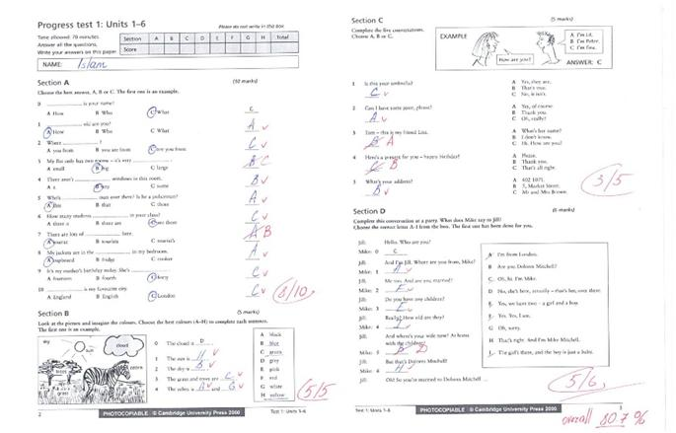

Picture 1 - Example of quiz

**Origin of the data**

The data is transferred between the students and teachers. So that first of all the teachers give students the exam papers with questions and students answer to them by taking the exam. After according to these answers, teachers check the knowledge of students and write the grades for each of them in the journal.

All information about examinations are written in the notebooks of the teachers. Often, their records consist of the main headings such as students’ names, exam question, students’ answers, number of correct answers, grades. The information in tables is used to estimate the weaknesses of the students, knowledge and quality of teaching the exactly one Unit.

**Form the data takes**

All the data are in tables because it is the most convenient way of data representation. The number of the tables depends on the number of Department Levels.

Here are the examples of data represented in Table-1 and Table-2.

Table-1 Results in Upper-Intermediate Department Level

|  |  |  |  |  |  |
| --- | --- | --- | --- | --- | --- |
| **Student Name** | **Exam question** | **Passing Grade** | **Student`s Grade** | **Student`s Result** | **Overall Result** |
| Islam Izdibaev | Superstitious | 75% | 80% | 80/100 | Passed |
|  |  |  |  |  |  |
| Yessetkhan Bazarbay | Grammar Quiz 2 | 75% | 45% | 45/100 | Failed |
|  |  |  |  |  |  |

Table-2 Results in Advanced Department Level

|  |  |  |  |  |  |
| --- | --- | --- | --- | --- | --- |
| **Student Name** | **Exam question** | **Passing Grade** | **Student`s Grade** | **Student`s Result** | **Overall Result** |
| Urazov Dias | Lexile Quiz | 75% | 84% | 84/100 | Passed |
|  |  |  |  |  |  |
| Imashev Olzhas | Grammar Quiz 5 | 75% | 45% | 45/100 | Failed |
|  |  |  |  |  |  |
| Eshimov Alisher | Grammar Quiz 5 | 75% | 75% | 75/100 | Passed |
|  |  |  |  |  |  |

Actually, the table is always flexible, because there can be a numerous number of students and their exams` results.

## (ii) Investigation and Analysis

### Investigation

As investigating, I provided two interviews with Mr. Makan, we had face-to-face question-answer dialogue to have a complete vision of full system we have and what we need. Also interview with potential user was provided.

**Interview 1**

To obtain the information on the current system, I need to Mr.Makan (client), so as to make the overall observation of the current system.

**Q:** As I know, at the moment the examinations occur in the traditional way, in the classrooms and written on the sheets of paper?

**A:** Absolutely, our centre works as simple as different schools in our city and this leads to the bigger problems such as time consuming and high expenses on the papers. Also, as a teacher I can tell you that we spend most of our time on checking the exam papers and sometimes get depressed or stressed which leads to the lose of concentration and misreading.

**Q:** Where do you record the data at the moment?

**A:** All teachers have own journals, where they write all information about the students’ names, exam question, students’ answers, number of correct answers, grades

**Q:** How do you record the data?

**A:** After checking all papers, our teachers always are writing down the results into their journals in the type of tables, which includes all necessary information about results done.

**Q:** What do you think about safety of your current system?

**A:** I think it has some weaknesses, suck as losing some workpapers or e.t.c.

**Q:** Do you have a website?

**A:** No, we do not have a website, but I think it would be good idea to have it, cause it would have many features starting by advertisment and ending by examinations.

**External research**

I researched on the internet, asked my client and find out the next principles of creating the online English examination:

1. Collect all data about passing exam.
2. Collect data about teachers and students.
3. Collect data about online exams.

After researching many information and surfing into the global internet, I found many sites of examining the students. As example, the image below is given in Picture-2.

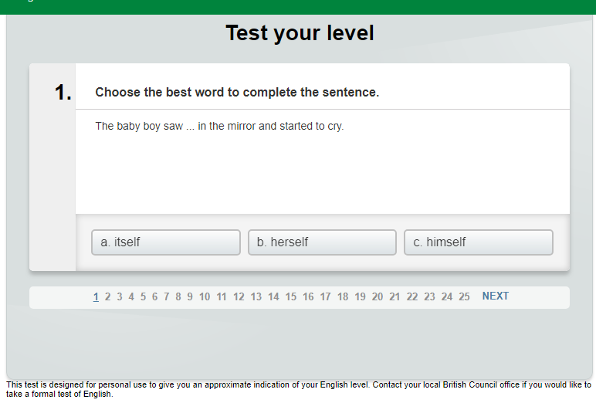

Picture-2. Example of Online Exam

Retrieved from: ([www.learnenglish.britishcouncil.org/online-english-level-test](http://www.learnenglish.britishcouncil.org/online-english-level-test))

**Interview 2**

I have asked some questions to Mr.Makan in (client) order to collect more details about the future system, such as its functions, design and the requirements of the system.

**Q:** There are many ways (*table 4* - alternative approaches) of solving our problem, creating software for desktops or application for mobile devices, but what do you think if the problem will be solved by creating a website?

**A:** I think, it would be the best way to solve the mentioned problems as to develop the online system to take the exams, as they can be passed via the Internet and for both students and teachers it is not necessary to meet in one classroom as exam can be taken anywhere and anytime. Moreover, the online system will check the answers by itself, so teacher will only teach the students and create the exam questions.

**Q:** What type of authomatization do you want to use in the system?

**A:** The most comfortable platform for all of our workers and students is computers, but some of them prefer smartphones, so we decided to develop the website which can be opened from the different devices despite the type and version of operating systems. Also, developing different software for different devices will bring new problems in finances and technology such as integrating them and etc. Moreover, I know many websites that are used to examine the students and I think it would be easier to use the website in those goals.

**Q:** Do you want authentication in the system?

**A:** I think the system should be used only by our students and teachers, so yes I do. This should be done to protect the system from the different trash coming from third party. Also, in order to know is the user student or teacher. So that if he is student then give him the exam and if he is teacher then provide him the opportunity to control the examinations and the whole system. Furthermore, I think any user should have the opportunity to create an account in the website, but is not allowed to use it until the teacher makes it available in his own panel.

**Q:** What do you think, as the way to protect the data will be recorded, would be encrypting? Encrypting is the process of encoding a message or information in such a way that only authorized parties can access it and those who are not authorized cannot.

**A:** I think it is the perfect thing what we need now.

**Q:** How do you see the panel of student and teacher?

**A:** I think students should be allowed to take the exams which are available and see own results if they have already taken some of them. While teacher should control everything, such as create users, activate them, create exams and etc.

**Q:** How safety it must be?

**A:** As I also learned ICT at school, I knew that some sites can have a framework to protect the catalogs. I mean if the user wants to open the configuration of the site, he must be redirected to an error page.

**Q:** Where the new recordings should be stored?

**A:** The results and scores of students in the different exams, user accounts, examinations should be stored in the database. Also, there must not be any loss of data.

**Q:** What are the requirements about the whole website?

**A:** First of all, it should be opened in the different browsers with no technical conflicts and functionality lost, so that it should work same well in the different browsers. Secondly, it should be user-friendly, the interface has to be simple and contents should be easy to understand, the colors must be very simple, not defiant ones.

**Interview 3**

I have asked some questions to Alisher (user) who is a student of DreamBuilders in order to collect more details about how the user`s panel should look like. Here is the script of the interview.

**Q:** What interface do you want to see?

**A:** The interface must be completely simple. Especially no ads! In general, it should include the main information about exam, its data period, the functions to take an exam and also viewing its results. In main page, the headings should include the buttons such as Exams and Log out, where Exam button redirects to page with exams list.

**Q:** What opportunities should user have in new system?

**A:** Maybe easy sign upping and login procedures, taking an exam, viewing the results of the exam, also user must have`s is to choose what department they want to learn.

**Q:** Is there any other preferences you want?

**A:** I think, coloring the answer given right or not. Sorting the exams by their dates should be also included. In addition, I must be sure, that nobody can hack my account, I mean it must be encrypted.

**Q:** If you face some problems?

**A:** As I know any application has a user manual or some guide book how to use the app. I mean, you should provide it too.

**Observation**

In summary, new system must:

1. Have friendly interface for user.
2. Be adapted on any device.
3. Have an safety authorization method.
4. Have a practical framework and security.
5. Include two panels: for student/teacher.
6. Be accessible for everyone from their party.

### Analysis

**Flow-chart of taking exam**

Current system consists of two parts, such as the exam and the checking process.

The exam: My client provides his own clients (students) the opportunity to test their level of English. To do that, first of all, he decides to exam the students. Then he appoints the exam on the certain date, which comfortable for all members of such system. When the day has come, the students take the exam papers and write the answers to the questions. After the exact period of time the teacher collects all exam papers.

Checking: After the papers are collected at all, the teacher starts to check the papers for correct and mistaken answers. First of all, he chooses the exam paper and checks the answers one by one. If the certain answer is correct he adds one point, else does nothing and after this goes to the next answers if there is no answer left. If this was the last one, he calculates all points by summing all points. Using such information, he enters the grades in the journal.

|  |  |
| --- | --- |
| Exam    (Figure-1.) | Checking    (Figure-2.) |

**Data flow diagram of current system (DFD-0 and DFD-1)**

0 Level:

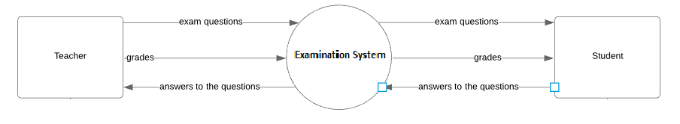

(Figure-3.)

According to Figure-3, teacher provides the students with the exam questions, then the students give the answers to the question. By checking the taken answers from the students, the teacher provides the students with their grades.

1 Level:

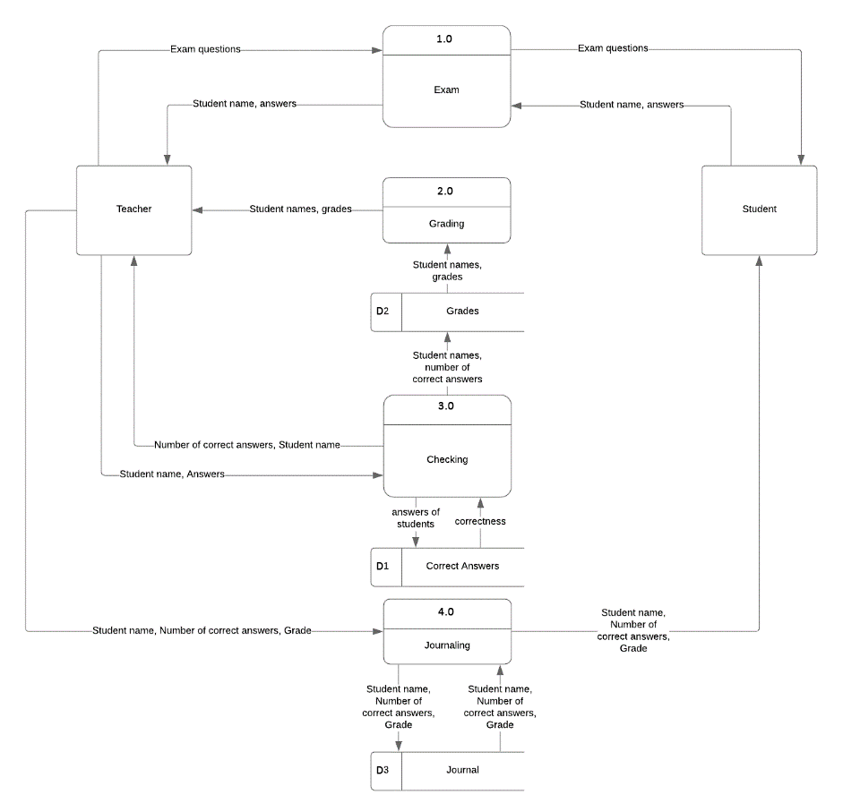

(Figure-4.)

When describing the data flow in the current system more comlex, we can divide the process of checking in three parts: “checking”, “grading”, “journaing”. Despite this process, there is the another one, which occurs before the mentioned one. It is the “Exam”, so when it occurs, teacher gives the exam questions, then receives the student names and answers from the students. Then in the process “checking”, teacher checks the answers for their correctness using the paper that consists of correct answers (shown as database in the DFD) and takes the number of correct answers for certain students. Then the “grading” process starts. He enters the taken from “checking” process numbers of correct answers and the student names in the grading table (shown as database in the DFD) and gets the grades for each of his students. Then the last process – “journaling” occurs, when teacher enters the taken number of correct answers, grade and student name in his journal, which is the main database of the current system.

**What works well what doesn't?**

The current system has its advantages and disadvantages. The process of data collection and storage is quite simple but takes time and efforts to enter the information into the journal. Moreover, there is a chance of making a mistake due to the human factors, such as bad attention or something else, which can lead to serious problems on both sides: company and customer. Automation and digitalization of the system would improve the efficiency of the system and help the learning center to develop and move forward in the future.

**Inputs and outputs of Current system**

|  |  |
| --- | --- |
| Inputs | Process |
| * Students’ names * Exam questions * Students’ answers * Number of correct answers * Grades | * Exam * Checking * Grading * Journaling |
| Outputs | Storage |
| * Number of correct answers * Grades * Questions * Students’ answers * Students’ names | * Correct Answers * Grades * Journal |

Table-3.

**Data capture method**

The data in the current system is captured in different ways. The details about students are taken from the students directly, during the registration of the course and their answers to the questions after the exam, certainly. The number of correct answers are calculated by teacher using the paper which contains the correct answers of the exam questions. And the grades are determined according to these numbers yet again using the certain external data, such as grading table. Then the data in output as students’ names, their number of correct answers and grades are stored in the journal of teacher.

**Processing**

The different data is recorded in the journal of teacher which functions as a database that stores the results of certain exams. It helps both teachers and students to know about the level grades of certain students in certain exams. This is easy method to store and take the data, but it is not comfortable, because teachers and students can take the data only during the meetings and lessons. Also, the records can be lost due to different life factors.

**Alternative approaches**

Table-4.

|  |  |  |
| --- | --- | --- |
| **Approach** | **Benefits** | **Drawbacks** |
| Website based on HTML and PHP | * The language is level 0, which means it is easy to use. HTML has always been a popular coding language and almost everyone associated with web designing and development is familiar with it. As a result, you can always find help and easily hire designers and developers to make changes to your site. * The fact that HTML websites are all browser compatible makes people move from PSD to HTML and other formats to HTML. HTML websites are supported by all major web browsers in comparison to other languages. Hence, if you get your site created using HTML language, it will be accessible on almost every web browser around the world. * HTML can be termed as the most search engine friendly coding language. Creating a website with the help of HTML is quite simple. Moreover, you do not need to worry to take multiple measures to get your site indexed. Although the website is able to rank well on the web, you can easily make the necessary tweaks to boost the SEO optimization. Search engine crawlers can easily identify your site if the codes are clean and bug-free. Hence, the crawlers will not take much time in indexing the content of the web pages and your website can be easily discovered. * PHP is Open Source. Open Source means you never need to rely on the manufacturer to release the next version if something doesn’t work or pay for expensive upgrades. * PHP is extendible. * Large amount of databases are supported. * PHP is platform independent. It will run on most of the platforms. * Compatible with servers like IIS and APACHE. * Low development and maintenance cost with very high performance and reliability | * Insufficient for Dynamic Pages * Unpredictable Behavior Across Browsers * The modern websites can be vulnerable against the hacking attacks such as SQLinjection, DoS, XSS and buffer overflow. * Limited for Displaying Content * Security: Since it is open sourced, all people can see the source code. If there are bugs in the source code, it can be used by people to explore the weakness of it. * Not suitable of large applications: It will be difficult to use it for programming huge applications. Since the programming language is not highly modular, huge applications created out of the programming language will be difficult to maintain. * Weak type: Implicit conversion may surprise unwary programmers and lead to unexpected bugs. Confusion between arrays and hash tables. This is slow and could be faster. There are often a few ways to accomplish a task. It is not strongly typed. It is interpreted and uses curly braces. * Poor Error Handling Method: The framework has a bad error handling method. It is not a proper solution for the developers. Therefore, as a qualified PHP developer, you will have to overcome it. * PHP is unable to handle large number of apps: The technology is helpless to support a bunch of apps. It is highly tough to manage because, it is not competent modular. It already imitates the features of Java language. |
| For new System | * Can be opened on any device * Open-source access availability * Easy to learn the syntaxis of languages * Remote control of the system * System can be updated in any place in any time | * Poor behaviour of several browsers. * Needs to have good server connection. |
| Tablet Program for iOS or Android | * Smartphones and tablets based on iOS and Android are very popular type of devices (gadgets) nowadays, so it has the wide audience * Most of devices that use iOS and Android are user-friendly and easy to handle * No need in different softwares such as browsers to open the app * Very mobile, because of the dimensions of such gadgets | * The tablet programms are depend on the OS, because iOS program can not be opened in Android OS or Windows and vice-verse, so the different apps should be developed in order to use on the different platforms * The extra storage is needed, because the app must be installed to be used by the user * The app should be published in the official markets, such as AppStore or PlayMarket, which require the paid license from the developer * Most of apps should be optimized to work fast and operate everything with no problems, but it needs the good knowledge of the different programming platforms |
| For new System | * Wide-arrangement among students. * It can be said that, following traditional methods, institutes can not pay equal attention to all students. Now, however, it is possible to reach out to all of them. Learning center communication apps make it possible to impart information to every student; they can inform them about new schedules, different forums, various conferences, and social school activities. | * Despite the fact, that nowadays everyone has smartphones, but not all of them will want to download, cause of some less place in storage or another reason. * Expensive method of publishing into Market. * Database will take most of the place in phone storage * Can be opened only on phones. |

|  |  |  |
| --- | --- | --- |
| Creating Windows software | * The most of used OSs in the local area are different versions of Windows * The interface can be very simple and used-friendly * Windows is one of the most recognizable systems in the world | * Computers are not mobile and most of users who do not have laptops, have to be “” * Also most of computers have not got the mobile Internet devices which are set on mobile phones, especially on smartphones. |
| For new System | * It would be easier to program the application, because we have already learned some desktop application developing programming languages. * Free using of the programs, which create the application. | * It would be opened only on Desktop Oss, which means that Learning Center must be equiped by many computers to run the application to be used. * App would take most of the storage in disk. |

**Chosen solution**

According to all the benefits and drawbacks listed in this table, the website was chosen as the best, cause of its high quality and wide-arrangement of use. Also, web-developing is the easiest way in comparison with others to solve the problem presented. Web-site can be opened on any device, by its optimization and adaptivity. In addition, I have already know the programming languages needed to create a website for new system such as HTML, PHP, SQL-requesting and JS.

**Requirements for the new system**

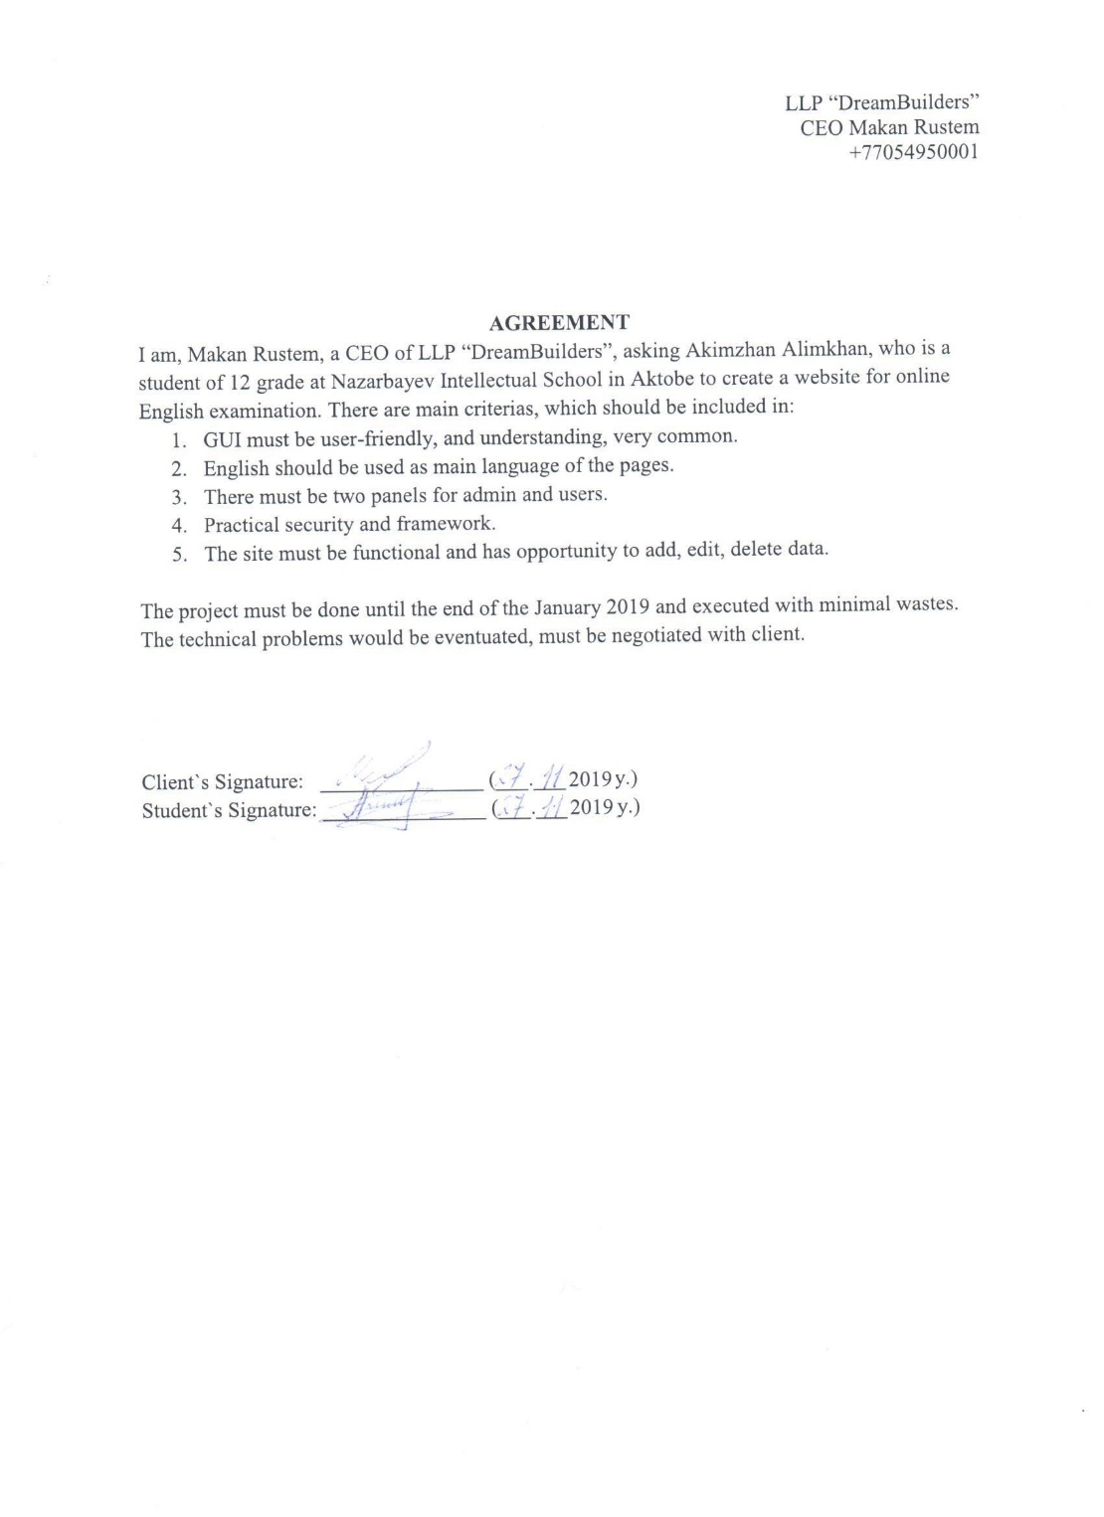

Picture-3. Client`s Agreement

These are the key requirements of the new system which were discussed and agreed with the client:

* The interface of system must be user-friendly, simple and easy to use;
* As the system is used to test the English-level of students, it should use the English, as the main language of the interface;
* System must allow users to register in the system;
* There must be administrator of the website, who allows the users to enter the system and who is the head of it;
* System must allow students to take the exam and see their grades;
* System must allow teachers add the exam and see the grades of students;
* Usernames of the users must be unique in order to prevent the conflicts during authorization;

# (C) DESIGN

## (i) Nature of solution

**Detailed requirements for the new system**

There is the list of discussed objectives for a website:

* The website should be loaded in the different browsers with no functionality lost and conflicts;
* The system should provide the opportunity to register new users in the system and store the details about them in the database;
* In registering stage, user can have a chance to choose the department level he wants to learn;
* The system must include practical authorization method;
* Database should store all recordings with no loss of data;
* Interface should be very simple and easy to understand;
* The administrator should have the opportunity to:
  + Add users profiles, departments, question, answers;
  + Edit users profiles, departments, question, answers;
  + Delete users profiles, departments, question, answers;
  + To time limit the passing exams;
  + See the results of the students` exam grades taken;
  + Check the results (“Checked/Not yet”);
  + Sort the data by date;
  + Activate/deactivate account;
  + Change passwords of users;
  + Assign the role of the user;
* The activated authorized student should have the opportunity to:
  + Take an exam;
  + View results of passed exam;
  + View passed grade and remarking;
* The system must not give the access to unauthorized users to use the website functions, such as taking exam, editing users and etc.;
* The system must allow the registered users to log in their accounts as the account is activated by the administrator;
* The encrypting of the password into database must be included;
* Site must be protected by own framework:
  + Not to permit access to direct open the path into the URL;
  + To redirect user to the error page, if the page is not existing;
  + To hide the full catalog of files that are stored in the hosting.

*\*The software and hardware below illustrated as a necessary list of requirements for client to run the project*

**Software requirements**

* Operating System:

The system which will be developed is the website, so it has not the dependence on the operation system, so it should be loaded by the different operating systems with no problems. However, there could be some differences in the styles and JavaScript functions which appear in the website window due to the different browser, which can differ due to the type and version of the operating system.

* Browser

The software provides a way to look at and interact with all the information on the World Wide Web. Browser is needed to have an access to Internet. Suitable interface to use a website.

* The Internet:

The access to the Internet is the most needed thing in order to load the website and its precise work. Because,

1. The Internet gives the provides the opportunity to load the website from the server, so the updates and modifications are appeared with no troubles and time delays;
2. The database is loaded directly from the online hosting system, so users do not need to download it to authorize the system. And when it is in the online host, it is secured. Also, all users can have the connection to the database if they have the access to the Internet;
3. All processes occur in the real-time, so every change made by one user of the system has to be appeared in the another user’s interface, to do that the Internet is used.

**Hardware requirements**

Table-5.

|  |  |  |
| --- | --- | --- |
|  | Device | Function |
| Input device | Keyboard  Touch screen | Used to fill in the inputs and forms, choose the option buttons, in order to login, take the exam and etc. |
| Output device | Screen of device | Screen resolution: 1024 × 768. |
| Processing | Processor | Intel Pentium 4 or sooner with support of SSE2.  Processor speed: not less than 1 GHz;  RAM: at least 256 MB; |
| Connection | Network interface controller | The width of the Internet channel is at least 128Kbps.  Availability of addresses in the * .livetex.ru domain.  For the text chat functions to work, it is necessary to ensure the availability of addresses in the * .livetex.ru domain using the HTTP / HTTPS, WebSocket / WebSocketSecure protocols (TCP ports: 80, 443).  Provides the opportunity to connect to the Network, which mostly is the Internet, that is needed to use such website |

**Inputs and outputs of desired system**

Table-6.

|  |  |
| --- | --- |
| Inputs | Process |
| * Username * Password * First name * Last name * Role * Department level * Exam checker (checkbox) * Enable (checkbox) * Department code * Department level * Exam name * From (date) * To (date) * Total points * Passing grade * Time limit (hours and minutes) * Question * Question type * Answer * Correct Answer (checkbox) | * Login * Passing exam * Add new user * Edit user * Delete user * Add new examination * Edit examination * Delete examination * Add new department * Edit department * Delete department * Add new question * Edit question * Delete question * Add new answer * Edit answer * Delete answer |
| Outputs | Storage |
| * Exam name * Examinee’s name * Remarks * Scores * Answers * Question * Exam period (date) * Department level * Passing grade * Total points * Time limit (hours and minutes) * Registered date (date) * Username * First name * Last name * Role | * “users” table * “user_roles” table * “department” table * “exams” table * “exams_answers” table * “exams_question” table * “transaction” table * “transaction_dtl” table |

**Entity relationship diagram**

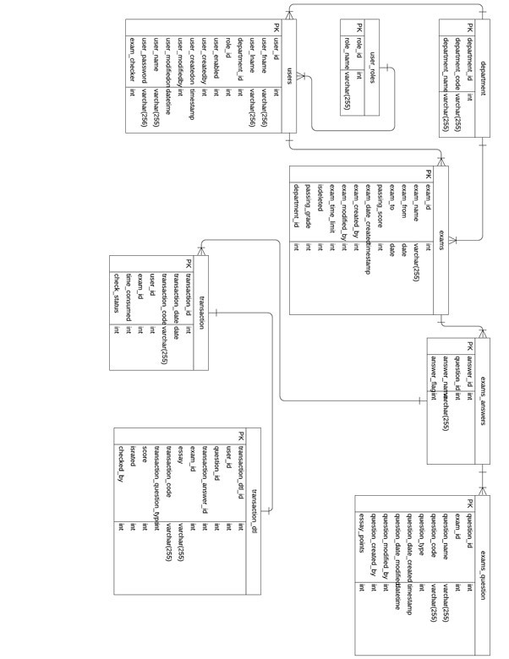

(Figure-5)

**Data Structure**

The website will use eight tables in the database, that will be used in the different processes such as login, exam taking, checking and etc.

**Table “users”**

Table-7.

|  |  |  |  |  |  |
| --- | --- | --- | --- | --- | --- |
| Field name | Type | Length | Validations | Description | Example |
| User_id | int | 11 | Unique | Primary key. Identification number of the user. Increments automatically | 75 |
| User_fname | varchar | 256 | Presence check | First name of user | Admin-Name |
| User_lname | varchar | 256 | Presence check | Last name of user | Admin-LastName |
| Department_id | int | 11 | Presence check | Foreign key. Identification number of department (level of English) | 2 |
| Role_id | int | 11 | Presence check | Foreign key. Identification number of the role.  4 by default | 1 |
| User_enabled | int | 11 | Presence check | Indicator, that shows user is enabled or not. 0 by default | 1 |
| User_createdby | int | 11 | Presence check | Identification number of user who created such user | 5 |
| User_createdon | timestamp |  | Valid date and time | Time and date when the user is created | 2019-09-22 18:50:21 |
| User_modifiedby | int | 11 | Presence check | Identification number of user who modified such user. Null by default | NULL |
| User_modifiedon | datetime |  | Valid date and time | Time and date when the user is modified. Null by default | NULL |
| User_name | varchar | 255 | Presence check | Username of the user | admin |
| User_password | varchar | 256 | Presence check | Password of the user, hashed due to security into MD5 | 21232f297a57a5a743894a0e4a801fc3 |
| Exam_checker | int | 11 | Presence check | Indicator, showing is user exam checker or not. | 1 |

**Table “department”**

Table-8.

|  |  |  |  |  |  |
| --- | --- | --- | --- | --- | --- |
| Field name | Type | Length | Validations | Description | Example |
| Department_id | int | 11 | Unique | Primary key. Identification number of a department (level of English). Unique and increments automatically | 1 |
| Department_code | varchar | 255 | Presence check | Code name of the department (level of English) | 3 |
| Department_  name | varchar | 255 | Presence check | Name of the department (level of English) | Advanced |

**Table “exams”**

Table-9.

|  |  |  |  |  |  |
| --- | --- | --- | --- | --- | --- |
| Field name | Type | Length | Validations | Description | Example |
| Exam_id | int | 11 | Unique | Primary key. Identification number of exam. Automatically increments | 10 |
| Exam_name | varchar | 255 | Presence check | Name of the exam | Superstitions |
| Exam_from | date |  | Valid date | Date when the exam starts | 2019-04-01 |
| Exam_to | date |  | Valid date | Deadline of the exam | 2019-04-09 |
| Passing_score | Int | 11 | Presence check | The minimum score to pass | 3 |
| Exam_date_created | timestamp |  | Valid date and time | The date and time when the exam is created | 2019-03-28 14:52:29 |
| Exam_created_by | Int | 11 | Presence check | The identification number of user who created such exam | 79 |
| Exam_modified_by | int | 11 | Presence check | The identification number of user who modified such exam | 1 |
| Exam_time_limit | Int | 11 | Presence check | The time limit to pass the exam | 300 |
| Isdeleted | Int | 11 | Presence check | Indicator, that shows is the exam deleted | 0 |
| Passing_grade | Int | 11 | Presence check | The minimum grade to pass the exam | 75 |
| Department_id | int | 11 | Presence check | Identification number of the department (level of English) | 2 |

**Table “exams_answers”**

Table-10.

|  |  |  |  |  |  |
| --- | --- | --- | --- | --- | --- |
| Field name | Type | Length | Validations | Description | Example |
| answer_id | int | 11 | Unique | Primary key. Identification number of an answer.  Unique and increments automatically | 35 |
| question_id | int | 11 | Presence check | Identification number of question | 1 |
| answer_name | varchar | 255 | Presence check | The content of the answer | adverb |
| Answer_flag | int | 11 | Presence check | Indicator, showing is answer correct or not. 0 by default | 1 |

**Table “exams_question”**

Table-11.

|  |  |  |  |  |  |
| --- | --- | --- | --- | --- | --- |
| Field name | Type | Length | Validations | Description | Example |
| question_id | int | 11 | Unique | Primary key. Identification number of question.  Unique and increments automatically | 35 |
| exam_id | int | 11 | Presence check | Identification number of exam | 1 |
| question_name | varchar | 255 | Presence check | The content of the question | A plural subject needs |
| Question_code | varchar | 255 | Presence check | Code name of the question | Q1 |
| Question_type | int | 11 | Presence check | Indicator, showing the type of the question | 0 |
| Question_date_created | timestamp |  | Valid date and time | The time and date when question is created | 2019-04-10 15:15:05 |
| Question_date_modified | datetime |  | Valid date and time | The time and date when the question is modified | 2019-04-10 15:22:44 |
| Question_modified_by | Int | 11 | Presence check | Identification number of user who modified the question | 1 |
| Question_created_by | int | 11 | Presence check | Identification number of user who created the question | 79 |
| Essay_points | int | 11 | Presence check | The essay points of the question if the answer should be given as an essay | 0 |

**Table “transaction”**

Table-12.

|  |  |  |  |  |  |
| --- | --- | --- | --- | --- | --- |
| Field name | Type | Length | Validations | Description | Example |
| transaction_id | int | 11 | Unique | Primary key. Identification number of a transaction.  Unique and increments automatically | 120 |
| transaction_date | date |  | Valid date | Date when the exam transaction occured | 2019-09-21 |
| transaction_code | varchar | 255 | Presence check | Code name of the exam transaction | 10a592aa |
| user_id | int | 11 | Presence check | Identification number of user who took the exam | 85 |
| exam_id | int | 11 | Presence check | Identification number of the exam | 34 |
| time_consumed | int | 11 | Presence check | Time needed to pass the exam | 36 |
| check_status | int | 11 | Presence check | Indicator that shows if exam checked or not | 0 |

**Table “transaction_dtl”**

Table-13.

|  |  |  |  |  |  |
| --- | --- | --- | --- | --- | --- |
| Field name | Type | Length | Validations | Description | Example |
| transaction_dtl_id | int | 11 | Unique | Primary key. Identification number of the details of a certain transaction.  Unique and increments automatically | 982 |
| user_id | int | 11 | Presence check | Identification number of user who passed the exam | 85 |
| question_id | int | 255 | Presence check | Identification number of question | 140 |
| transaction_answer_id | int | 11 | Presence check | Identification number of answer | 305 |
| exam_id | int | 11 | Presence check | Identification number of the exam | 34 |
| essay | varchar | 255 | Presence check | The answer of user given as an essay | The best way to make a wish is dreaming |
| transaction_code | varchar | 255 | Presence check | Code name of the transaction | 10a592aa |
| transaction_question_type | int | 11 | Presence check | Type of the question answered by th the user | 0 |
| score | int | 11 | Presence check | Score given to the examinee | 1 |
| israted | int | 11 | Presence check | Indicator showing if the answer of examinee checked or not | 1 |
| checked_by | int | 11 | Presence check | Id of user who checked the exam | 1 |

**Table “user_roles”**

Table-14.

|  |  |  |  |  |  |
| --- | --- | --- | --- | --- | --- |
| Field name | Type | Length | Validations | Description | Example |
| role_id | int | 11 | Unique | Primary key. Identification number of a role.  Unique and increments automatically | 1 |
| role_name | varchar | 255 | Presence check | Name of the role | Admin |

**Arrays**

**$_SESSION** is used to store and retain the data in the different pages of the website. It stores the data about the user when he logged in.

**$data** is used to store the exam data, such as question name, type and id. Except these data, it can store different data in another PHP functions and files.

**$row** is used to store different data, including the details of the answers, such as name and id. However, it is used in the different PHP files and functions, so it can store another data, too.

**$var** is used to store the time values used in the system.

The role of these four arrays are described according to the mentioned PHPs. However, they are used in other files, too.

**Data Flow Diagram of  New System (DFD-1)**

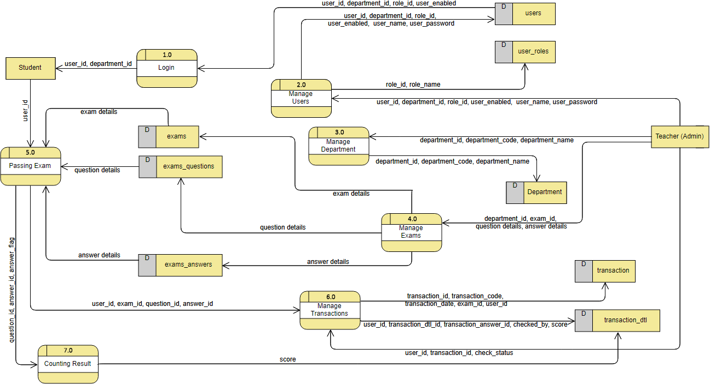

(Figure-6.)

The entities that act in the system are teacher (admin) and student. The given Data Flow Diagram describes the ways of data motion in the system, also it shows the main processes that occur in it, such as passing exam by student, login or adding new examination by the teacher. First of all, to use the system at all the user must log in the website using his credentials which are username and password, the system checks them and takes the role of user and redirects user to different pages according to his role.

As far as student enters the system he can pass the examination. The examination itself is loaded from three different databases that store exam details, questions and answers. Then the details about the exam passing is stored in two different databases, which keep the answers of student, data of taking the exam, scores and etc.

Admin or teacher has more functions in the system, they all are related with the structure of the exams and the system. For example, teacher can add new users, such as students or other teachers. Also, he can add new exams, questions and answers for these exams. And all of these processes use different or sometimes same data.

When admin adds new users he enters the details about him such as first and last names, username, password, role and if he can check the exams, also activates the user or not. Then he can edit the information about each of the users, the data flow is the same with the adding process, but there is one more data which is identification number of user. Also, when deleting the user only the identification number is used.

The same, all remained processes have the similar data flow. When adding and editing the user can work with most of data used in those processes, while deleting the only data is identification number of the “object” (exam, question, answer, department level).

Also, we can see that eight databases are used in the DF diagram. They are used to store the different data about certain processes happening in the system. For example, “transaction” and “transaction_dtl” store the data about the answers and results of the examination of certain students, while “exams”, “exams_question” and “exams_answers” keep the data about exam details, questions of the exams and answers if the question is multiple choice, respectively.

**Menu and module design**

The project is divided into different modules and forms, because:

* There is no need in unauthorized users, so all users must log in to use the website;
* There is no need for students can use the privileges of the admins (teachers);
* To use the functions of the website users must login;
* When student logs in he should be able to pass the exam which is accessible;
* When admin (teacher) logs in he should be able to add new users, exams, questions, answers and departments, to edit them and to delete them;
* Both students and teachers should be able to see the results (own results for students, all results for teachers);
* Users can contact with the developer of the website using the contact information given in the footer.

The general view of the forms of the design is looks like the structure given below:

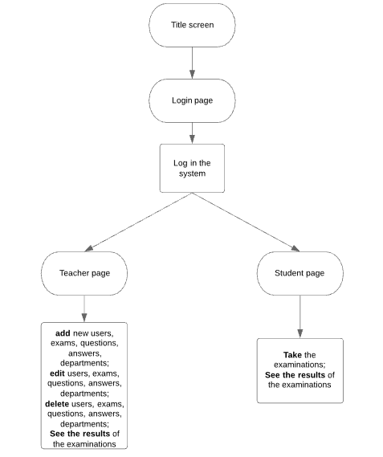

(Figure-7.)

**Input and output forms**

**Input design:**

Design consists of the familiar elements of web pages such as input forms, links, buttons, selectors and checkboxes. This was done in order to make the system very simple and easy to use. Also in order to achieve the better interaction with the user the regular words are used, for example, login, logout, username, password and etc. These features are important, because they make the website more user-friendly and easy to handle. As we can see the Figure-8 shows the title page of the website, which is login page also. The used language is English and all of the words are simple and familiar, so, every user should know them. The “login” form is given here, too. So it contains two inputs for username and password, two labels that mark what to write in the appropriate fields, one button to submit the form (log in) and one link to go to sign up. Also, there is footer with the contact information of the developer is given. It is written in English and used words are plain, so every user should understand it. All fields are required to fill.

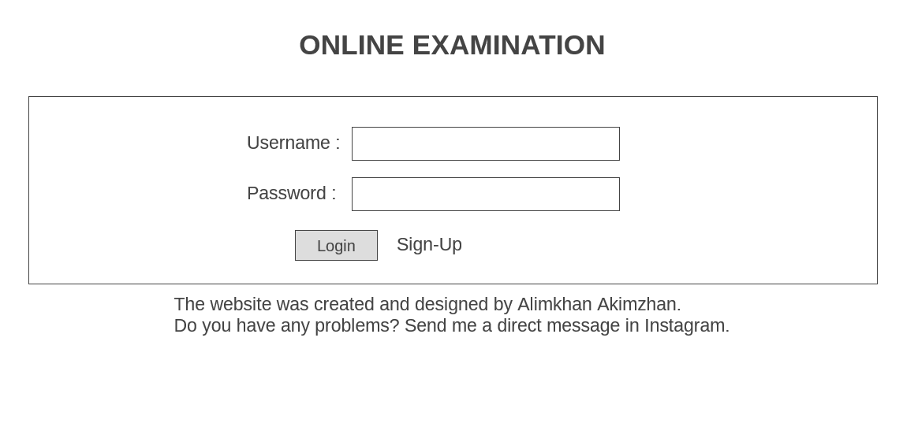

(Figure-.8)

“Sign up” form can be seen from the Figure-9 is as simple as the login page of the website, because it is also contains of familiar inputs fields, selector, labels and buttons. The elements of the form are aligned, so that the interface is comfortable and there is no mess in the dispositions of different objects. In first four fields user must write the text values, but the entered value in password input is hidden under the dots, because of its type, which is password, then in selector user has to choose his level of English. In order to sign up user has to click on “Save” button or if he wants to terminate the process, he clicks on “Cancel” button. All fields are required to fill.

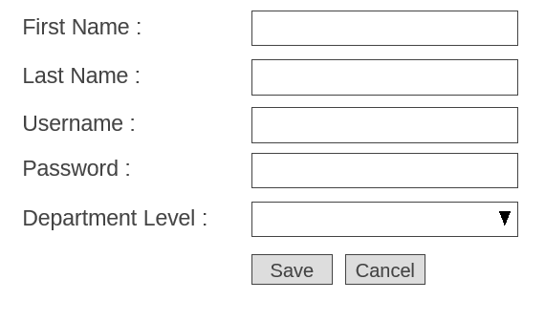

(Figure-9)

The student can take the exam by clicking on “Take Exam”. The new tab with the exam is opened and the question appear. On the top the remaining time is shown in order to countdown and inform the student about his time. Then the question itself is displayed and several option buttons, if the question is multiple-choice or textform, if the question is essay are provided students to enter their answers. Also, there is the button “Next question”, which will be used to go to next one. And the questions replace each other until the end of the exam.

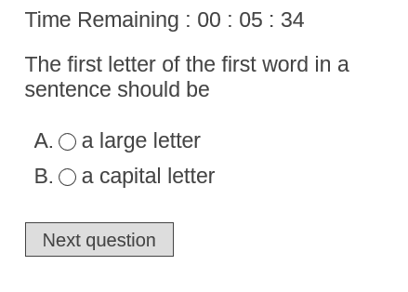

(Figure-10.)

“Add examination” form contains of seven input fields, one selector, nine labels and two buttons. This form is used to add new examinations in the system. So teacher enters name of exam, the date from which it is available and deadline, selects the department level, enters total points, passing grade and time limit given in hours and minutes. After that he submits the form by clicking “Save” in order to finally add an exam or “Cancel” to cancel this process and close this window. All fields are required to fill.

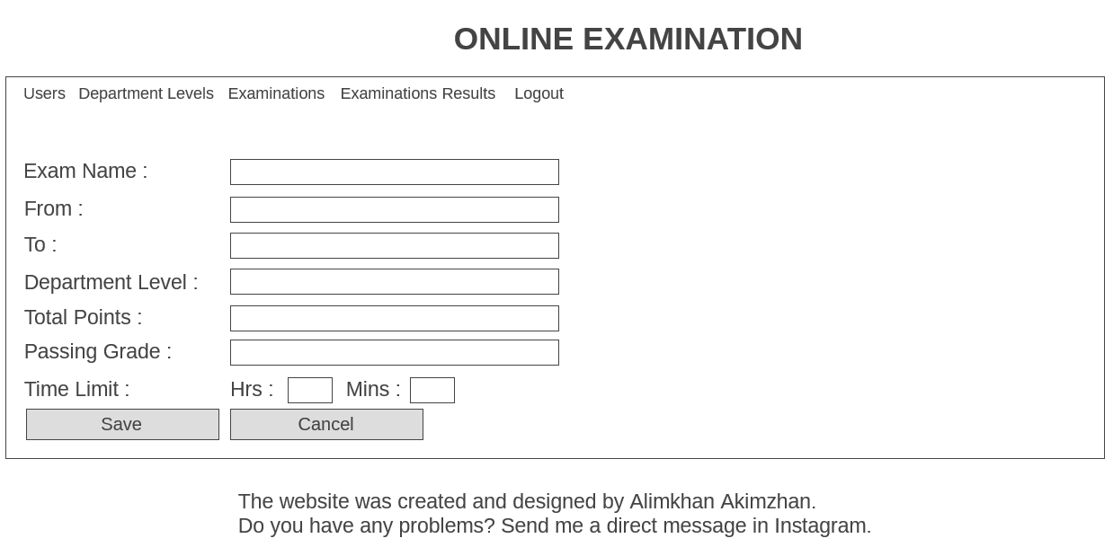

(Figure-11.)

The “Edit examination” form has the same structure as the “add examination” form, but the only difference is that the values of each input are loaded from the database for the certain exam and form is used to update the details about the chosen examination. All fields are required to fill.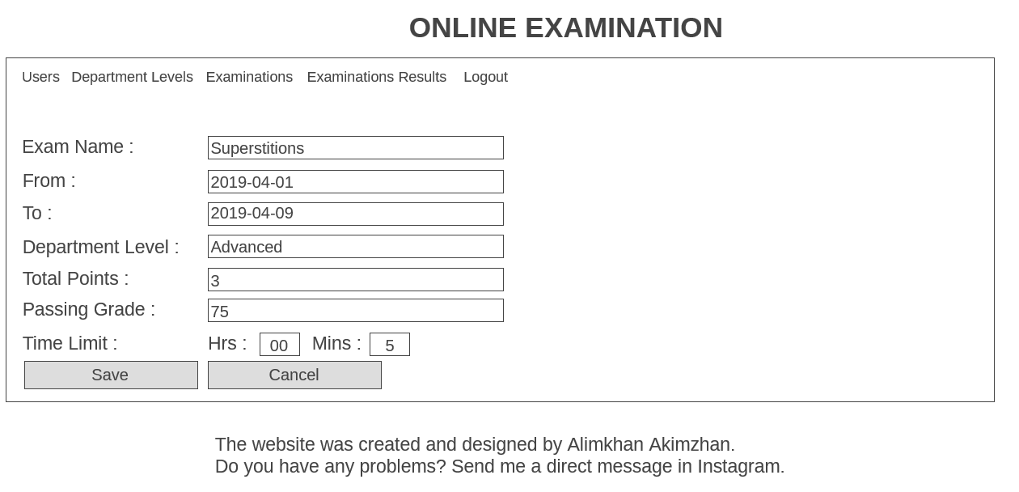

(Figure-12.)

The “Add user” form consists of four text fields, two selectors, two checkboxes and two buttons, which are used to add new user to the system. First name, last name, username, password, role, department level, exam checker indicator, enable indicator are entered to these elements to add new user in the database and the form is submitted by clicking “Save” button or cancelled by clicking “Cancel” button. All fields are required to fill.

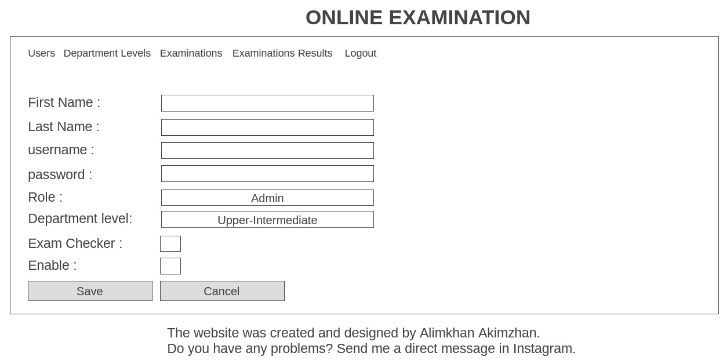

(Figure-13.)

The “Edit user” has a similar structure, but there is no input field for password, but there is button used to open the “Change password” form and the detail about the certain user are loaded from the database and it is used to update the information about that user. All fields are required to fill.

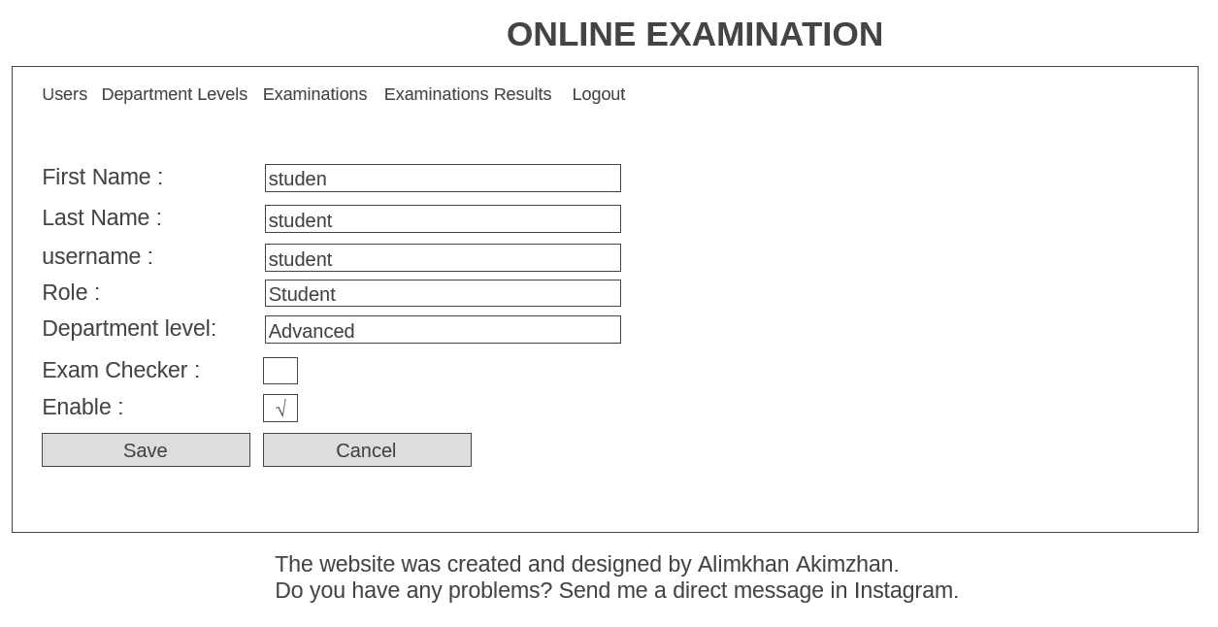

(Figure-14.)

“Change password” form is very simple, because there are only two inputs, two labels and two buttons. Both inputs are used to enter the password. To update the password of certain user the admin has to enter new password in the first field and re-type it in the second one, then submit the form by clicking “Save” or cancel the process by clicking “Cancel”. Both fields are required to fill

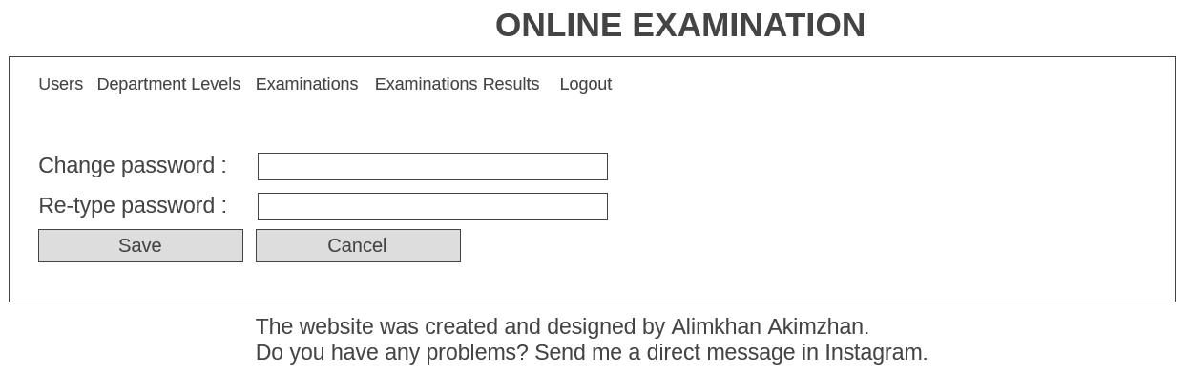

(Figure-15.)

The “Add new department” from is used to add new department level in the database. Its structure is simple, because there are only two input fields, two labels and two buttons. The inputs are used to enter the department code and department level. The form is submitted by clicking on “Save” button and cancelled by clicking “Cancel” button. Both fields are required to fill. 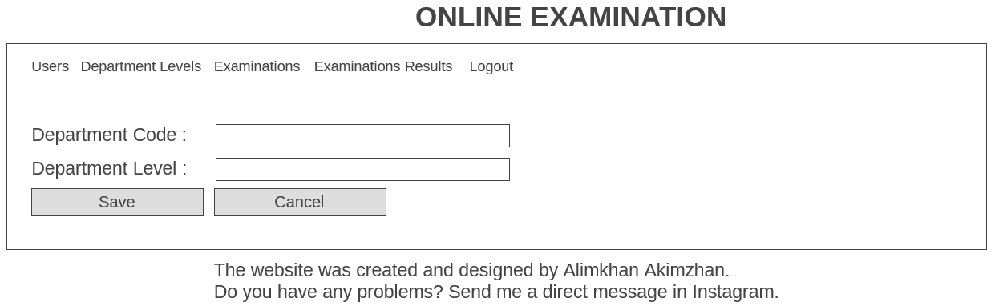

(Figure-16.)

The “Edit department level” is the simplest form in the system, because there is only one input field and it is department level, despite that there is one label and two buttons. The form is used to update the name of certain department level and is submitted by clicking on “Save” button and cancelled by clicking on “Cancel” button. The input field is required to fill.

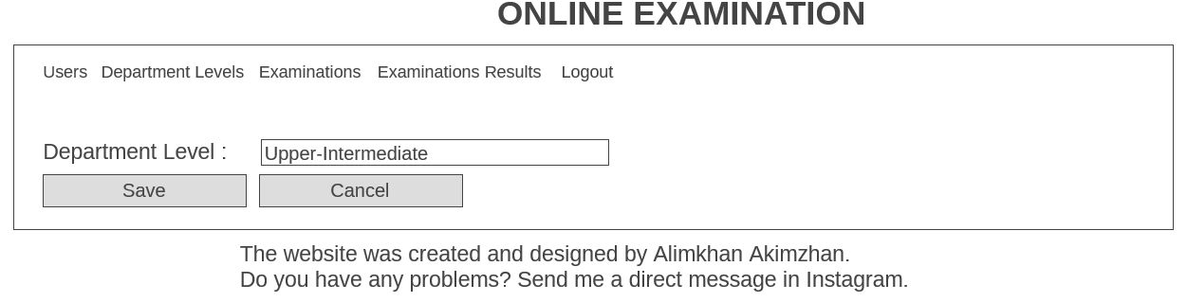

(Figure-17.)

“Add new question” form consists of one textarea, one selector, two labels and two buttons. This form is used to add new question in the certain exam. The question is written in the textarea and the type of question is selected from the list in the selector. If the type is “essay” (Figure-19.), one more label and input field appear. The number of essay points should be written in this field. The form is submitted by clicking “Save” and cancelled by clicking “Cancel”. All fields are required to fill.

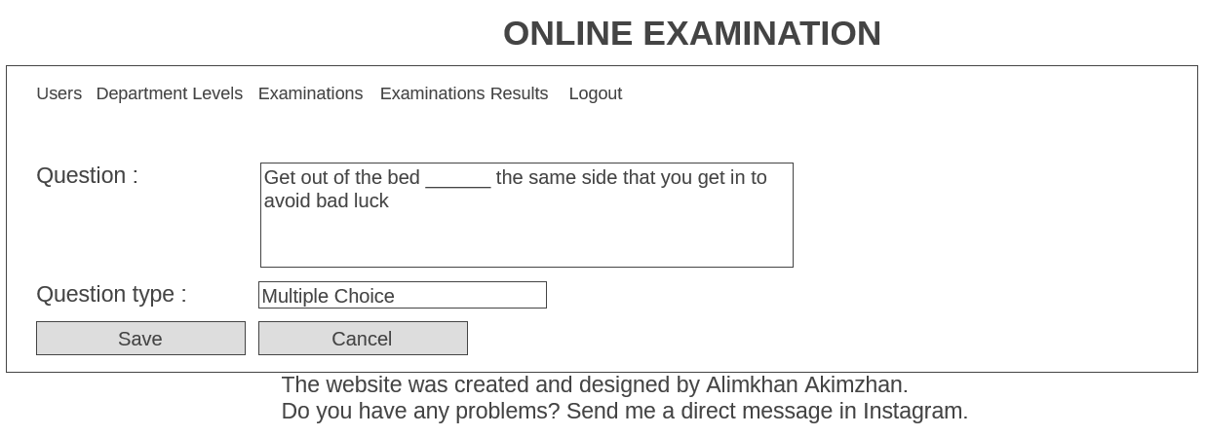

(Figure-18.)

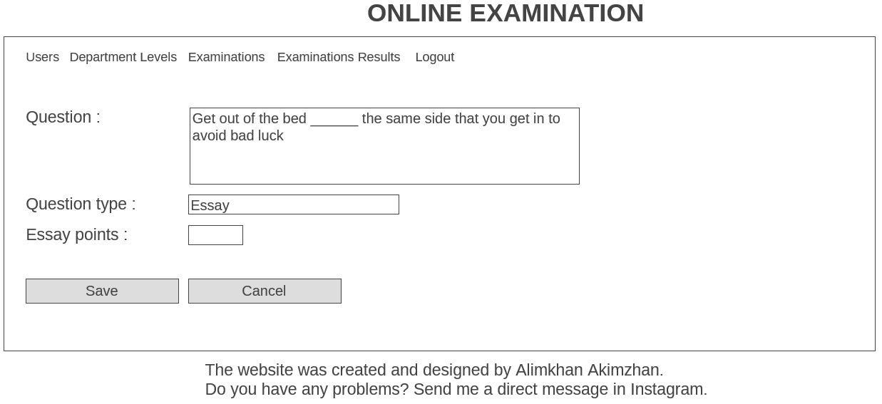

(Figure-19.)

The “Add answer” form is used to add the answers for the certain question. It consists of one input field, one checkbox, two labels and two buttons. The answer has to be written in the only input field of the form and the checkbox is responsible for the indicating that the answer is correct for the question. Input field is required to fill, checkbox is optional to check. To submit the form the button “Save” is used, while the “Cancel” button is used to cancel the form.

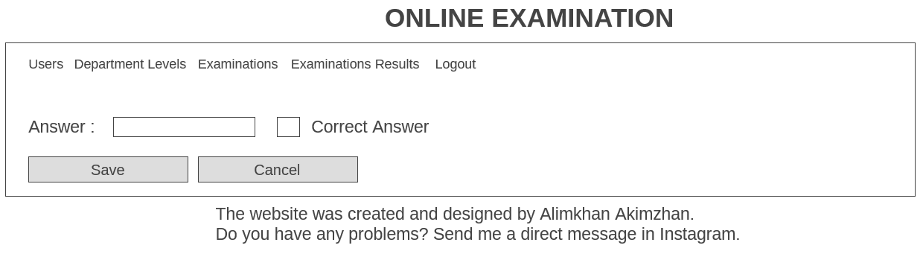

(Figure-20.)

The “Edit question” form is used to update the question for the certain exam. Its structure is same with the “Add new question” form, so there is one textarea for question, one selector for question type, two labels and two buttons. Also, when the question type is “essay” the extra input field appears, where the essay points should be written. But the difference is that the current data is loaded from the database and can be edited by submitting the form by clicking “Save”, the edit can be cancelled by clicking “Cancel”. All fields are required to fill.

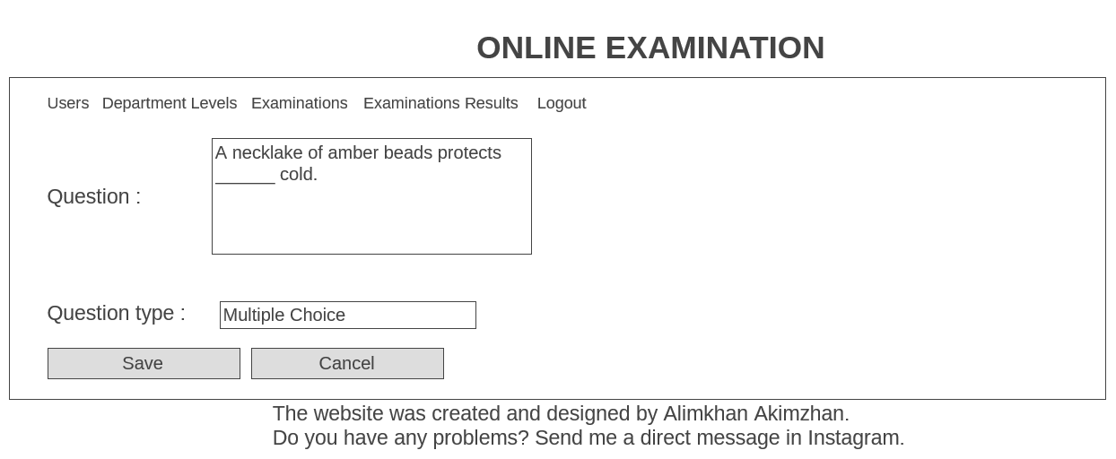

(Figure-21.)

The “Edit answer” form is used to update the answer for the certain question. Its structure is same with the “Add answer” form, so there is one input field for answer, one checkbox for indication if the answer correct for this question. The difference is that the current data is loaded from the database and can be edited by submitting the form by clicking “Save”, the edit can be cancelled by clicking “Cancel”. The only input field is required to fill.

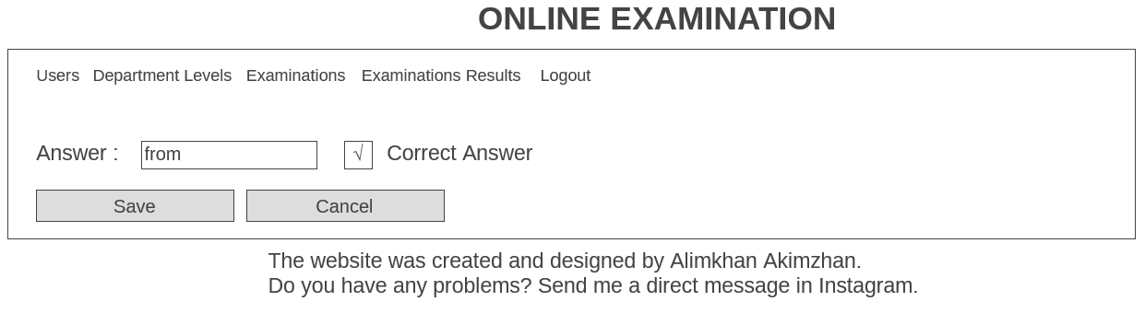

(Figure-22.)

**Output design**

When the student logs in the Student panel he can see the table storing examination that are published in the website, he can view own results if he has passed the exam or take the exam in order to get the result. Also the table contains the name of examination, its period when it is available, its passing grade.

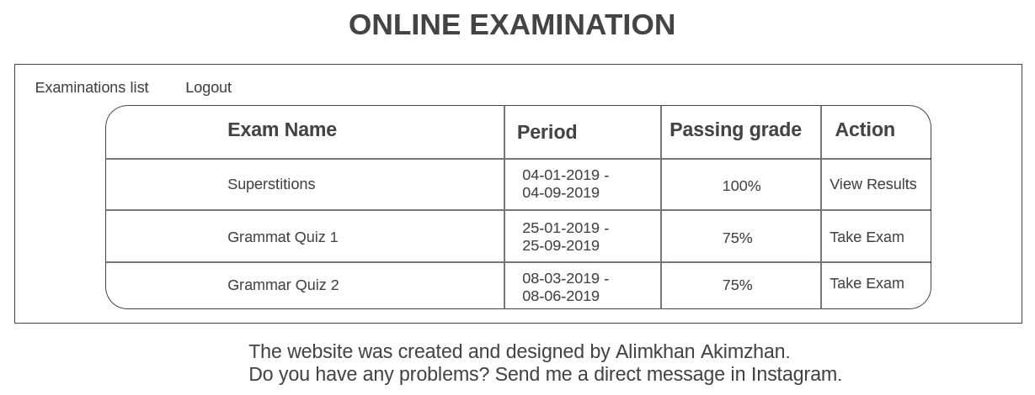

(Figure-23.)

The detailed information about the result of the exam can be seen by clicking on “View Results” link near the appropriate exam. The table in the appeared tab shows the questions and the answers given by the students to that. The incorrect answers are colored red. At the bottom of the table the details about the examination result is given. It shows the scores erned by the students out of total questions, his grade in percents and the remark which shows if student failed or passed the exam.

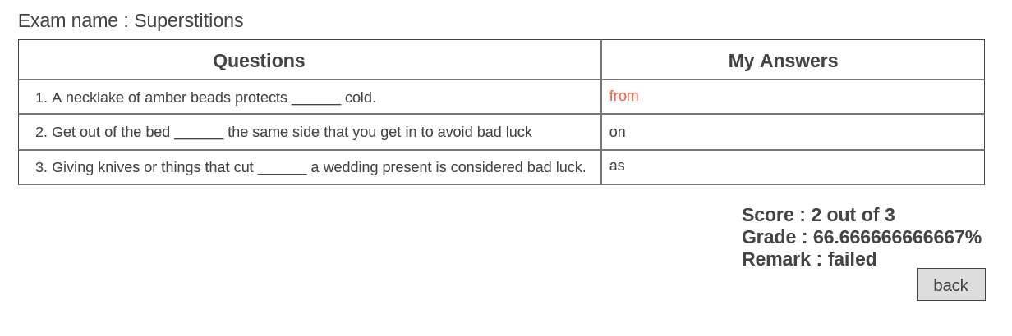

(Figure-24.)

When the teacher logs in the Admin (Teacher) panel immediately sees the examinations displayed in the table, which shows the name, period, department level and actions that can be done on them, such as edit and delete. The table displays the examinations for different periods of time, to set it teachers can use two inputs with date that are responsible for the exam periods.

Also, there is “Add new” link which opens the window which is used to add new examination. 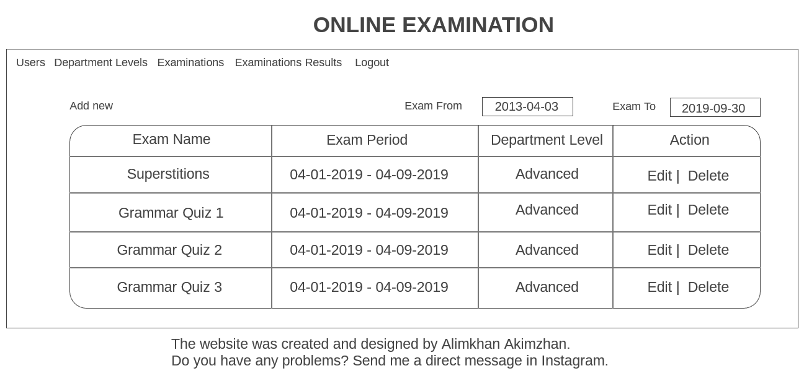

(Figure-25.)

When admin enters the “users” tab he can see all registered in the system people and all information about them, such as first and last name, username, department level, role and registered date. The information is given in the table structure, so it is easy to understand everything.

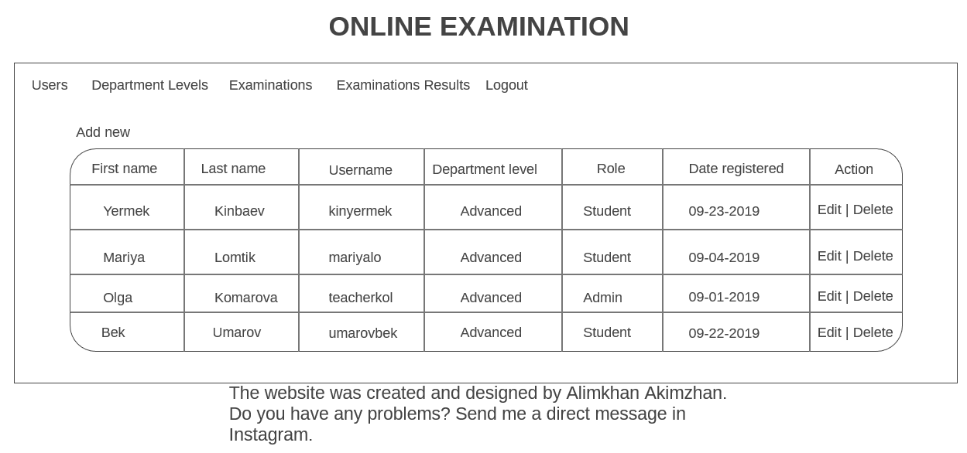

(Figure-26.)

When admin goes to the “department levels” tab he can see all existing department levels in the database. The information is given in the table structure and it consists of two columns, such as department level and action that can done on those levels.

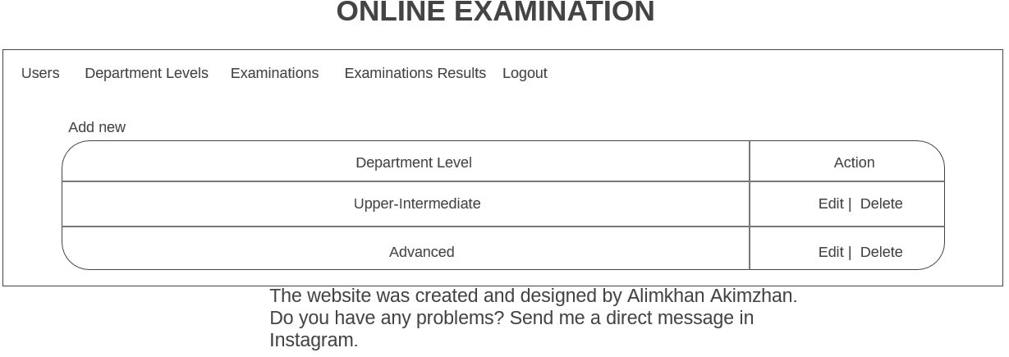

(Figure-27.)

When admin enters the “examinations results” tab he can see examination results of all students who have been taken the exam. The information is given in the table structure, so it is easy to understand everything. There are four columns and they represent the name of examinee, exam name, remarks about it and view (check results).

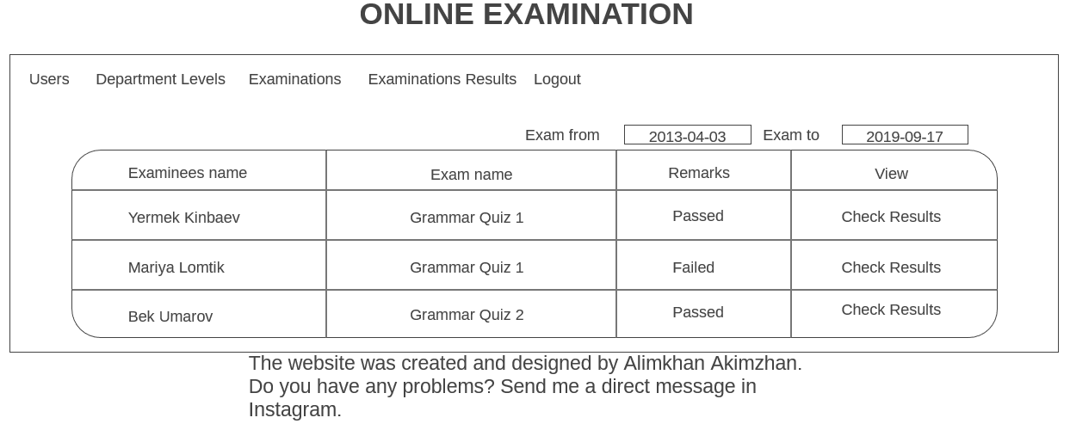

(Figure-28.)

When admin clicks on “check results” he is sees the results of a certain student with more details, such as answers and scores for each of the questions. Also there is more information under the table, that shows the scores out of maximum, grade in percents and remark that shows if student passed or failed.

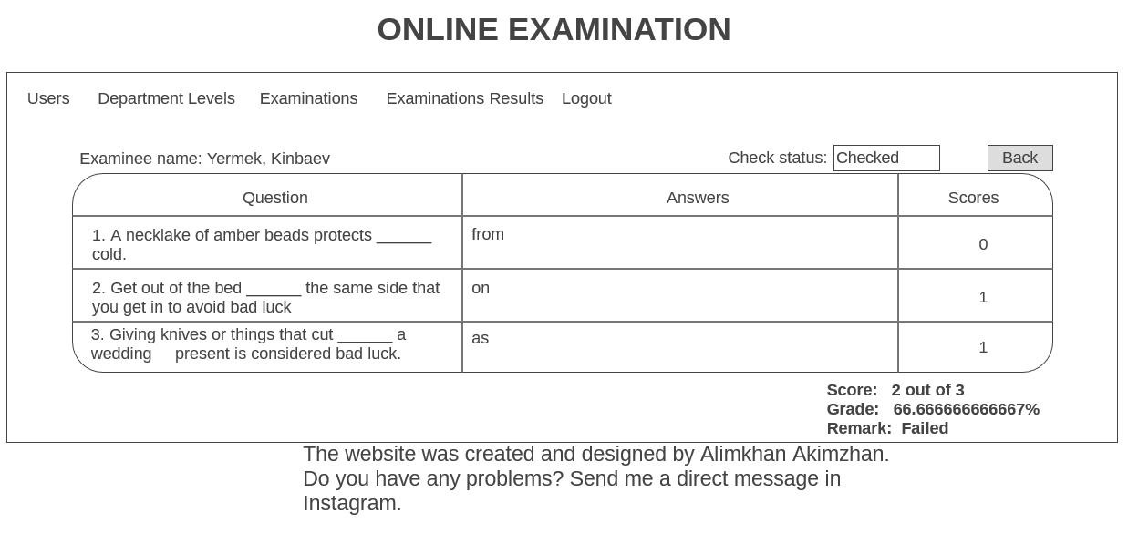

(Figure-29.)

**Evidence of user`s design agreement**



**Flowchart for main page**

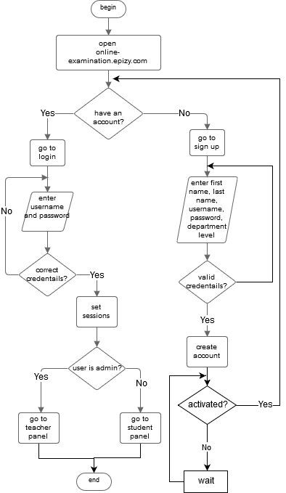

(Figure-30.)

The flowchart given above represents the basic processes occurring when the website is opened. The first window which is seen is login page, so the very first process is authorization, which consists of two actions, such as login or sign-up. If user already has an account, he right away can enter his credentials and go to teacher or student panels, else if he has not an account, he goes to sign up and enters the information that is asked by the system, such as first and last names, username, password and department level. And if the entered data is valid then a new account is created in the database, but if is not user has to enter again and submit the form. Then he has to wait until the account is activated by the admin. If the credentials of the user are correct in the login the system sets the sessions that store the information about the user. And according to his role kept in the database, he is redirected to the student panel or teacher panel.

**Flowchart for different modules and classes of new system**

|  |  |
| --- | --- |
| (Figure-31)  ***Overview***  The Figure-8 displays the general form of the main process in the system. So, if the user is not teacher, he can pass the exam which is published in the website and see their own results, if the user teacher (admin) he can see the exam results of the students (users, who are not teachers). | (Figure-32)  ***Authorization***  The flowchart depicts the process of authorization which consists of two main processes such as login and sign up. The system separates each of them using the decision (if-clause). So if user has an account, he can login the system right away, else he has to create an account and wait until admin activates it. As soon as the account is activated, the user can enter the system using his username and password, used during registration. If they are valid the system provides the user an access, else not. Also, it shows different layouts according their roles. |
| (Figure-33)  ***Passing exam***  As long as the student logged in, he can pass the exam, to do that he should check if there any available exams. If so, he chooses one of them and enters the answers for the questions until no questions left, if there any he goes to the next question. As far as he answers all questions, he finishes the exam and the system shows the result of it. | (Figure-34)  ***Checking own results***  When student has passed the exam, he can check own results. To do that, he has to choose the certain exam and if there is available result he can open it and system shows it, else he should pass that exam. If he wants to see the result of another exam work, he should repeat the steps above. |
| (Figure-35)  ***Adding new user***  Admin (teacher) of the system can add new users in the system. To do that he has to open the “add user” window and enter first and last names of user, username, password, role, department level and check the boxes to make him exam checker or make him enable, then submit the form. If every entered data is valid, the system stores the user in the database and new user is added. | (Figure-36)  ***Adding new department level***  Admin (teacher) of the system can add new department levels in the website. To do that he goes to “add new department” window, then enters the department code and department level. After that submits the form, if the entered data is valid, the system adds new department level in the database. |
| (Figure-37)  ***Edit department level***  Admin (teacher) chooses the exact department and opens the edit window. In this window he enters new department level, then submits the form. If the entered value is valid, the department is updated. | (Figure-38)  ***Delete department level***  When admin (teacher) wants to delete the department level, he chooses the department to delete and clicks on “delete”. Then the system shows an alert box to submit. If user submits, the department will be deleted, else not. |
| (Figure-39)  ***Adding examination***  When admin (teacher) adds a new examination in the system, he goes to “add new examination” window and fills in the inputs, such as exam name, from, to, department level, total points, passing grade and time limit. Then submits the form and if the entered values are valid, the system adds new examination in the database, else not. | (Figure-40)  ***Editing examination***  Admin (teacher) chooses the exact examination and opens the edit window. In this window he enters new details for the exam if it is needed. Then he submits the form, if entered data is valid, the system updates the stored details about the chosen examination, else not. |
| (Figure-41)  ***Delete examination***  When admin (teacher) wants to delete the examination, he chooses the department to delete and clicks on “delete”. Then the system shows an alert box to submit. If user submits, the examination will be deleted, else not. | (Figure-42)  ***Add question***  When admin (teacher) adds a new question in the examination, he chooses the certain exam and goes to “add new question” window and fills in the input question and chooses the type of it. If it is multiple choice he has to add answers for it or if it is essay he has to enter the essay points. After that user submits the form and if the entered data is valid, then the question is stored in the database, else not. |
| (Figure-43)  ***Add answers***  When admin (teacher) adds a new question in the examination, he chooses the certain exam and certain question of it, then goes to “add answer” window and fills in the input answer and checks the box if it is correct answer. After that user submits the form and if the entered data is valid, then the question is stored in the database, else not. User repeats adding answers until he adds all answer options of the question. | (Figure-44)  ***Edit question***  When admin (teacher) edits the question he has to choose the certain one and go to edit window. Then edits the values in the inputs which are needed to be updated and submits the form. If the values are valid the system stores new values in the database, else not. |
| (Figure-45)  ***delete question***  When admin (teacher) wants to delete the question, he chooses the examination, then the question to delete and clicks on “delete”. Then the system shows an alert box to submit. If user submits, the question will be deleted, else not. | (Figure-46)  ***delete answer***  When admin (teacher) wants to delete the answer, he chooses the examination, then the question which has such answer and clicks on “delete”. Then the system shows an alert box to submit. If user submits, the answer will be deleted, else not. |
| (Figure-47)  ***Edit answer***  When admin (teacher) edits the answer he has to choose the examination and question where the certain answer is given and go to edit window. Then enters new values by replacing the old ones in the inputs which are needed to be updated and submits the form. If the values are valid the system stores new values in the database, else not. | (Figure-48)  ***Logout***  When user logs out of the system, he clicks on “logout” link and the system clears sessions that store the data about the user and keep the user logged in the website. Then the user is redirected to the login page. |

## (ii) Intended benefits

* Rapid operations. Each user of the system could be able to use all provided opportunities with high speed of operation. All data in the website is organized and passed to different files very fast. This is done to economy the time of teachers and students.
* Simple and handy interface. The website consists of elements which are familiar for every user of Intertnet-services. These elements mainly are input fields, labels, links, buttons, textareas and checkboxes. As the website is used to test the level of English of students, English has been chosen as the main language of the website, so all texts are written in this language. Due to this factors the system is considered as user-friendly, so user may not understand how these elements are related and interact with each other, however use the system with no problems and misunderstandings. According to these features user can note that the website is easy to use.
* Functionality. As the system is website user uses the browser which can be launched on the different platforms such as smartphones, computers, laptops with different operating systems. Nevertheless, despite the type of device and version of OS students can take the exam and teachers can do all provided things in their own controlling panel. So the relevance of the project is pretty high.
* Security. To have access to the panel of student or teacher and do some processes all users must authorize the system, else students can't take the exam and teachers can't control anything.
* Protected records. As the journals are used in the old system many people could have access to it, even students, who are not privilegied, also that records could be easily lost, because journal is physical thing, which is not secured from the real life factors. While the new system uses a MySQL database provided by the online hosting server, so all data is saved online and even to get access to the database hacker should have the credentials of the developer. Even if he gets access to it, most of data such as password is encrypted and there is no 100% guaranty that hacker decrypts it.
* Time saving and comfortable. New system really helps save time, as students do not need to go to the test centre, take the paper and etc., they can take the exam even if they are far away from that place, also teachers will not spend their time to check the exams, the system does everything by itself, then teacher only can take their exam results and that is all.

## (iii) Limits of the scope of the solution

The developed website can solve the problem of examination and grading that occur in real life. However, using website in such operations can lead to some troubles and different limitations of the system can bring more problems for both the system and users.

First of all, as there is no control during the exam the academic dishonesty such as cheating may happen. This can lead to the misunderstandings between students and teachers and it brings the troubles during the exam period. Also, the misgrading can occur after the exam, because some students will cheat and get higher grades.

Secondly, the website needs the access to the Internet connection to be used, because the online server is used to store the database and the files of the website, such as PHP, JS and CSS files, which are essential to launch it. This is limitation, because user have to be online very often to stay informed about examinations.

Thirdly, the website in some cases can be uncomfortable for users, because there is the activation process when the user creates an account and he has to wait until the admin activates his account. So this can put the users in some circumstances which are not beneficial for them.

Fourth, the databases are threatened if even under a little, because every server can become the victim of a hacking attack and this is the technical problem which can lead to the deletion of data used in the website or stop the work of it. So, the highly secured hosting server should be chosen to be used for the website. Otherwise, it will be in danger of hacking atack.

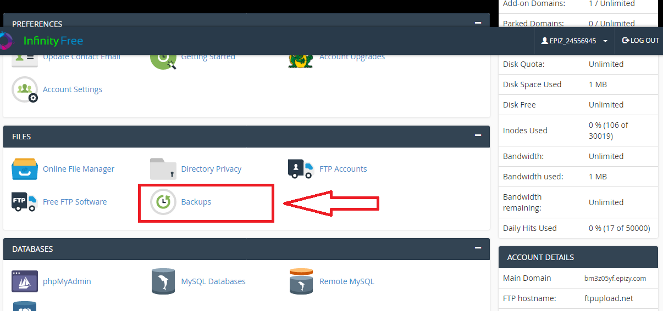

And the last one is that, the disk space the hosting provides, which can be used is unlimited, but with increasing space used, the speed of processing the functions is decreasing.

Table-15. Limitations of the data in database in MB per month.

|  |  |  |  |  |
| --- | --- | --- | --- | --- |
| Table | Fields | Example | Maximum Size  (in Bytes) | Size of table(in Bytes) *estimated number of records in a month |
| department | department_id | 1 | 11 | 521*7=3647  *max number of departments is 7 |
| department_code | D2 | 255 |
| department_name | Advanced | 255 |
| exams | exam_id | 515032 | 11 | 382 * 60 = 22920  *max number of exams is 60 in one department for one month |
| exam_name | 12561 | 255 |
| exam_from | 2019-04-10 | 10 |
| exam_to | 2019-04-15 | 10 |
| passing_score | 5 | 11 |
| exam_date_created | 2019-04-10 15:01:09 | 19 |
| exam_created_by | 79 | 11 |
| exam_modified_by | 1 | 11 |
| exam_time_limit | 120 | 11 |
| isdeleted | 0 | 11 |
| passing_grade | 75 | 11 |
| department_id | 2 | 11 |
| exams_answers | answer_id | 351 | 11 | 288 * 1200 = 345600  *max number of answers that can be given is equal to 1200 |
| question_id | 54 | 11 |
| answer_name | from | 255 |
| answer_flag | 0 | 11 |
| exams_question | question_id | 54 | 11 | 614 * 300 = 184200  *max number of questions which can be saved is equal to 300 |
| exam_id | 6 | 11 |
| question_name | Which is correct? | 255 |
| question_code | Q51 | 255 |
| question_type | 0 | 11 |
| question_date_created | 2019-04-10 15:15:05 | 19 |
| question_date_modified | 2019-04-11 11:32:08 | 19 |
| question_modified_by | 79 | 11 |
| question_created_by | 79 | 11 |
| essay_points | 0 | 11 |
| transaction | transaction_id | 120 | 11 | 320 * 600 = 192000  *max number of transactions is equal to 600 |
| transaction_date | 2019-09-21 | 10 |
| transaction_code | 10a592aa | 255 |
| user_id | 85 | 11 |
| exam_id | 34 | 11 |
| time_consumed | 36 | 11 |
| check_status | 1 | 11 |
| transaction_dtl | transaction_dtl_id |  | 11 | 609 * 2400 = 1461600  *max number of details for transactions is equal to 2400 |
| user_id |  | 11 |
| question_id |  | 11 |
| transaction_answer_id |  | 11 |
| exam_id |  | 11 |
| essay |  | 255 |
| transaction_code |  | 255 |
| transaction_question_type |  | 11 |
| score |  | 11 |
| israted |  | 11 |
| checked_by |  | 11 |
| users | user_id |  | 11 | 1138 * 60 = 68280  *max number of students is equal to 60 in a month |
| user_fname |  | 256 |
| user_lname |  | 256 |
| department_id |  | 11 |
| role_id |  | 11 |
| user_enabled |  | 11 |
| user_createdby |  | 11 |
| user_createdon |  | 19 |
| user_modifiedby |  | 11 |
| user_modifiedon |  | 19 |
| user_name |  | 255 |
| user_password |  | 256 |
| exam_checker |  | 11 |
| user_roles | role_id | 1 | 11 | 266 * 2 = 532  *there are only admin and students |
| role_name | Admin | 255 |
| Size of records in one month | | | | 2 278 779 |
| Add (+) overheads (10%) | | | | 2 506 657 |
| **Size of database (in MBs)**  bytes *10-3 | | | | Approx. = 2.5 |

# (D) SOFTWARE DEVELOPMENT, PROGRAMMING, TESTING AND INSTALLATION

## (i) Development

The development of the website was started with setting up of different comfortable softwares needed to create and write the PHP, CSS, JS code. And my choice was Sublime Text 3 as it provides the opportunities to code with no problems, as Sublime has user-friendly interface and handy features such as highlighting different syntax structures, moving between files of the project and etc. I used the build 3144, which was downloaded from [www.sublimetext.com](http://www.sublimetext.com), the official website of this software.

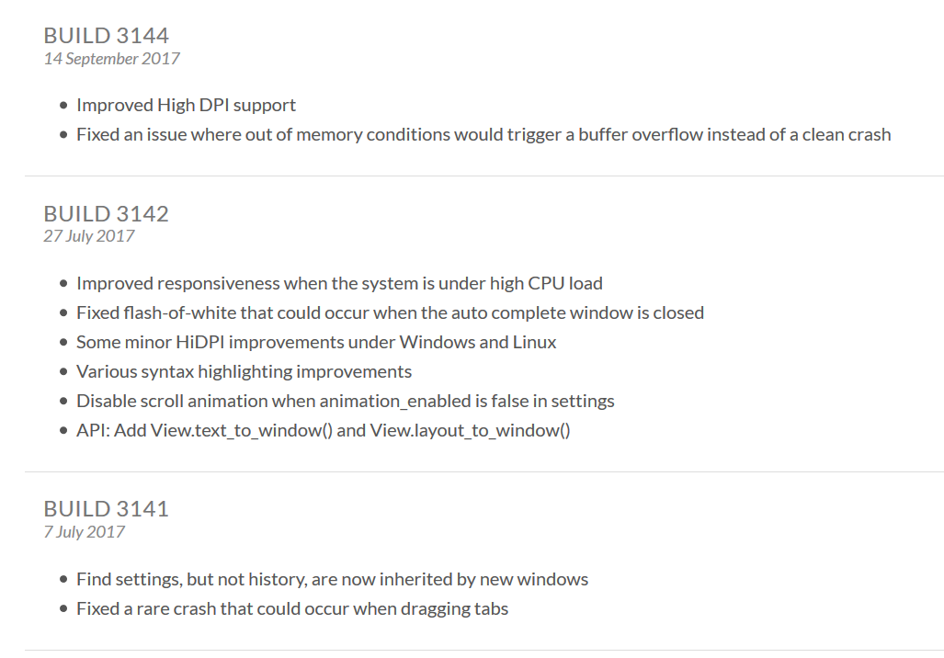

(Picture-4.)

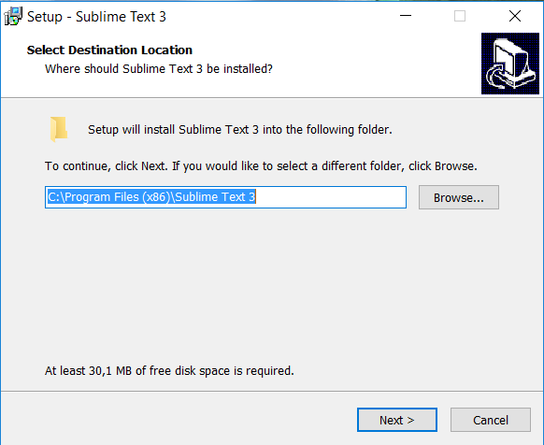

(Picture-5.)

Also, to work with the databases and PHP functions the MySQL and Apache are neede, to use them the XAMPP was installed to my computer. So it was downloaded from [www.sourceforge.mirrorservice.org/](http://www.sourceforge.mirrorservice.org/), because there are different versions of this software. XAMPP provides the opportunity to host the local server and use the database and PHP processes. The 1.7.7 version of it was installed, because it uses PHP 5, which I was going to use in development.

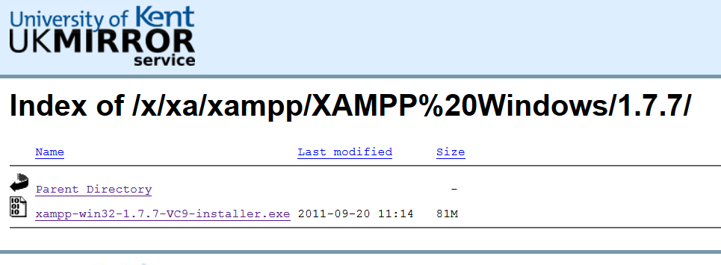

(Picture-6.)

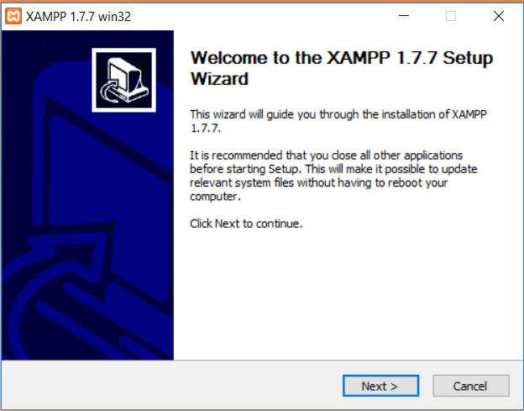

(Picture-7.)

**Used programs**

Except of main applications were also used:

* Notepad++ as text editor as it offers convenience and great extensibility;
* Mockingbird service to design the website;
* Creately.com service to create flowcharts and data flow diagrams;
* Lucidchart.com services to design ERD diagrams and table relationships;
* Total Commander as FTP manager.
* MySQL to work with queries;
* Opera and Microsoft Edge web browsers to run and test my system;
* The screen capture tool “Scissors” to take and save screens

**System design**

* Draughts
* Forms
  + - * error404.php
      * index.php
      * PHP_errors.php
      * adminController.php
      * authenticateController.php
      * indexController.php
      * staffController.php
      * pagination.php
      * session.php
      * Common.php
      * Controller.php
      * Loader.php
      * Router.php
      * Set.php
      * URI.php
      * db.php
      * adminModel.php
      * authenticateModel.php
      * staffModel.php
      * index.php
      * layouts.php
      * layouts2.php
      * answer-add.php
      * answer-edit.php
      * checkresults.php
      * department_list.php
      * departments-add.php
      * departments-edit.php
      * departments.php
      * essay_rate.php
      * exams-add.php
      * exams-edit.php
      * exams.php
      * exams_list.php
      * examresult.php
      * examresult_data.php
      * navigation.php
      * questions-add.php
      * questions-add2.php
      * questions-edit.php
      * questions-edit2.php
      * questions.php
      * questions_list.php
      * sign-up.php
      * users-edit.php
      * users.php
      * usersadd.php
      * login-failed.php
      * view-results.php.mno
      * exam-next.php
      * exam.php
      * exams-list.php
      * examsresult.php
      * examsresult_data.php
      * index.php
      * navigation.php
      * thankyou.php
      * view-results.php
      * view-results2.php
      * config.php
* Tables
  + - * department
      * exams
      * exams_answers
      * exams_question
      * transaction
      * transaction_dtl
      * users
      * user_roles
* Classes
  + - * authenticateModel
      * adminModel
      * staffModel
      * request_handler
      * adminController
      * authenticateController
      * indexController
      * staffController
      * Pagination
      * Session
      * _Controller
      * Loader
      * Router
      * Set
      * URI
      * _Db
* Queries
  + - * SELECT to check the credentials during the authentication
      * SELECT to load the department levels, the roles from the database, user accounts, exam results, questions, answers
      * DELETE to delete the user, department level, exam, question or answer from the database
      * UPDATE to edit the information about the user, department level, exam, question or answer
      * INSERT to add new users, department levels, questions or answers into the database

**Structure of the project folder**

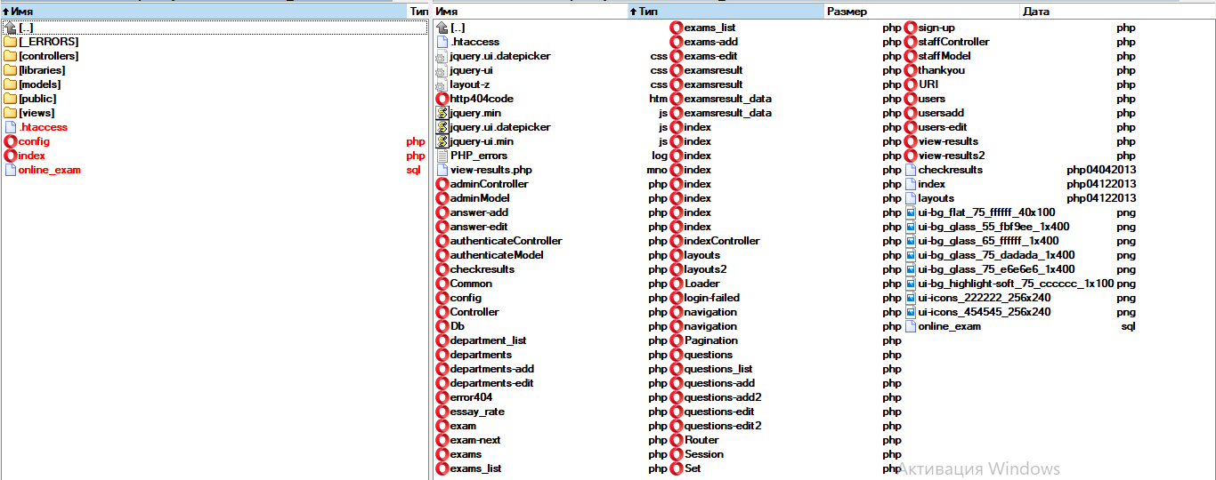

(Picture-8.)

**Tables of database**

**Creation of the tables in database**

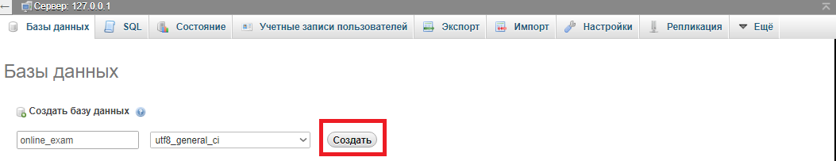

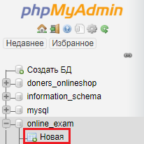

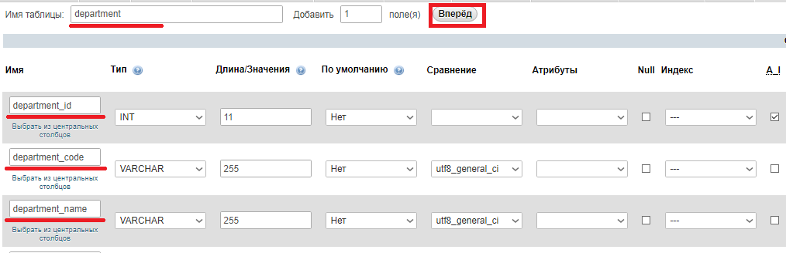

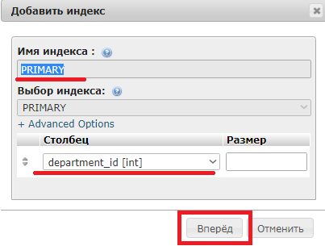

**“department” table**

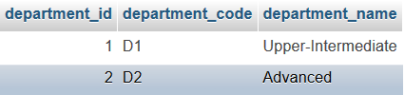

(Figure-49)

The picture above depicts the content of the “department” table, which stores the different data related with the department levels of the system, such as idenficiation number, code and name of the it. The “department_id” column stores the unique numbers for each of the levels which exist in the table.

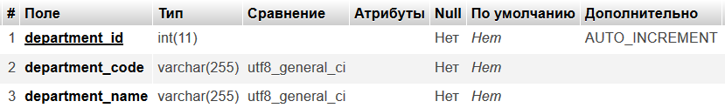

(Figure-50)

The “department” table has structure which consists of three columns such as “department_id”, “department_code” and “department_name”. The primary key is “department_id”, so it stores only unique values, also the value in this column automatically increments, it means that the value increases by one every time when the new row of records is created. The type of this column is integer, so it stores only integer numbers, while other two columns have the type of varchar, so they store set of different characters.

**“exams” table**

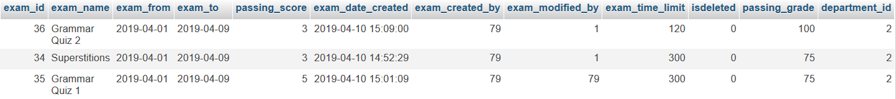

(Figure-51)

The given picture shows the content of the “exams” table which stores the different data about exams, such as its identification number, name, deadline period, passing score, date when its created, id number of user who created it, id number of user who modified it, time limit to take the exam, indicator showing if the exam is deleted, passing grade and the id number of department level for whom is given this exam. The “exam_id” column stores the unique numbers for each of the levels which exist in the table.

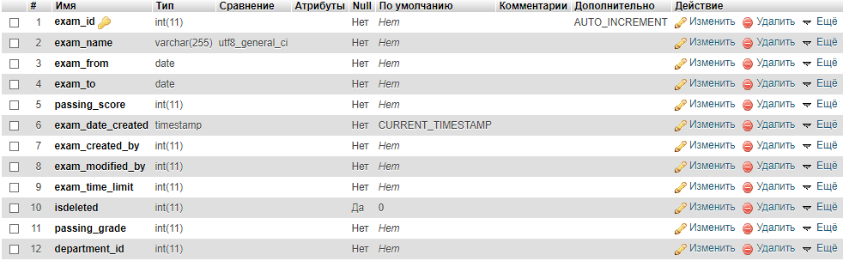

(Figure-52)

The image displays the structure of “exams” table, which consists of twelve different columns, such as “exam_id”, “exam_name”, “exam_from”, “exam_to”, “passing_score”, “exam_date_created”, “exam_created_by”, “exam_modified_by”, “exam_time_limit”, “isdeleted”, “passing_grade”, “department_id”. The primary key is “exam_id” which stores the identification number of each row of records, also its values are unique and increment automatically when the new row is inserted into the table. Eight columns’ type is integer, so they store only integer numbers, the date type is used in two columns, one has varchar type and the last one has timestamp type. The “exam_date_created” column is filled with the current date and time by default, similarly the “isdeleted” column is filled with “0” value by default.

**“exams_answers”** table

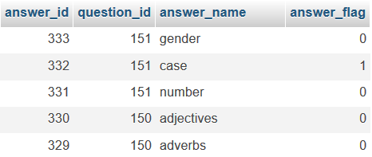

(Figure-53)

The “exams_answers” table which is displayed in the picture given above stores the different data about the answers of the exams, such as its identification number, question’s id number which it belongs to, the name of answer and flag showing is the answer correct or not. The “answer_id” column stores unique numbers which are the id number of each row.

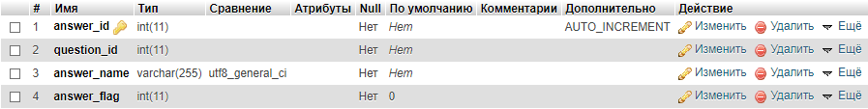

(Figure-54)

The picture above shows the structure of “exams_answers”, so it can be seen that table consists of four columns, such as “answer_id”, “question_id”, “answer_name”, “answer_flag”. The primary key of the table is “answer_id” column, so it contains the unique values and they increment automatically when the new row is entered in the table. Three columns have the type of integer, while the remaining one has the type of varchar. The “answer_flag” colums is filled with the value of “0” by default.

**“exams_question”** table

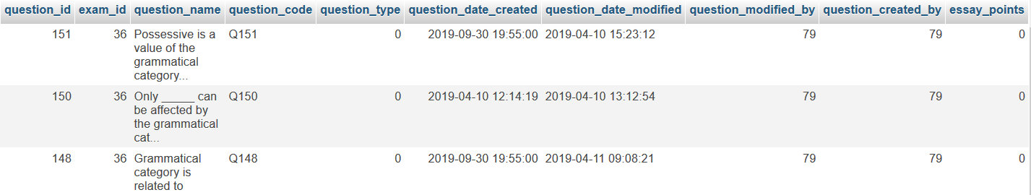

(Figure-55)

The picture given above shows the content of “exams_question” table which stores different data about the exam question, such as identification number of question, identification number of examination, which it belongs to, its name, code, type, date and time when it is created, date and time when it is modified, id number of user who modified the question, id number of user who created it and essay points. The “question_id” column stores the unique values and they increment automatically when the new row of records is created.

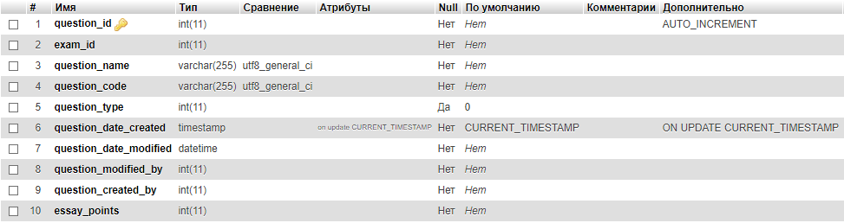

(Figure-56)

The structure of “exams_question” table is displayed in the picture above. It contains ten columns, such as “question_id”, “exam_id”, “question_name”, “question_code”, “question_type”, “question_date_created”, “question_date_modified”, “question_modified_by”, “question_created_by”, “essay_points”. The “question_id” column is the primary key of the table, so it stores the unique values, which increment automatically every time when the next row of records is created. Six columns are integer type, one is varchar, one is varchar, two others contain date and time, so one is timestamp type, while the other is datetime type. The “question_type” column is filled with “0” value, similarly the “question_date_created” column is filled with the current date and time by default.

**“transaction”** table

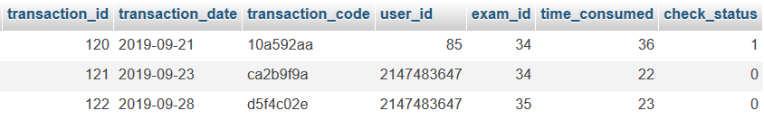

(Figure-57)

The graphic representation of “transaction” table is given above and it is seen that it stores different data about transactions, which occur when the exam is taken by the student. The identification number of transation, date, code, id number of user who passed it, id of examination, consumed time and status of check are considered as those data. The “transaction_id” column stores the unique values and they increase by 1 automatically when the new row of records is created.

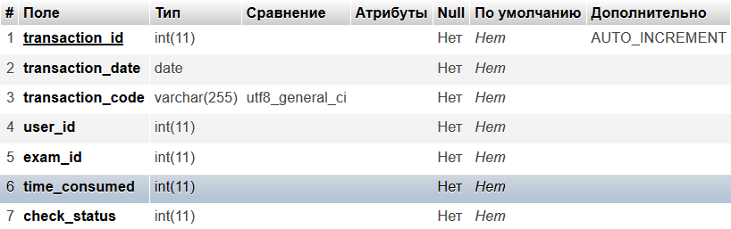

(Figure-58)

The picture above displays the structure of “transaction” table which contains seven columns, such as “transaction_id”, “transaction_date”, “transaction_code”, “user_id”, “exam_id”, “time_consumed”, “check_status”. The primary key of the table is “transaction_id”, so its values are unique and increase by 1 when new row is inserted into the table. Five colums are integer type, one is date type and the last one is varchar type.

**“transaction_dtl”** table

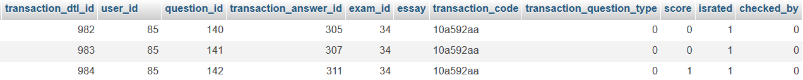

(Figure-59)

The picture above represents the “transaction_dtl” table which stores the data sets about the transactions occurred when the student takes an exam. There are identification number of transaction details, id number of user, id number of question, id number of answer, id number of exam, essay points, code of transaction, type of question, score, indicator about the rating, and id number of user who checked are in the such data sets. The “transaction_dtl_id” column stores the unique integer numbers which increase automatically when the new row is added in the database.

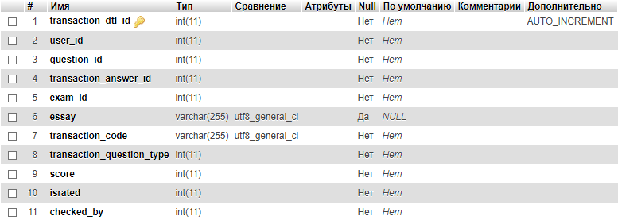

(Figure-60)

The image provided above depicts the structure of “transaction_dtl” table which consists of eleven columns, such as “transaction_dtl_id”, “user_id”, “question_id”, “transaction_answer_id”, “exam_id”, “essay”, “transaction_code”, “transaction_question_type”, “score”, “israted”, “checked_by”. The “transaction_dtl_id” is the primary key of the table, so it stores unque values and they increment automatically. Nine columns of the table are integer type, while one of two others is varchar and the last one is varchar.

**“users”** table



(Figure-61)

The picture above represents the “users” table which stores the data sets about the users who are registered in the system, such as their identification numbers, first and last names, id of the department level which they belong to, id of the role, flag showing is user activated, id of user who created this user, date and time when user was added, id of user who modified him, the time and date of modification, username, password of user and flag if this user is checker of examination.

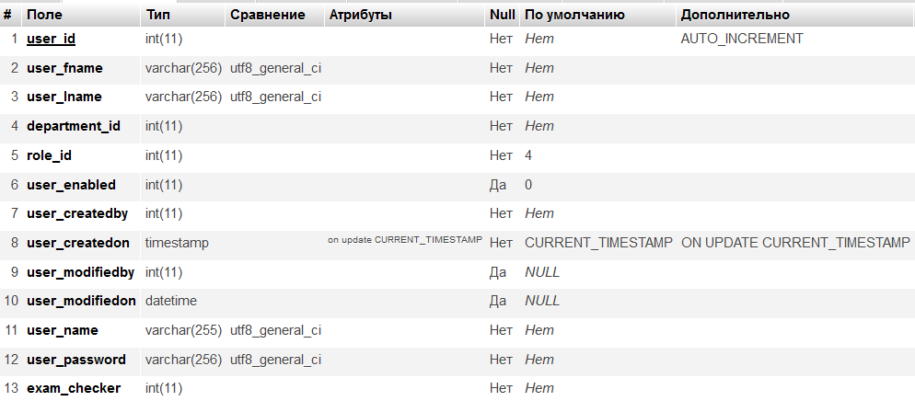

(Figure-62)

The figure-62 displays the structure of “users” table which consists of thirteen columns, such as “user_id”, “user_fname”, “user_lname”, “department_id”, “role_id”, “user_enabled”, “user_createdby”, “user_createdon”, “user_modifiedby”, “user_modifiedon”, “user_name”, “user_password”, “exam_checker”. The “users” table’s primary key is “user_id” column, so the id numbers of the users are unique and increment automatically when the new user is added in the system. There are seven columns which are integer type, four are varchar type, one is timestamp and the last one is datetime.

**“user_roles”** table

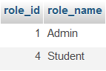

(Figure-63)

The picture above shows the content of “user_roles” table which stores the identification number and name of the role. The “role_id” is the unique identification number of the roles.

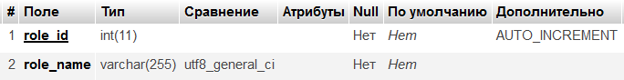

(Figure-64)

The given image displays the structure of the “user_roles” table which consists of two columns, such as “role_id” and “role_name”. The primary key is “role_id” column, so it stores unique values which increment automatically when the new row is created. Identification number is integer type, while the name of role is varchar type.

## (ii) Programming

All main programming scripts, also SQL queries are declared in /models folder, the processes that occur in Admin (teacher) panel are described in adminModel.php, authentication is described in authenticateModel.php and the processes that occur in Student panel are described in staffModel.php

**Authorization**

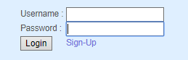

(Figure-65)

**Description**

This SQL query is used during authentication, so it takes the users from the database with same username and password as written in the login form.

**SQL**



(Figure-66)

1. **SELECT** * **FROM** users **WHERE** user_name ='$user_name' AND user_password = '$user_password'

**Code**

1. //declare the function login
2. **public** **function** login($user_name, $user_password){
3. //return the result of the given SQL query
4. **return** $this->fetch_all_rows("SELECT * FROM users WHERE user_name ='$user_name' AND user_password = '$user_password'");
5. }

**Adding New User**

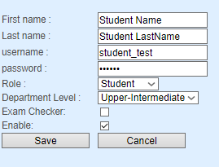

(Figure-67)

**Description**

This SQL query is used to add new users in the Admin (teacher) panel. The query inserts the taken values from the form into the table, where users are stored.

**SQL**



(Figure-68)

1. **insert**('users', array('user_fname' => "'$user_fname'", 'user_lname' => "'$user_lname'", 'user_name' => "'$user_name'",
2. 'user_password' => "'$user_password'", 'role_id' => $role_id, 'department_id' => $department_id,
3. 'user_enabled' => $enabled, 'user_createdby' => $user_id, 'exam_checker' => $ischecker)

**Code**

1. //declare the function addnewuser
2. **public** **function** addnewuser($user_fname, $user_lname, $user_name, $user_password, $role_id, $department_id, $enabled=0, $user_id, $ischecker) {
3. //insert the taken data in the table ‘users’ using SQL query
4. $this->insert('users', **array**('user_fname' => "'$user_fname'", 'user_lname' => "'$user_lname'", 'user_name' => "'$user_name'",
5. 'user_password' => "'$user_password'", 'role_id' => $role_id, 'department_id' => $department_id,
6. 'user_enabled' => $enabled, 'user_createdby' => $user_id, 'exam_checker' => $ischecker));
7. }

**Editing Users**

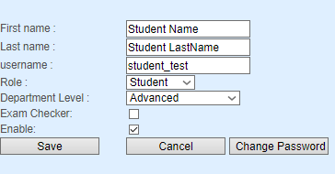

(Figure-69)

**Description**

This SQL query is used to edit the existing users in the Admin (teacher) panel. The query updates the old values which are stored in the database using new values entered in the form and they are stored in the database.

**SQL**

1. **UPDATE** users **SET** user_fname = '$user_fname', user_lname='$user_lname', user_name='$user_name',role_id=$role_id,department_id=$department_id, user_enabled=$enabled,user_modifiedby=$current_user_id,user_modifiedon='$modify_date', exam_checker = $ischeckerWHERE user_id = $edit_id

**Code**

1. //declare function userupdate
2. **public** **function** userupdate($user_fname, $user_lname, $user_name, $role_id, $department_id, $enabled=0, $current_user_id, $edit_id, $ischecker=0) {
3. //if variable enabled does not exist
4. **if** (!isset($enabled)) {$enabled = 0;   //the value of $enabled is equal to 0}
5. //if variable ischecker does not exist
6. **if** (!isset($ischecker)) {
7. $ischecker = 0; //the value of $ischecker is equal to 0
8. }
9. $modify_date = date("Y-m-d", time());   //the value of $modify_date is equal to current date
10. echo $sql;  //display the value of $sql
11. $this->query($sql);  //call the function query
12. $sql = "UPDATE users SET user_fname = '$user_fname', user_lname='$user_lname', user_name='$user_name',role_id=$role_id,department_id=$department_id, user_enabled=$enabled,user_modifiedby=$current_user_id,user_modifiedon='$modify_date',
13. exam_checker = $ischecker WHERE user_id = $edit_id";    //SQL query needed to edit the user data in the database
14. $this->query($sql);  //call the function query
15. }

**Changing User`s Password**

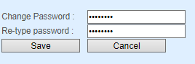

(Figure-70)

**Description**

This SQL query is used during changing the password of existing users in the Admin (teacher) panel. The query updates the old password which is stored in the database using new password entered in the form and it is stored in the database.

**SQL**

1. UPDATE users **SET** user_password = '$change_pass', user_modifiedon='$modify_date' **WHERE** user_id = $edit_id

**Code**

1. //declare function called userupdate2
2. **public** **function** userupdate2($edit_id , $change_pass){
3. $modify_date = date("Y-m-d", time());   //the value of $modify_date equals to current date and time
4. $change_pass = md5($change_pass);   //the value of $change_pass equals to an entered password encrypted in md5
5. $sql = "UPDATE users SET user_password = '$change_pass', user_modifiedon='$modify_date' WHERE user_id = $edit_id";  //sql query used to change password in the database
6. $this->query($sql);  //call the function query
7. }

**Loading User`s Department And User`s Roles**

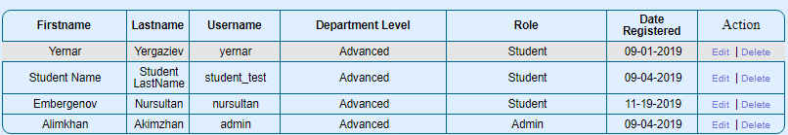

(Figure-71)

**Description**

This SQL query is needed to load the department levels and roles used in the system. The query selects all data stored in “department” and “user_roles” tables, then store them in the “result” array

**SQL**

1. **SELECT** * **FROM** department
2. **SELECT** * **FROM** user_roles

**Code**

1. //declare the function loadDepartmentandRole
2. **public** **function** loadDepartmentandRole() {
3. $result['department'] = $this->fetch_all_rows('select * from department');   //store the loaded data using SELECT SQL query in the ‘department’ cell of ‘result’ array
4. $result['role'] = $this->fetch_all_rows('select * from user_roles');     //store the loaded data using SELECT SQL query in the ‘role’ cell of ‘result’ array
5. **return** $result; //return the value of the array ‘result’
6. }

**Loading User`s Detailed Data**



(Figure-72)

**Description**

The given SQL query is used to load the users stored in the database of the system. It selects all data about each of the existing user in the system, also shows their department level and roles by joining with the “department” and “user_roles” tables, then orders the users by the value of “user_enabled” field

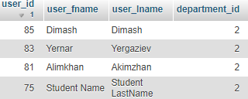

(Figure-73)

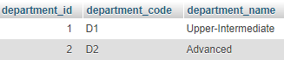

(Figure-74)

**SQL**

1. **SELECT** * **FROM** users LEFT join department **on** users.department_id = department.department_id Left Join user_roles a **ON** users.role_id = a.role_id **ORDER** **BY** user_enabled **asc**

**Code**

1. //declare the function loadUsers
2. **public** **function** loadUsers() {
3. **return** $this->fetch_all_rows('select * from users LEFT join department on users.department_id = department.department_id Left Join user_roles a ON users.role_id = a.role_id Order by user_enabled asc');    //return the result of the SQL query
4. }

**Loading All users from Database**

**Description**

The SQL query used to select the user. It loads all data related with the certain user with the same id as it was given from the “users” database.

**SQL**



(Figure-75)

1. **select** * from users where user_id =' . $user_id

**Code**

1. //declare the function selectuser
2. **public** **function** selectuser($user_id) {
3. **return** $this>fetch_all_rows('select * from users where user_id =' . $user_id);
4. //return the result of the SQL query
5. }

**Deleting User**

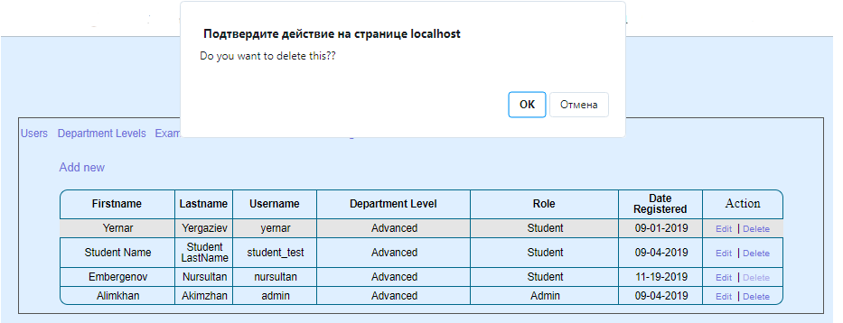

(Figure-76)

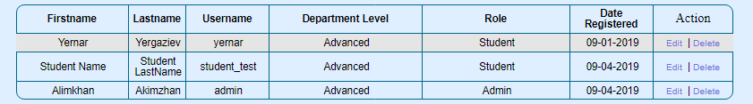

(Figure-77)

**Description**

The SQL query is used to delete the certain user with the same id as it was chosen by the user.

**SQL**

1. delete **from** users **where** user_id = $user_id

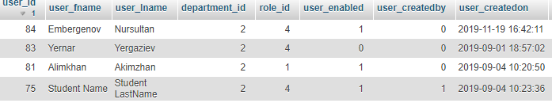

(Figure-78)

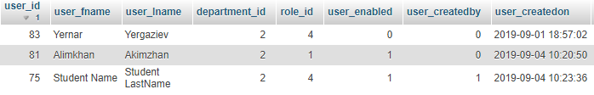

(Figure-79)

**Code**

1. //declare function called userdelete
2. **public** **function** userdelete($user_id) {
3. $sql = "delete from users where user_id = $user_id"; //SQL query used to delete the user with the certain id
4. $this->query($sql);   //call the function query
5. }

**Adding New Sign Upped User**

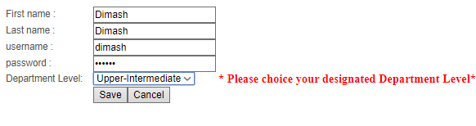(Figure-80)

**Description**

The SQL query is needed to add new user after the sign-up. It collects all data entered in the form and stores them in the “users” database. But before that it checks if there any user in the database with the same username, if there is the user is not added, else the INSERT SQL query is processed.

**SQL**

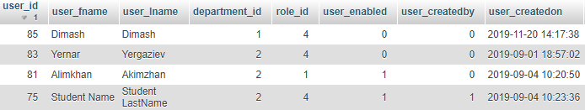

(Figure-81)

1. **SELECT** * **FROM** users **WHERE** user_name ='$user_name'
2. **insert**('users', array('user_fname' => "'$user_fname'", 'user_lname' => "'$user_lname'", 'user_name' => "'$user_name'",  'user_password' => "'$user_password'", 'department_id'=>$department_id))

**Code**

1. //declare function signupadd
2. ublic **function** signupadd($user_fname, $user_lname, $user_name, $user_password, $department_id) {
3. $sql = "SELECT * FROM users WHERE user_name ='$user_name'";  //sql query used to
4. $result = $this->query($sql); //set the value of $result equal to the result of function query
5. //if the value of $result is array
6. **if** (is_array($result)) {
7. echo "1";    //display 1
8. } **else** {
9. $this->insert('users', **array**('user_fname' => "'$user_fname'", 'user_lname' => "'$user_lname'", 'user_name' => "'$user_name'", 'user_password' => "'$user_password'", 'department_id'=>$department_id));    //insert the collected data in the database ‘insert’
10. echo "0";    //display 0
11. }
12. }

**Adding New Department Level**

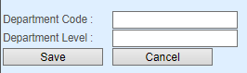

(Figure-82)

**Description**

The given SQL query is used to add new department in the system. As far as the form is submitted, the SQL query takes the data entered and inserts them as a new row in the database.

**SQL**

1. **insert**('department', array('department_code' => "'$department_code'", 'department_name' => "'$department_name'"))

**Code**

1. //declare function called savedepartmentnew
2. public **function** savedepartmentnew($department_code, $department_name) {
3. $this->insert('department', **array**('department_code' => "'$department_code'", 'department_name' => "'$department_name'"));   //call the insert SQL query to insert new row in ‘department’ table  }

**Loading the Department Levels**



(Figure-83)

**Description**

This SQL query is used to load the department levels that exist in the system. The query loads all data stored in the “department” table.

**SQL**

1. **select** * **from** department

**Code**

1. //declare function loadDepartment
2. public **function** loadDepartment() {
3. **return** $this->fetch_all_rows('select * from department'); //return the result of SELECT SQL query
4. }

**Loading the Data of Department Level**

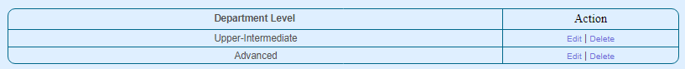

(Figure-84)

**Description**

The SQL query is used to load the data related with the level which has the same id as the chosen department level.

**SQL**

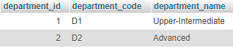

(Figure-85)



(Figure-86)

1. select * **from** department **where** department_id = $department_id

**Code**

1. //declare the function departmenedit
2. public **function** departmentedit($department_id) {
3. **return** $this -> fetch_all_rows("select * from department where department_id = $department_id");
4. //return the result of SELECT SQL query
5. }

**Editing Department Level**

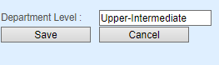

(Figure-87)

**Description**

The SQL query is used to edit the current information about the certain department level. The query replaces the old values with the new ones entered in the form.

**SQL**

1. UPDATE department **SET** department_name ='$department_name' **WHERE** department_id = $department_id

**Code**

1. //declare function called departmenupdate
2. public **function** departmentupdate($department_id, $department_name) {
3. $sql = "UPDATE department SET department_name ='$department_name' WHERE department_id = $department_id"; //SQL query used to update the row related with the certain department level
4. $this->query($sql);   //call the function query
5. }

**Deleting Department**

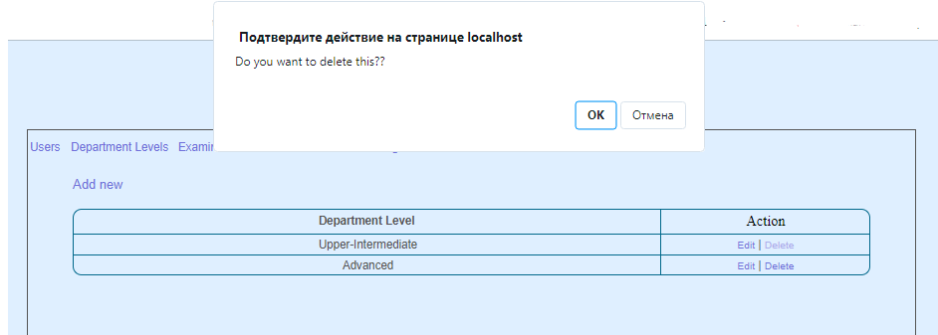

(Figure-88)

**Description**

This SQL query is used to delete the certain department level from the system. It deletes all data related with such department level from the table “department”

**SQL**

1. **DELETE** **FROM** department **WHERE** department_id = $department_id

**Code**

1. //declare function called departmentdelete
2. **public** **function** departmentdelete($department_id) {
3. $this->query("DELETE FROM department WHERE department_id = $department_id"); //call the function query to delete the certain department level from the database
4. }

**Adding New Exam**

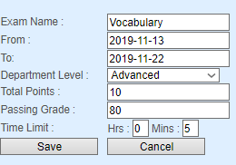

(Figure-89)

**Description**

This SQL query is used to add new examination in the system. It inserts the entered data into the database that stores the exams.

**SQL**

1. **insert**('exams', array('exam_name' => "'$exam_name'", 'exam_from' => "'$exam_from'", 'exam_to' => "'$exam_to'", 'exam_created_by' => $user_id, 'passing_score' => $total_points, 'exam_time_limit' => $**time**, 'passing_grade' => $passing_grade, 'department_id' => $department_id))

**Code**

1. //declare function called saveexamsnew
2. **public** **function** saveexamsnew($exam_name, $exam_from, $exam_to, $user_id, $total_points, $time, $passing_grade, $department_id) {
3. $this->insert('exams', **array**('exam_name' => "'$exam_name'", 'exam_from' => "'$exam_from'", 'exam_to' => "'$exam_to'", 'exam_created_by' => $user_id, 'passing_score' => $total_points, 'exam_time_limit' => $time, 'passing_grade' => $passing_grade, 'department_id' => $department_id));   //call the INSERT SQL to insert new records in the database ‘exams’
4. }

**Updating Exam`s Data**

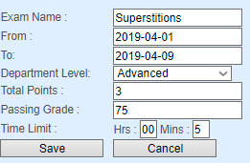

(Figure-90)

**Description**

This SQL query is needed to update the information about the certain examination. The query replaces the old data with the new ones, which are entered in the form.

**SQL**

1. **UPDATE** exams **SET** exam_name='$exam_name',exam_from = '$exam_from', exam_to='$exam_to',exam_modified_by=$user_id,passing_score=$total_points, exam_time_limit=$**time**,passing_grade=$passing_grade, department_id = $department_id **WHERE** exam_id = $exam_id

**Code**

1. //declare function called saveexamsupdate
2. **public** **function** saveexamsupdate($exam_name, $exam_from, $exam_to, $user_id, $total_points, $time, $exam_id, $passing_grade,$department_id) {
3. $sql = "UPDATE exams SET exam_name='$exam_name',exam_from ='$exam_from', exam_to='$exam_to',exam_modified_by=$user_id,passing_score=$total_points, exam_time_limit=$time,passing_grade=$passing_grade, department_id = $department_id WHERE exam_id = $exam_id";    //SQL query used to update the data about the certain exam
4. echo $sql;
5. $this->query($sql);
6. }

**Loading the Examination List**

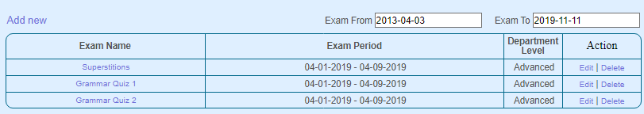

(Figure-91)

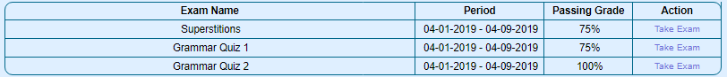

(Figure-92)

**Description**

This SQL query is used to load the examinations from the “exams” table using different filters such as deadline dates, also joining with the department levels. It loads the all rows stored in such table and orders the records by identification numbers of exams

**SQL**

1. **select** * **from** exams $**WHERE**
2. LEFT JOIN department **ON** exams.department_id = department.department_id **WHERE** exam_from >= '$from' AND exam_to <= '$to'  **ORDER** **BY** exam_id **ASC**
3. LEFT JOIN department **ON** exams.department_id = department.department_id **WHERE** CURDATE() BETWEEN exam_from AND exam_to **ORDER** **BY** exam_id **ASC**

**Code**

1. //declare function called loadExams
2. **public** **function** loadExams($from, $to) {
3. //if both $from and $to variables are not empty
4. **if** ($from != '' && $to != '') {
5. $WHERE = " LEFT JOIN department ON exams.department_id = department.department_id WHERE exam_from >= '$from' AND exam_to <= '$to'  ORDER BY exam_id ASC"; //set the value of $WHERE as given to show only the exams in the chosen period of time
6. } **else** {
7. $WHERE = " LEFT JOIN department ON exams.department_id = department.department_id WHERE CURDATE() BETWEEN exam_from AND exam_to ORDER BY exam_id ASC";  //set the value of $WHERE as given to show only the exams where the current date in the period of time of the exam
8. }
9. $sql = "select * from exams $WHERE ";   //SQL query to load the exams from ‘exams’ table with the $WHERE filtering
10. **return** $this->fetch_all_rows($sql);  //return the result of the SQL query
11. }

**Loading Results of Examinations**



(Figure-93)

**Description**

This SQL query is used to load the results of examinations from the “transaction” table joining it with the “users” and “exams” tables.

**SQL**

1. **SELECT** * **FROM** **transaction** **INNER** JOIN users **ON** **transaction**.user_id = users.user_id **INNER** JOIN exams **ON** **transaction**.exam_id = exams.exam_id $**WHERE**
2. **WHERE** exam_from >= '$from' AND exam_to <= '$to' **ORDER** **BY** exams.exam_id, **transaction**.user_id **ASC**
3. **WHERE** CURDATE() BETWEEN exam_from AND exam_to **ORDER** **BY** exams.exam_id, **transaction**.user_id **ASC**
4. **SELECT** SUM(score) **AS** 'score' **FROM** transaction_dtl **WHERE** user_id = $row[user_id]  AND exam_id = $row[exam_id] **ORDER** **BY** exam_id, user_id **ASC**

**Code**

1. //declare function called examsresult
2. **public** **function** examsresult($from = '', $to = '') {
3. //if both $from and $to are not empty
4. **if** ($from != '' && $to != '') {
5. $WHERE = " WHERE exam_from >= '$from' AND exam_to <= '$to' ORDER BY exams.exam_id, transaction.user_id ASC";  //set the value of $WHERE so that to display the exam results between the chosen dates
6. } **else** {
7. $WHERE = " WHERE CURDATE() BETWEEN exam_from AND exam_to ORDER BY exams.exam_id, transaction.user_id ASC";  //set the value of $WHERE so that to display the exam results which have the deadline period with current date in it
8. }
9. $sql = "SELECT * FROM transaction
10. INNER JOIN users ON transaction.user_id = users.user_id
11. INNER JOIN exams ON transaction.exam_id = exams.exam_id
12. $WHERE";    //SQL query needed to load all the transactions and join the related data with the users and exams tables
13. $result['exam'] = $this->fetch_all_rows($sql);   //store the result of SQL query in the ‘exam’ cell of $result array
14. //if $result is array
15. **if** (is_array($result['exam'])) {
16. //foreach loop
17. **foreach** ($result['exam'] **as** $row) {
18. $sql = "SELECT SUM(score) AS 'score' FROM transaction_dtl WHERE user_id = $row[user_id]  AND exam_id = $row[exam_id] ORDER BY exam_id, user_id ASC";    //SQL query needed to select the scores of certain users from the certain exam loaded from ‘transaction_dtl’ table
19. $result[$row['user_id']][$row['exam_id']] = $this->fetch_all_rows($sql); //store the result of a SQL query
20. }
22. }
23. **return** $result; //return the value of $result array
24. }

**Loading The Data for Answers Given by User**

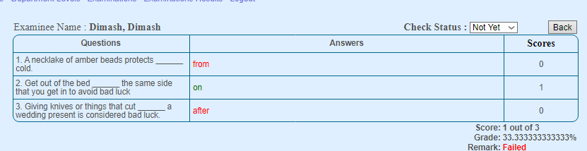

(Figure-94)

**Description**

The SQL query given below is used to display the answers for each questions given by the students and their result according the answers in the certain exam

**SQL**

1. **SELECT** * **FROM** exams **WHERE** exam_id = $exam_id
2. **SELECT** * **FROM** transaction_dtl **INNER** JOIN **transaction** **ON** transaction_dtl.user_id = **transaction**.user_id AND transaction_dtl.exam_id = **transaction**.exam_id **INNER** JOIN exams_question **ON** transaction_dtl.question_id = exams_question.question_id **INNER** JOIN users **ON**  transaction_dtl.user_id = users.user_id LEFT JOIN exams_answers **ON** transaction_dtl.transaction_answer_id = exams_answers.answer_id **WHERE** transaction_dtl.user_id = $user_id AND transaction_dtl.exam_id = $exam_id **ORDER** **BY** exams_question.question_id **ASC**

**Code**

1. //declare function called examsresult
2. **public** **function** checkresult($exam_id, $user_id) {
3. $sql = "SELECT * FROM exams WHERE exam_id = $exam_id";  //SQL query used to load the data related with the certain exam
4. $result['exam_name'] = $this->fetch_all_rows($sql);  //store result of SQL query in the “exam_name” cell of $result array
5. $sql = "SELECT * FROM transaction_dtl INNER JOIN transaction ON transaction_dtl.user_id = transaction.user_id AND transaction_dtl.exam_id = transaction.exam_id INNER JOIN exams_question ON transaction_dtl.question_id = exams_question.question_id INNER JOIN users ON  transaction_dtl.user_id = users.user_id
6. LEFT JOIN exams_answers ON transaction_dtl.transaction_answer_id = exams_answers.answer_id WHERE transaction_dtl.user_id = $user_id AND transaction_dtl.exam_id = $exam_id ORDER BY exams_question.question_id ASC";    //SQL query to load the data stored in ‘transaction_dtl’ table
7. $result['transaction_dtl'] = $this->query($sql);     //store result of SQL query in the “transaction_dtl” cell of $result array
8. **return** $result;} //return the value of $result array

**Loading Transaction`s Details**



(Figure-95)

**Description**

The SQL query given below is needed to load the data about certain transaction details.

**SQL**

1. SELECT * **FROM** transaction_dtl **WHERE** transaction_dtl_id = $transaction_dtl_id

**Code**

1. //declare function called rate
2. **public** **function** rate($transaction_dtl_id) {
3. $sql = "SELECT * FROM transaction_dtl WHERE transaction_dtl_id = $transaction_dtl_id";  //SQL query used to load the data about the certain transaction stored in ‘transaction_dtl’
4. **return** $this->query($sql);   //return the result of the called function query
5. }

**Updating a Details of Transaction**

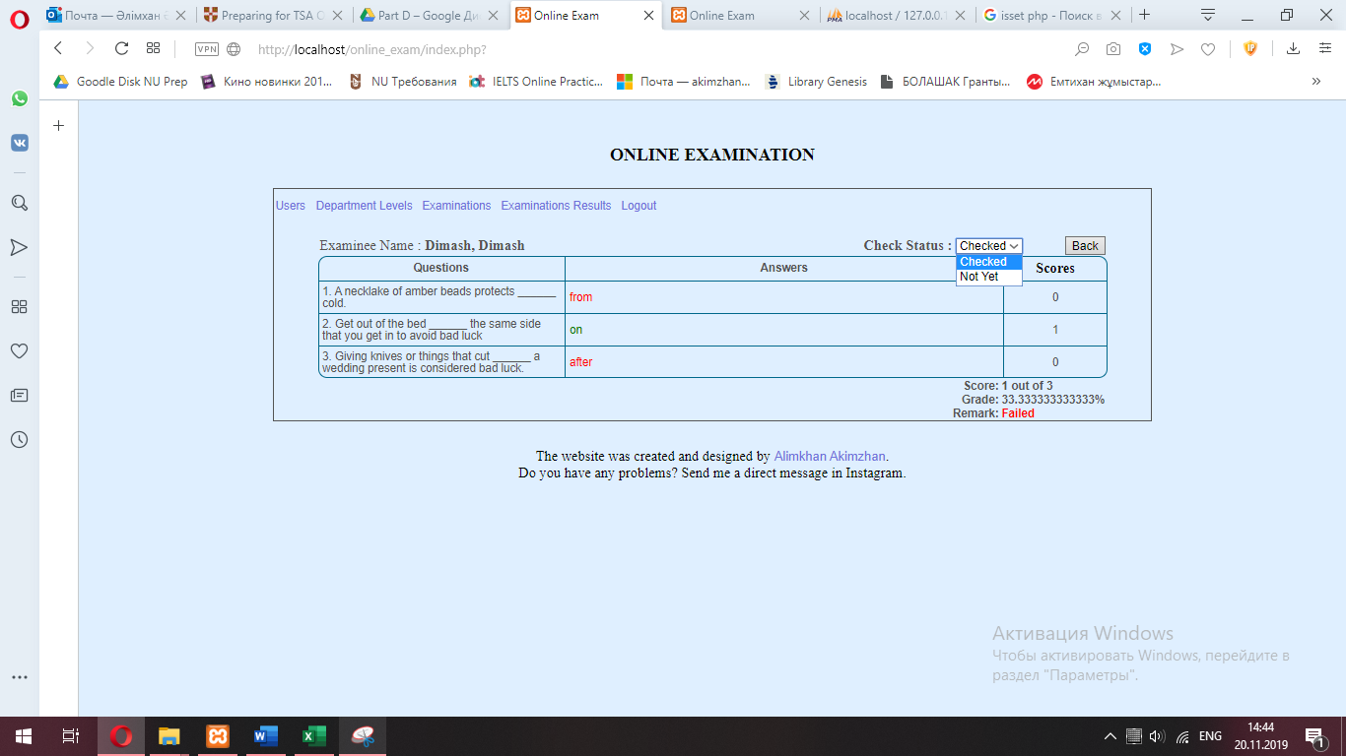

(Figure-96)

**Description**

The SQL query is used to update the certain transaction details and set that it was rated by certain teacher.

**SQL**

1. **UPDATE** transaction_dtl **SET** score = $score, israted=1, checked_by =$checked_by **WHERE** transaction_dtl_id = $transaction_dtl_id

**Code**

1. //declare function called rateupdate
2. **public** **function** rateupdate($transaction_dtl_id, $score, $checked_by) {
3. //if variable $score does not exist
4. **if** (!isset($score)) {
5. $score = 0; //set the value of $score equals to 0
6. }
7. $sql = "UPDATE transaction_dtl SET score = $score, israted=1, checked_by =$checked_by WHERE transaction_dtl_id = $transaction_dtl_id";  //SQL query used to update the transaction details
8. $this->query($sql);  //call the function query
9. }

**Updating a Checking Status**



(Figure-97)

**Description**

The SQL query is used to update the certain transaction and set that the students’ answers were checked by the teacher

**SQL**

1. **UPDATE** **transaction** **SET** check_status = $status **WHERE** user_id = $user_id AND exam_id = $exam_id

**Code**

1. //declare function called checkstatus
2. **public** **function** checkstatus($status, $user_id, $exam_id ){
3. //if variable $status does not exist
5. **if** ( !isset($status) ){
6. $status = 0;    //set the value of $status equals to 0
7. }
8. $sql = "UPDATE transaction SET check_status = $status WHERE user_id = $user_id AND exam_id = $exam_id"; //SQL query used to update the certain transaction
9. $this->query($sql);  //call the function query
10. }

**Creating a new Question**

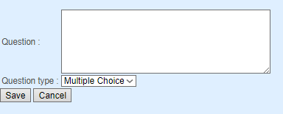

(Figure-98)

**Description**

This SQL query is used to insert new question that belongs to the certain exam into the database

**SQL**

1. **insert**('exams_question', array('exam_id' => $exam_id, 'question_name' => "'$question_name'", 'question_type' => $question_type, 'question_created_by' => $user_id, 'essay_points' => $essay_points))

**Code**

1. //declare function called questionaddinsert
2. **public** **function** questionaddinsert($exam_id, $question_name, $question_type, $user_id, $essay_points) {
3. //if variable $question_type does not exist
4. **if** (!isset($question_type)) {
5. $question_type = 0; //set the value of $question_type equals to 0
6. }
7. //if variable $essay_points does not exist
8. **if** (!isset($essay_points)) {
9. $essay_points = 0;  //set the value of $essay_points equals to 0
10. }
11. $this->insert('exams_question', **array**('exam_id' => $exam_id, 'question_name' => "'$question_name'", 'question_type' => $question_type, 'question_created_by' => $user_id, 'essay_points' => $essay_points));  //call the SQL query function to insert new row of records in the ‘exams_question’ database
12. }

**Loading the Questions**

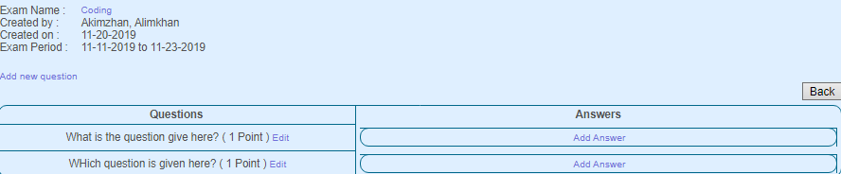

(Figure-99)

**Description**

This SQL query is used to load the questions of certain exam.

**SQL**

1. **SELECT**  * **FROM** users LEFT JOIN exams **ON** users.user_id = exams.exam_created_by LEFT JOIN exams_question **ON** exams.exam_id = exams_question.exam_id **WHERE** exams.exam_id =" . $exam_id . " **ORDER** **BY** exams_question.question_id **ASC**
2. **SELECT** * **FROM** exams_answers **WHERE** question_id = $row[question_id] **order** **by** answer_id **asc**

**Code**

1. //declare function called questionaddinsert
2. **public** **function** loadQuestion($exam_id) {
3. $sql = "SELECT  * FROM users LEFT JOIN exams ON users.user_id = exams.exam_created_by LEFT JOIN exams_question ON exams.exam_id = exams_question.exam_id WHERE exams.exam_id =" . $exam_id . " ORDER BY exams_question.question_id ASC";    //SQL query used to load the users from the ‘users’ database to show the creator of the question
4. $result['exam'] = $this->fetch_all_rows($sql);   //store the result of the SQL query in the ‘exam’ cell of $result array
5. //if $result is an array
6. **if** (is_array($result['exam'])) {
7. //foreach loop
8. **foreach** ($result['exam'] **as** $row) {
9. $sql = "SELECT * FROM exams_answers WHERE question_id = $row[question_id] order by answer_id asc";  //SQL query used for loading the answers of certain question stored in the ‘exams_answers’ table
10. $result[$row['question_id']] = $this->fetch_all_rows($sql);}}   //store the result of the SQL query in the $result array
11. **return** $result; }//return the value of $result

**Updating Questions Details**

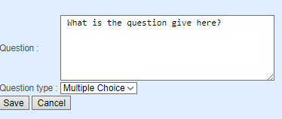

(Figure-100)

**Description**

This SQL query is used to update the certain question of a certain exam.

**SQL**

1. UPDATE exams_question **SET** question_name ='$question_name', question_type = $question_type, essay_points = $essay_points **WHERE** question_id =" . $question_id

**Code**

1. //declare function called questionedit
2. **public** **function** questionupdate($question_name, $question_type, $question_id, $essay_points) {
3. //if variable $question_type does not exist
4. **if** (!isset($question_type)) {
5. $sql = "UPDATE exams_question SET question_name ='$question_name', question_type = $question_type, essay_points = $essay_points WHERE question_id =" . $question_id;    //SQL query used to update the certain question of the certain exam
6. $this->query($sql); } //call the function query

**Deleting Exam**

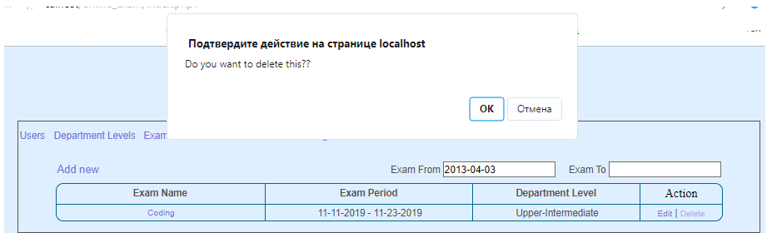

(Figure-101)

**Description**

This SQL query is used to delete the certain exam from the system.

**SQL**

1. **DELETE** **FROM** exams **WHERE** exam_id = $exam_id

**Code**

1. //declare function called questiondelete
2. **public** **function** questiondelete($exam_id) {
3. $sql = "DELETE FROM exams WHERE exam_id = $exam_id";    //SQL query used to delete te exam from the database
4. $this->query($sql);  //call the function query
5. }

**Editing the Answer`s Details**

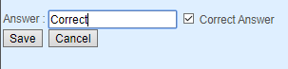

(Figure-102)

**Description**

This SQL query is used to edit the data related with the certain answer for the certain question.

**SQL**

1. “**UPDATE** exams_answers **SET** answer_flag = 0 **WHERE** question_id = " . $question_id)
2. "UPDATE exams_answers SET answer_name ='$answer_name', answer_flag = 1 answer_id = " . $answer_id
3. "UPDATE exams_answers SET answer_name ='$answer_name' WHERE answer_id = " . $answer_id

**Code**

1. //declare function called answerupdate
2. **public** **function** answerupdate($answer_id, $answer_name, $flag, $question_id) {
3. //if the value $flag equals to 1
4. **if** ($flag == 1) {
5. $this->query("UPDATE exams_answers SET answer_flag = 0 WHERE question_id = " . $question_id);    //set the ‘answer_flag’ of answers for the certain question 0
6. $sql = "UPDATE exams_answers
7. SET answer_name ='$answer_name', answer_flag = 1
8. WHERE answer_id = " . $answer_id;   //SQL query used to update the certain answer for the certain question
9. } **else** {
10. $sql = "UPDATE exams_answers SET answer_name ='$answer_name' WHERE answer_id = " . $answer_id;}  //SQL query to update the certain answer for the certain question
11. $this->query($sql);}  //call the function query

**Deleting the Answer**

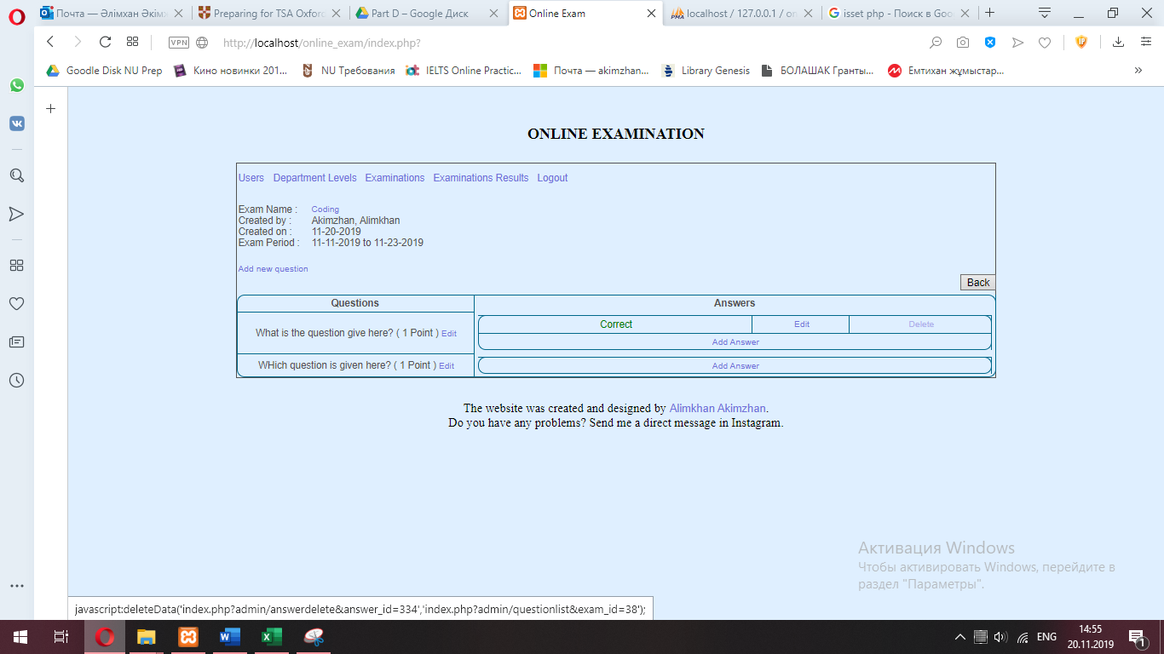

(Figure-103)

**Description**

This SQL query is used to delete the answer of a certain exam and question from the database.

**SQL**

1. **DELETE** **FROM** exams_answers **WHERE** answer_id = $answer_id

**Code**

1. //declare function called answerdelete
2. **public** **function** answerdelete($answer_id) {
3. $this->query("DELETE FROM exams_answers WHERE answer_id = $answer_id"); } //SQL query to delete the certain answer from the ‘exams_answers’ table

**Loading Exam Table for Student**



(Figure-104)

**Description**

This SQL query is used to show the exams for students.

**SQL**

1. **SELECT** * **FROM** exams **INNER** JOIN  users **ON** exams.department_id = users.department_id  users.user_id = $user_id **ORDER** **BY** exam_id **ASC**

**Code**

1. //declare function called exam_list
2. **public** **function** exam_list($user_id){
3. $sql = "SELECT * FROM exams INNER JOIN  users ON exams.department_id = users.department_id WHERE users.user_id = $user_id ORDER BY exam_id ASC";    //SQL query to load the exams
4. $result['exam'] = $this-> fetch_all_rows($sql);   //store the result of the SQL query in the ‘exam’ cell of $result array
5. //if the $result is an array
6. (is_array($result['exam'])){
7. //foreach loop
8. **foreach**($result['exam'] **as** $row){
9. //if the ‘isdeleted’ cell of $row array equals to 0
10. **if** ($row['isdeleted'] == 0){
11. $sql = "SELECT * FROM transaction_dtl where user_id=$user_id and exam_id =".$row['exam_id'] . " ORDER BY exam_id ASC" ; //SQL query to transaction details related with the user and certain exam
12. $result[$row['exam_id']] = $this-> fetch_all_rows($sql);  //store the result of SQL query in the $result array
13. } } }
14. **return** $result;} //return the value stored in the $result array

**Checking if the user took and exam or not**

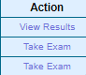

(Figure-105)

**Description**

This SQL query is used to load the data related to the transaction details of certain user and exam in order to check if user has taken the certain exam or not.

**SQL**

1. **SELECT** * **FROM** transaction_dtl **WHERE** user_id = $user_id AND exam_id = $exam_id

**Code**

1. //declare function called alreadytaken
2. **public** **function** alreadytaken($user_id, $exam_id){
3. $sql = "SELECT * FROM transaction_dtl WHERE user_id = $user_id AND exam_id = $exam_id"; //SQL query to load the certain transaction details
4. **return** $this->fetch_all_rows($sql); } //return the result of the SQL query

**Submitting the Answer**

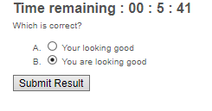

(Figure-106)

**Description**

This SQL query is used to submit the answers for the certain questions in the certain exam.

**SQL**

1. **insert**('transaction',array('transaction_date'=>"'$date'",'transaction_code'=>"'$uuid'",'user_id'=>$user_id,'exam_id'=>$exam_id,'time_consumed'=>$time_consumed))
3. **SELECT** * **FROM** exams_question **WHERE** question_id = $qtype
5. **SELECT** * **FROM** exams_answers **WHERE** answer_id = $row  **insert**('transaction_dtl',array('user_id'=>$user_id,'question_id'=>$_SESSION['question_id'][$row],'transaction_answer_id'=>$row, 'exam_id'=>$exam_id,'essay'=>"'$answer'", 'transaction_code'=>"'$uuid'",'transaction_question_type'=>$question_type,'score'=>$score,'israted'=>$israted))
6. **insert**('transaction_dtl',array('user_id'=>$user_id,'question_id'=>0,'transaction_answer_id'=>0,'exam_id'=>$exam_id,'transaction_code'=>"'$uuid'",'israted'=>0))

**Code**

1. //declare function called submitresult
2. **public** **function** submitresult( $user_id, $exam_id, $time_consumed ){
3. $sql = "SELECT UUID()"; //SQL query to load UUID
4. $uuid = $this->query($sql);  //store the result of SQL query in $uuid
5. $uuid = substr($uuid[0]['UUID()'],0,8); //restore the value of $uuid by cutting a part of its initial value
6. $date = date("Y-m-d");  //set $date as current date
7. $this->insert('transaction',**array**('transaction_date'=>"'$date'", 'transaction_code'=>"'$uuid'",'user_id'=>$user_id,'exam_id'=>$exam_id,'time_consumed'=>$time_consumed));     //insert the data about the certain transaction in the table
8. //if the session ‘question_id’ exists
9. **if** (isset($_SESSION['question_id'])){
10. //foreach loop
11. **foreach**($_SESSION['answer_id'] **as** $row){
12. //if the session ‘answer’ ‘row’ exists
13. **if** (isset($_SESSION['answer'][$row])){
14. $answer = $_SESSION['answer'][$row];    //set the value of $answer the same as the session’s ‘answer’ ‘row’
15. }**else**{
16. $answer='null'; //set the value of $answer ‘null’
17. }
18. $qtype = $_SESSION['question_id'][$row];    //set the value of $qtype the same as the session’s ‘question_id’ ‘row’
19. $question_type = $this->query("SELECT * FROM exams_question WHERE question_id = $qtype");    //set the value of question_type as the result of the SQL query
20. $question_type = $question_type[0]['question_type'];    //set the value of $question_type the same as the session’s ‘0’ ‘question_type’
21. $sql = "SELECT * FROM exams_answers WHERE answer_id = $row";        //SQL query to load the answers of the certain exam
22. $correct = $this->fetch_all_rows($sql);  //set the value of $correct the same as the result of the SQL query
23. $score = 0; //set the value of $score 0
24. $israted=0;     //set the value of $israted 0
25. //if the value $correct ‘0’ ‘answer_flag’ equals to 1
26. **if** ($correct[0]['answer_flag']==1){
27. $score = 1; //set the value of $score 1
28. }
29. //if the value of $question_type is 0
30. **if** ( $question_type==0 ){
31. $israted=1; //set the value of $israted 0
32. }
33. $this->insert('transaction_dtl',**array**('user_id'=>$user_id, 'question_id'=>$_SESSION['question_id'][$row], 'transaction_answer_id'=>$row,   'exam_id'=>$exam_id,'essay'=>"'$answer'",'transaction_code'=>"'$uuid'", 'transaction_question_type'=>$question_type,'score'=>$score,'israted'=>$israted)); //call the INSERT SQL query
34. }
35. }**else**{
36. $this->insert('transaction_dtl',**array**('user_id'=>$user_id,'question_id'=>0, 'transaction_answer_id'=>0,'exam_id'=>$exam_id,'transaction_code'=>"'$uuid'",'israted'=>0));
37. //call the INSERT SQL query
38. }}

**Viewing the Results**

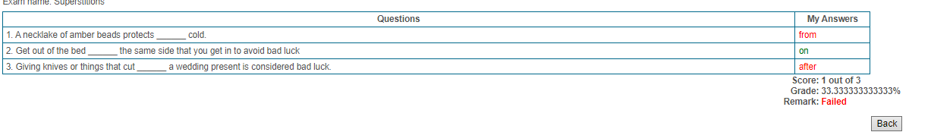

(Figure-107)

**Description**

This SQL query is used to load and view the results from the already taken exams by the certain student.

**SQL**

1. **SELECT** * **FROM** exams **WHERE** exam_id = $exam_id
2. **SELECT** * **FROM** transaction_dtl **INNER** JOIN exams_question **ON** transaction_dtl.question_id = exams_question.question_id LEFT JOIN exams_answers **ON** transaction_dtl.transaction_answer_id = exams_answers.answer_id **WHERE** user_id = $user_id AND transaction_dtl.exam_id = $exam_id **ORDER** **BY** exams_question.question_id **ASC**

**Code**

1. //declare function called viewresults
2. **public** **function** viewresults( $exam_id,$user_id){
3. $sql = "SELECT * FROM exams WHERE exam_id = $exam_id";  //SQL query to load the data about the certain exam
4. $result['exam_name'] = $this->fetch_all_rows($sql);  //store the result of the SQL query in the ‘exam_name’ cell of $result array
5. $sql = "SELECT *
6. FROM transaction_dtl
7. INNER JOIN exams_question ON transaction_dtl.question_id = exams_question.question_id
8. LEFT JOIN exams_answers ON transaction_dtl.transaction_answer_id = exams_answers.answer_id
9. WHERE user_id = $user_id AND transaction_dtl.exam_id = $exam_id ORDER BY exams_question.question_id ASC";   //SQL query to load the transaction details from the ‘transaction_dtl’ table
10. $result['transaction_dtl'] = $this->query($sql);     //store the result of the SQL query in the ‘exam_name’ cell of $result array
11. **return** $result; //return the value of $result array
12. }

**Loading the Results of Exam Taken**



(Figure-108)

**Description**

This SQL query is used to load the results and see the scores from the already taken exams by the certain student.

**SQL**

1. **SELECT** * **FROM** **transaction** **INNER** JOIN users **ON** **transaction**.user_id = users.user_id **INNER** JOIN exams **ON** **transaction**.exam_id = exams.exam_id $**WHERE**
2. **WHERE** exam_from >= '$from' AND exam_to <= '$to' **ORDER** **BY** exams.exam_id, **transaction**.user_id **ASC**
3. **WHERE** CURDATE() BETWEEN exam_from AND exam_to **ORDER** **BY** exams.exam_id, **transaction**.user_id **ASC**
4. **SELECT** SUM(score) **AS** 'score' **FROM** transaction_dtl **WHERE** user_id = $row[user_id]  AND exam_id = $row[exam_id] **ORDER** **BY** exam_id, user_id **ASC**

**Code**

1. //declare function called examresult
2. **public** **function** examsresult($from = '', $to = '') {
3. //if variables $from and $to are not empty
4. **if** ($from != '' && $to != '') {
5. $WHERE = " WHERE exam_from >= '$from' AND exam_to <= '$to' ORDER BY exams.exam_id, transaction.user_id ASC";  //set the filter $WHERE
6. } **else** {
7. $WHERE = " WHERE CURDATE() BETWEEN exam_from AND exam_to ORDER BY exams.exam_id, transaction.user_id ASC";  //set the filter $WHERE
8. }
9. $sql = "SELECT * FROM transaction
10. INNER JOIN users ON transaction.user_id = users.user_id
11. INNER JOIN exams ON transaction.exam_id = exams.exam_id
12. $WHERE";    //SQL query to load the data stored in ‘transaction’ table
13. $result['exam'] = $this->fetch_all_rows($sql);   //store the result of SQL query in the ‘exam’ cell of $result array
14. //if the $result is array
15. **if** (is_array($result['exam'])) {
16. //foreach loop
17. **foreach** ($result['exam'] **as** $row) {
18. $sql = "SELECT SUM(score) AS 'score' FROM transaction_dtl WHERE user_id = $row[user_id]  AND exam_id = $row[exam_id] ORDER BY exam_id, user_id ASC";    //SQL query to load the scores from the ‘transaction_dtl’ table
19. $result[$row['user_id']][$row['exam_id']] = $this->fetch_all_rows($sql);}} //store the result of SQL query in the $result array
20. **return** $result; }

**Loading the Exam List**

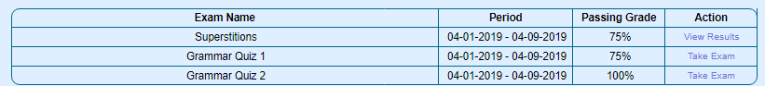

(Figure-109)

**Description**

This SQL query is used to load the exams from the database

**SQL**

1. **select** * **from** exams $**WHERE**
2. LEFT JOIN department **ON** exams.department_id = department.department_id **WHERE** exam_from >= '$from' AND exam_to <= '$to'  **ORDER** **BY** exam_id **ASC**
3. LEFT JOIN department **ON** exams.department_id = department.department_id /\***WHERE** CURDATE() BETWEEN exam_from AND exam_to*/ **ORDER** **BY** exam_id **ASC**

**Code**

1. //declare function called examresult
2. **public** **function** examresult($from, $to) {
3. //if variables $from and $to are not empty
4. **if** ($from != '' && $to != '') {
5. $WHERE = " LEFT JOIN department ON exams.department_id = department.department_id WHERE exam_from >= '$from' AND exam_to <= '$to'  ORDER BY exam_id ASC"; //set the value of filter $WHERE for SQL query
6. } **else** {
7. $WHERE = " LEFT JOIN department ON exams.department_id = department.department_id /*WHERE CURDATE() BETWEEN exam_from AND exam_to*/ ORDER BY exam_id ASC";      //set the value of filter $WHERE for SQL query
8. }
9. $sql = "select * from exams $WHERE ";   //SQL query to load the exams from the database
10. **return** $this->fetch_all_rows($sql);}  //return the result of SQL query

**Calculating the Score**

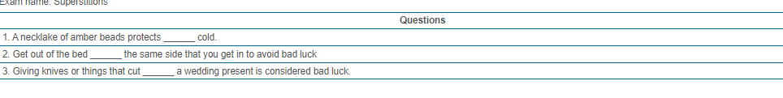

(Figure-110)

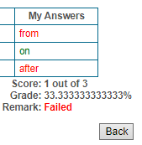

(Figure-111)

**Description**

Calculating the overall score of correct answers and grade percent the student passed.

**Code**

1. <?php
2. $cnt = 0;
3. $correct = 0;
4. **if** (is_array($data['transaction_dtl'])){
5. **foreach**($data['transaction_dtl'] **as** $row){
6. $cnt++;
7. **if** ($row['israted'] <> 0){
8. $correct += $row['score'];}
9. ?>
10. <?php echo $correct . ' out of ' . $data['exam_name'][0]['passing_score']; ?>
11. <?php  $grade = ($correct/$data['exam_name'][0]['passing_score']) * 100 ;
12. echo $grade.'%';
13. ?>

**Denying an Access**

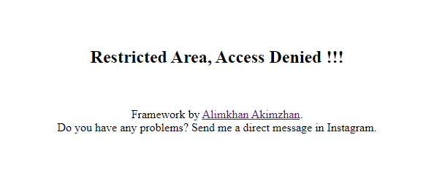

(Figure-112)

**Description**

Not to allow the access for users, who don’t have any access to exact catalogue or direct requesting the files.

**Code (.htaccess)**

1. #Anyone who wants to open configuration script of database (**as** example) of the site can`t get an access to direct request of the file.
2. <FilesMatch "config.php">
3. Order Deny,Allow
4. Deny from all
5. </FilesMatch>
7. #Doesnot show the catalog of accessable files **if** the file exists.
8. Options -Indexes
10. #If in the URL-area, the mistake is made
11. ErrorDocument 403 /_ERRORS/index.php

**Redirecting to an Error Page**

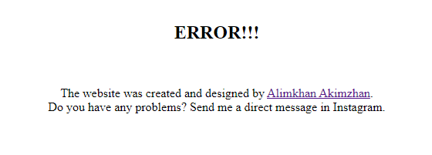

(Figure-113)

**Description**

Redirect to an error page if the path in the URL isn`t existed

**Code (.htaccess)**

1. #If the page is not found
2. ErrorDocument 404 /_ERRORS/error404.php

## (iii) Testing

**Test plan**

1. Plan a test strategy.
2. Provide testing for client and user.
3. Receive a test evidences from client and user.

**Test strategy**

The test plan is based on the testing method called black box. To use it, user has to enter the sets of inputs which can be considered as typical, erroneous or extreme values. Then according to the comparison of the expected result with the output values the result of the test will be given. If they are same, the test is passed and the website is working with no errors, else, it means that the system should be debugged and fixed. The result of a black box test is given in the Table below.

Table-16.

|  |  |  |  |  |  |
| --- | --- | --- | --- | --- | --- |
| **Test№** | **Description** | **Data type** | **Expected result** | **Pass/Fail** | **Reference** |
| **T1** | The website can be opened in the different web browsers | 1.Typical-the layouts are loaded with no errors and problems | 1.The website is opened in Google Chrome  2. The website is opened in Mozilla Firefox | Pass  Pass | T1 1.1  T1 1.2 |
| **T2** | Users can sign-up | 1.Typical-try to sign up with the valid data  2.Erroneous-try to submit the form of registration with empty inputs  3.Erroneous- try to submit the form of registration with the same username as one which already exists  4.Typical- encrypting the password into MD5 encrypting algorithm | 1. New user is added into the database  2. Website alerts the success message  1. Website shows the warning message that tells to fill in the fields  1. Website alerts the error with message which tells that there is user whose username is same  1. The data saved in database is encrypted | Pass  Pass  Pass  Pass  Pass | T2 1.1  T2 1.2  T2 2.1  T2 3.1  T2 4.1 |
| **T3** | Users can login the panels | 1.Typical – authenticate with the credentials that exist in the database  2.Erroneous-login with not filled inputs  3.Erroneous-login with using credentials of user who does not exist in the system | 1.The user is redirected to the panel (Admin or Student)  1.Website shows error with message, telling “incorrect username or password”  1. Website shows error with message, telling “incorrect username or password” | Pass  Pass  Pass | T3 1.1  T3 2.1  T3 3.1 |
| **T4** | Taking an exam | 1.Typical- choose the options during the exam and submit them  2.Erroneous- do not choose any options and try to submit | 1. The next question is shown  2. After all questions, the website shows success message  1. Website shows the message telling to choose the answer | Pass  Pass  Pass | T4 1.1  T4 1.2  T4 2.1 |
| **T5** | Adding new user | 1.Typical-add new user using valid data about him  2. Erroneous-try to submit the form with empty fields | 1. The new user is added into the database  1. Website shows the message telling that input fields are empty | Pass  Pass | T5 1.1  T5 2.1 |
| **T6** | Edit the users’ accounts | 1.Typical-edit with the correct and valid inserts  2.Erroneous-submit the form with empty fields  3.Extreme- submit the form with the value in the maximum border of the input | 1. The new values are saved in the database  1. Website shows the message telling that input fields are empty  1. The new values are saved in the database | Pass  Pass  Pass | T6 1.1  T6 2.1  T6 3.1 |
| **T7** | Adding new department level | 1. Typical-submit the form with the valid data  2.Erroneous-submit the form with the empty input fields  3. Erroneous- submit the form with the value in the maximum border of the input | 1. The new department level is added into the system.  1.Website shows the message telling that fields are empty  1. The new department level is added into the system. | Pass  Pass  Pass | T7 1.1  T7 2.1  T7 3.1 |
| **T8** | Editing the details of department levels | 1. Typical-submit the form with the valid data  2.Erroneous-submit the form with the empty input fields  3. Erroneous- submit the form with the value in the maximum border of the input | 1. The details of the certain department level is updated.  1.Website shows the message telling that fields are empty  1. The details of the certain department level is updated. | Pass  Pass  Pass | T8 1.1  T8 2.1  T8 3.1 |
| **T9** | Adding new question in the certain exam | 1.Typical-add new question using valid data | 1. New question is added | Pass | T9 1.1 |
| **T10** | Editing the details of a certain the exam | 1.Typical-submit the form with valid data in the fields  2. Erroneous-try to submit the form with empty fields | 1.The examination details are updated  1.Website shows the message telling that fields are empty | Pass  Pass | T10 1.1  T10 2.1 |
| **T11** | Adding new answer for the certain question | 1.Typical-add new answer using valid data | 1. New answer for a certain question is added | Pass | T11 1.1 |
| **T12** | Editing the answer of a certain the question | 1.Typical-submit the form with valid data in the fields | 1.The answer details are updated | Pass | T12 1.1 |
| **T13** | 1.Getting access to configuration files of site and database.  2.Getting access to full catalog of files of the site.  3.Opening the path, which are not exists in the system | 1. Typical-the layouts are loaded with no errors and problems  1. Typical-the layouts are loaded with no errors and problems  1. Typical-the layouts are loaded with no errors and problems | 1. The website redirects user to the error page (403)  1. The website redirects user to the error page (403)  1. The website redirects user to the error page (404) | Pass  Pass  Pass | T13 1.1.1  T13 2.1.1  T13 3.1.1 |
| **114** | Calculating the score of the exam the user had taken. | 1. Typical-calculating the number of correct answers the student had  2. Typical – calculating the percentage of correct answers out the number of all questions. | 1. The number is counted right.  1. The percentage of grade taken is calculated. | Pass  Pass | T14 1.1  T14 2.1 |

**T1**

1.1. The website is opened with no problems in the Google Chrome browser, all styles and layouts are loaded, also the functions work without errors.

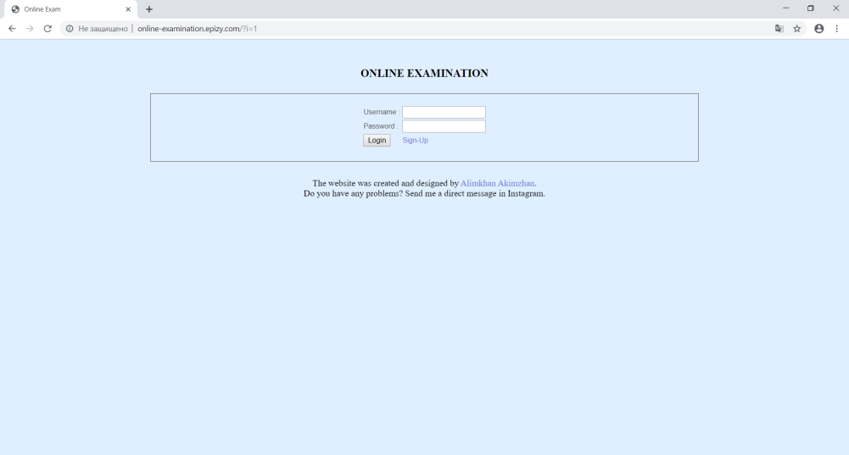

(Figure-114)

1.2. The website is opened with no problems in the Mozilla Firefox browser, all styles and layouts are loaded, also the functions work without errors.

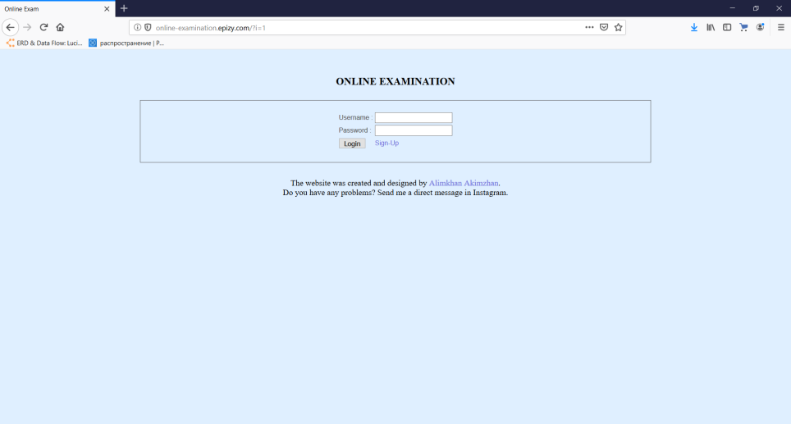

(Figure-115)

**T2**

1.1, 1.2. New user is added into the database and the website shows the success message telling that the user is registered.

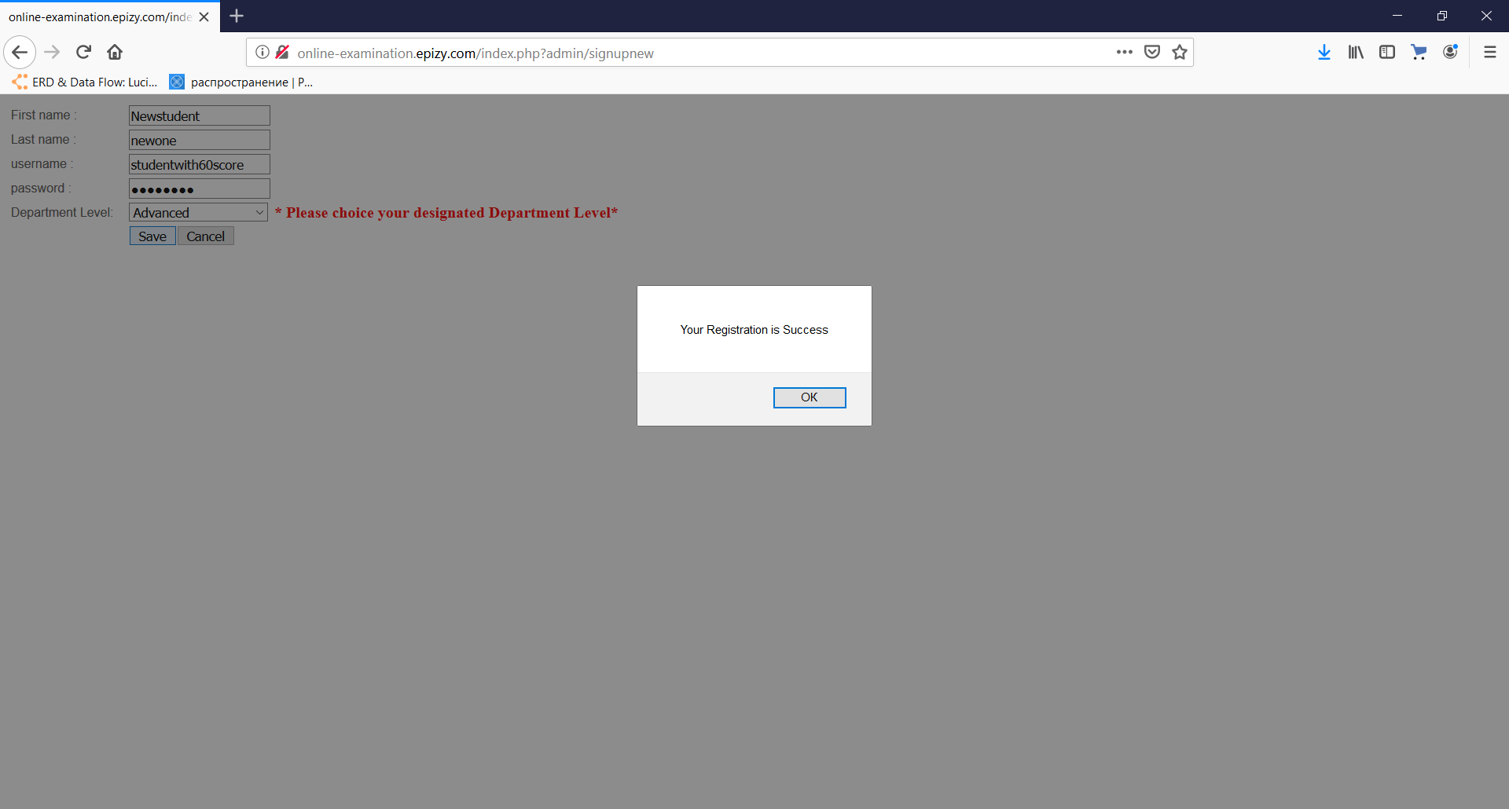

(Figure-116)

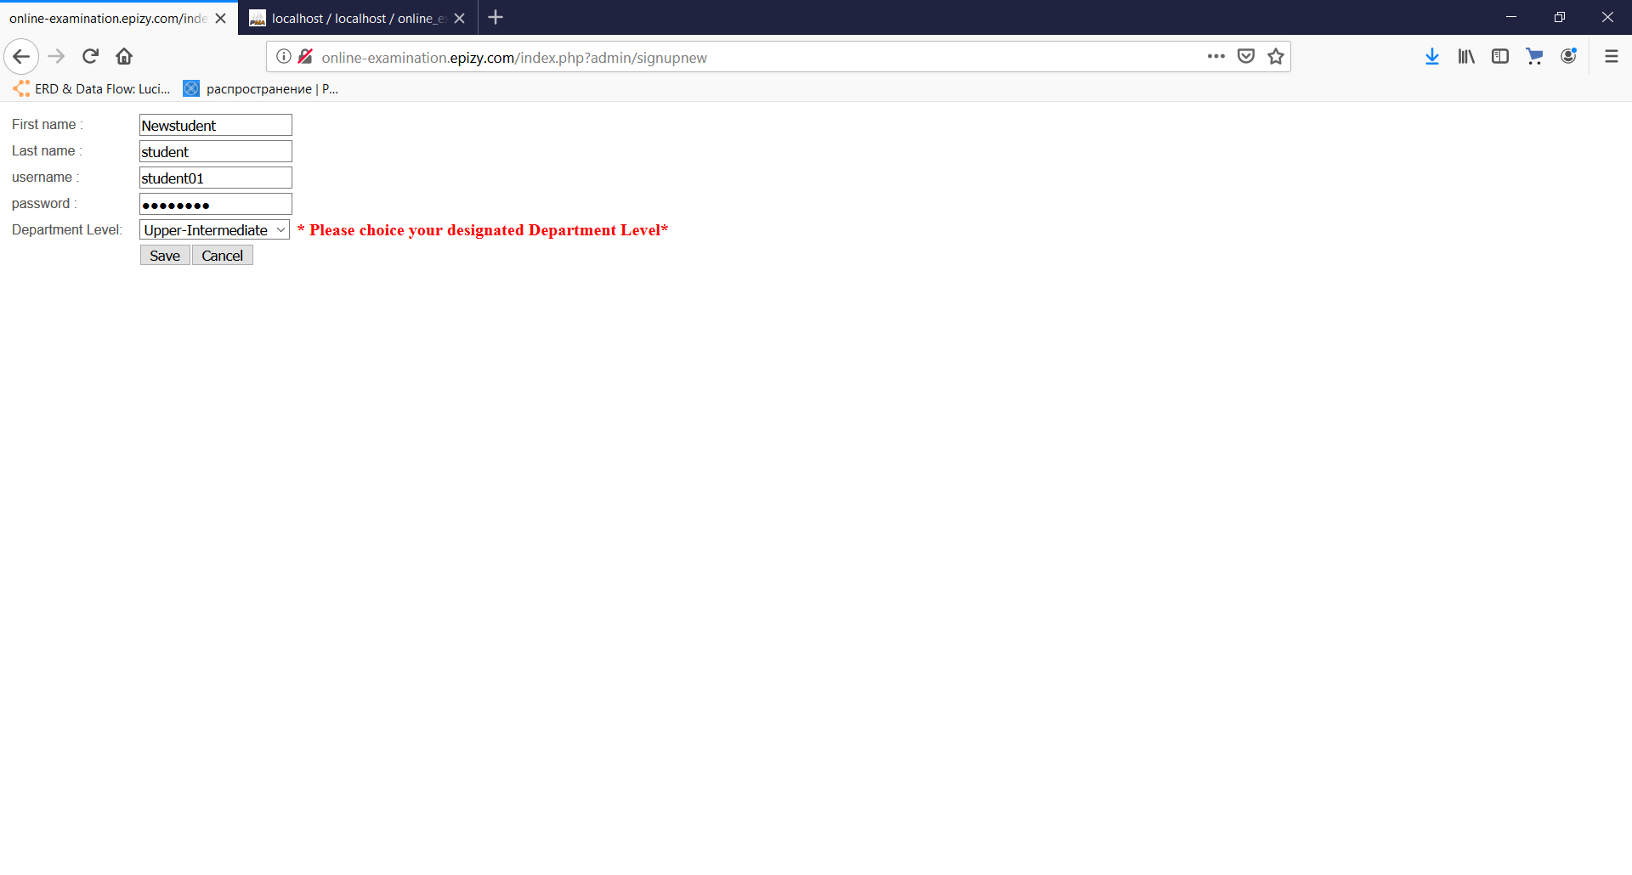

(Figure-117)

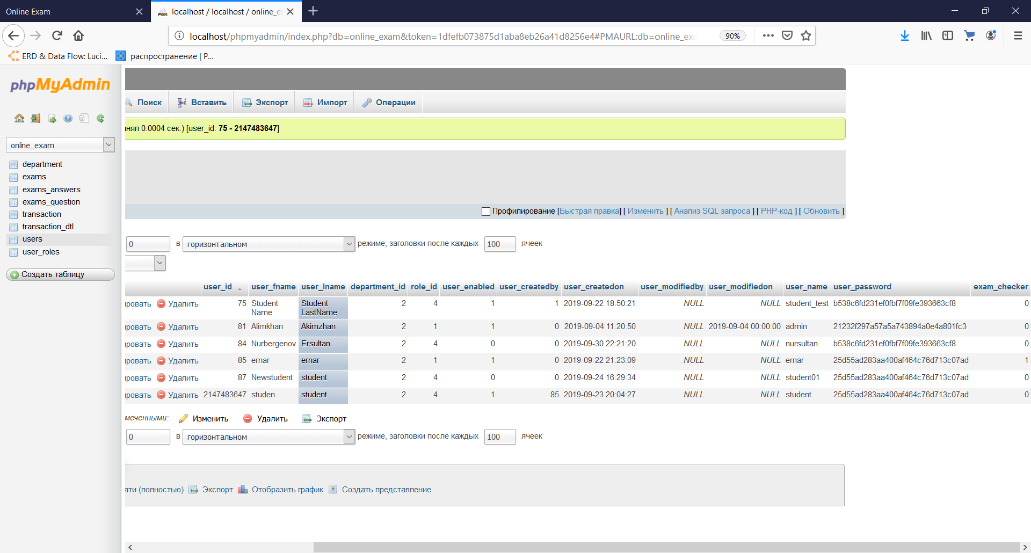

(Figure-118)

2.1. The website shows the message telling that fields are empty when trying to submit the form with empty inputs.

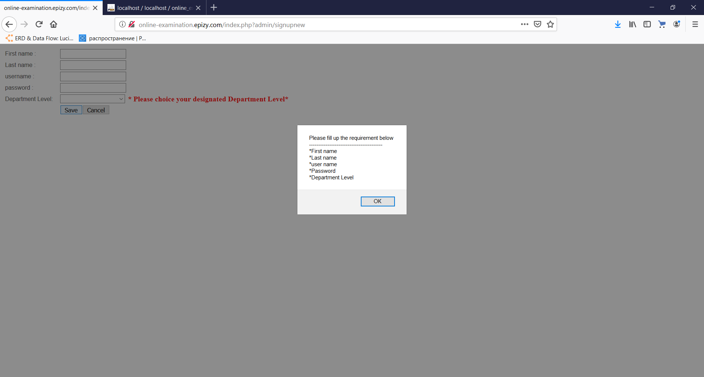

(Figure-119)

3.1. The website shows the message telling that the user with the same username is already exists.

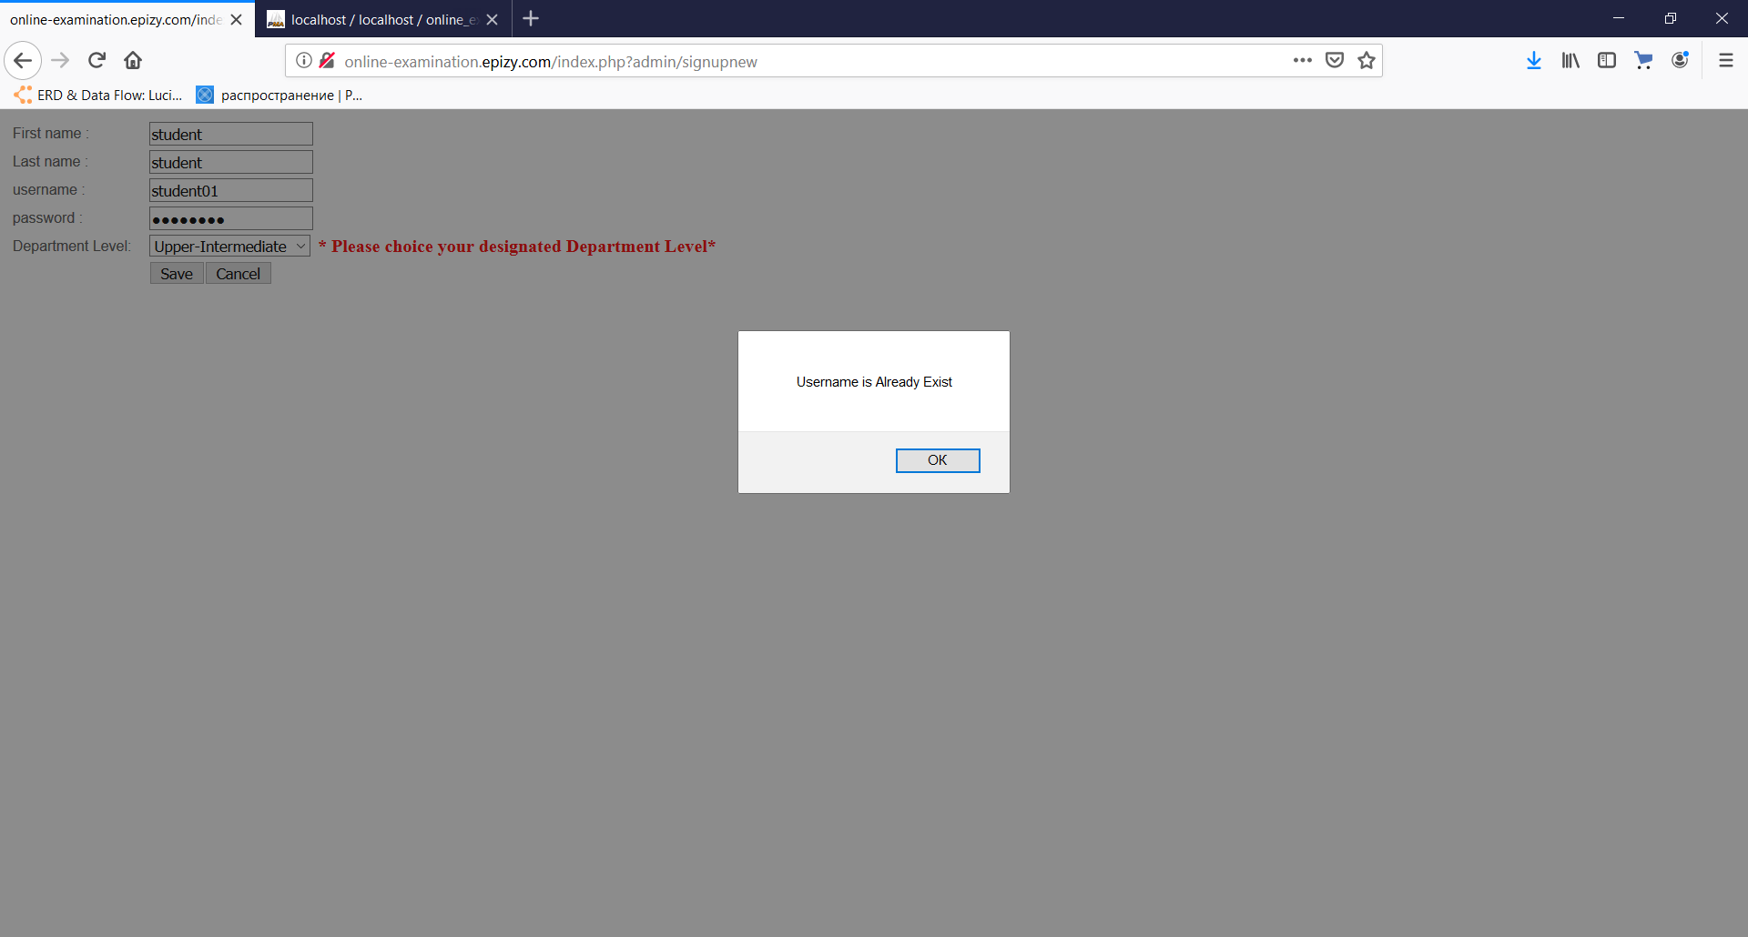

(Figure-120)

**T3**

1.1. The user is redirected to the Admin (teacher) of Student panel when logins with correct credentials

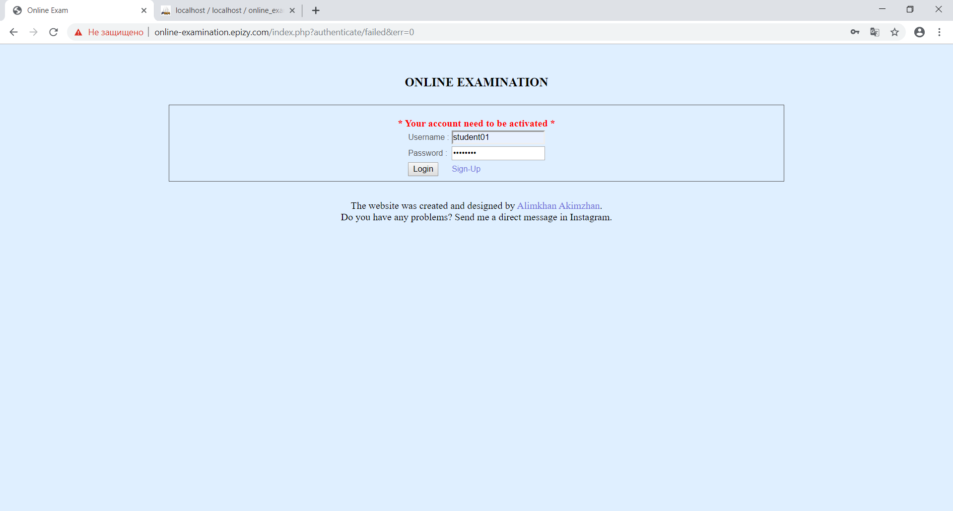

(Figure-121)

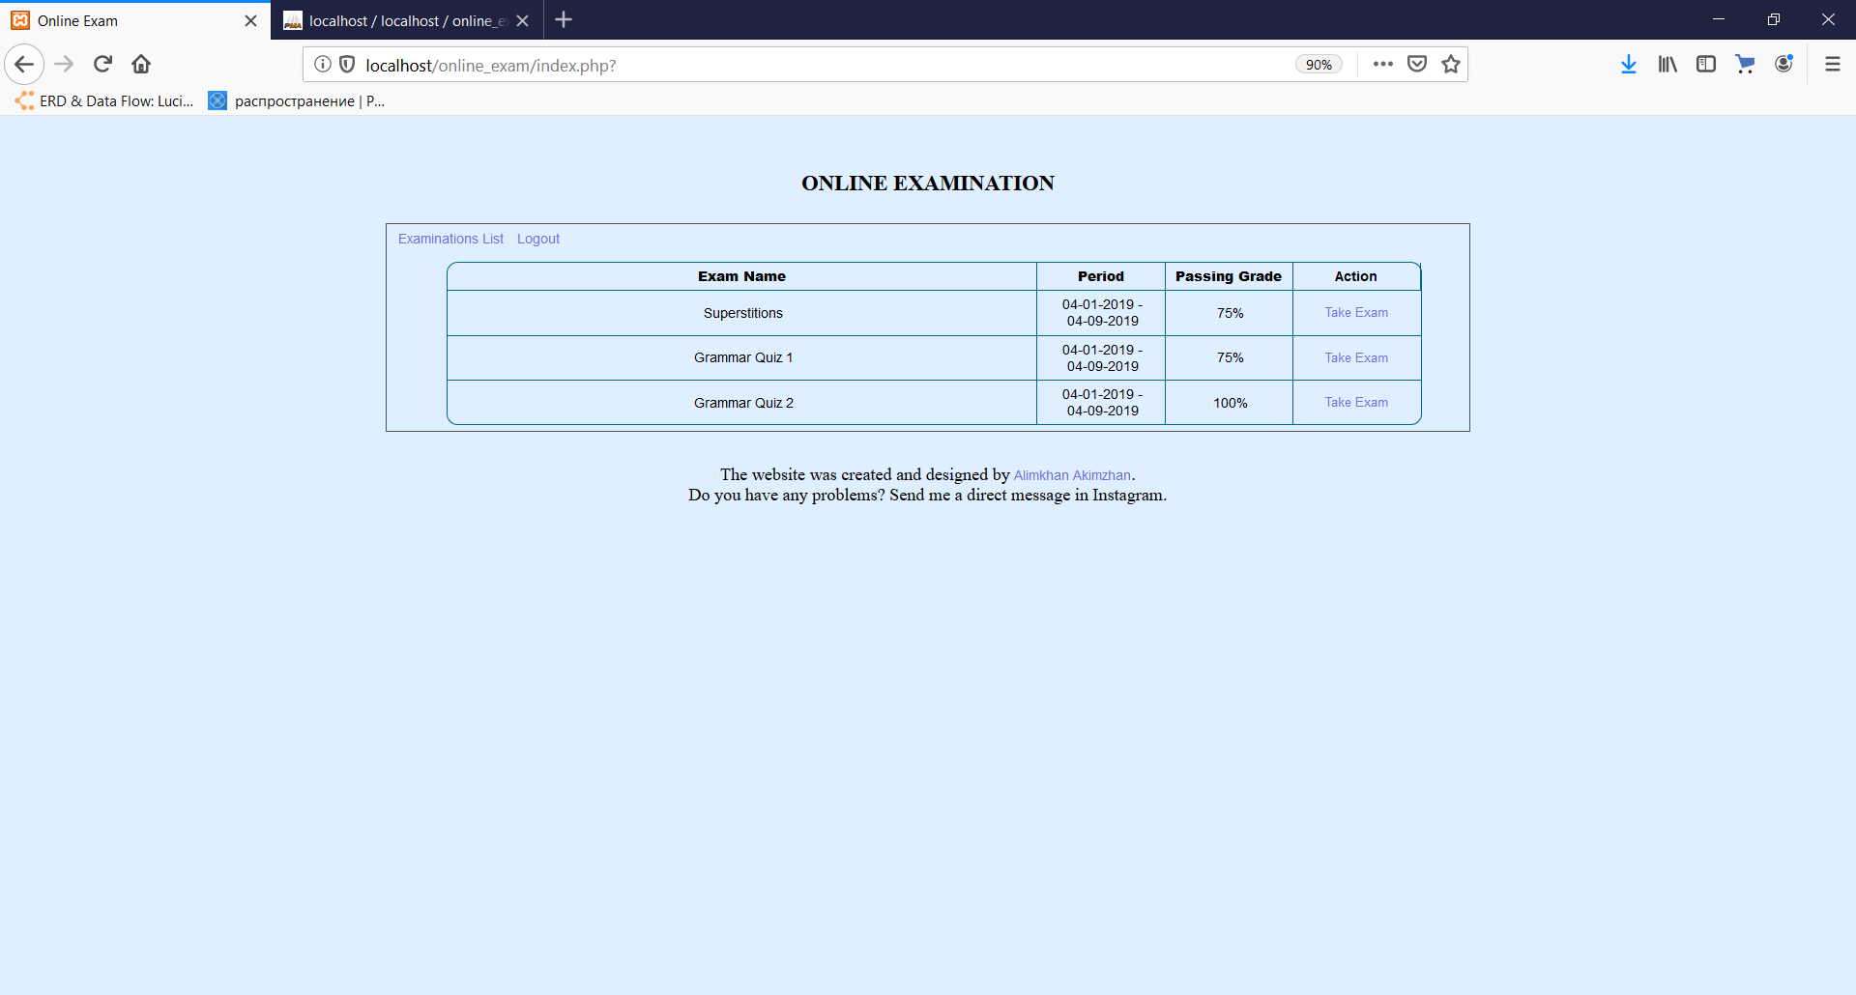

(Figure-122)

2.1, 3.1. When user tries to login with empty fields or with the credentials which do not exist in the database, the website shows an error telling that the username or password is incorrect.

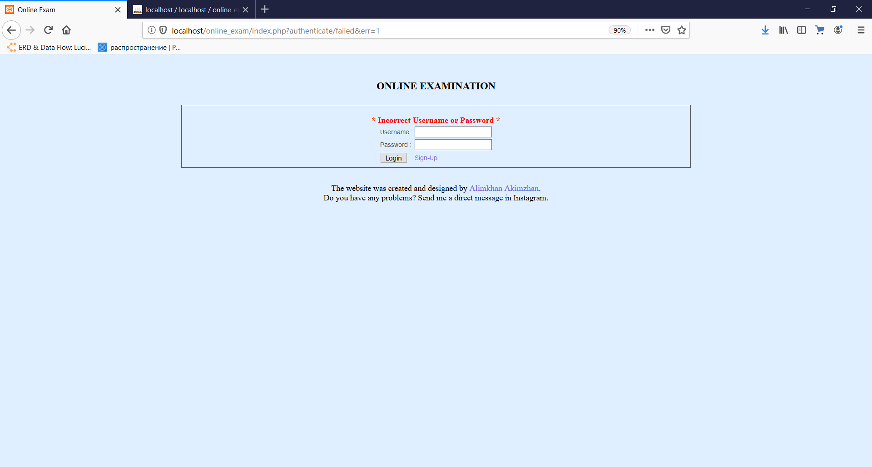

(Figure-123)

4.1 The password which a user entered into a password holder was encrypted into MD5 encryption algorithm.



(Figure-124)

**T4**

1.1, 1.2. When the student takes an exam, he enters the answers by choosing the options in multiple-choice questions. By submitting the answers, he moves to the next one. And when all questions are answered the website shows a message telling that this is the end of the exam.

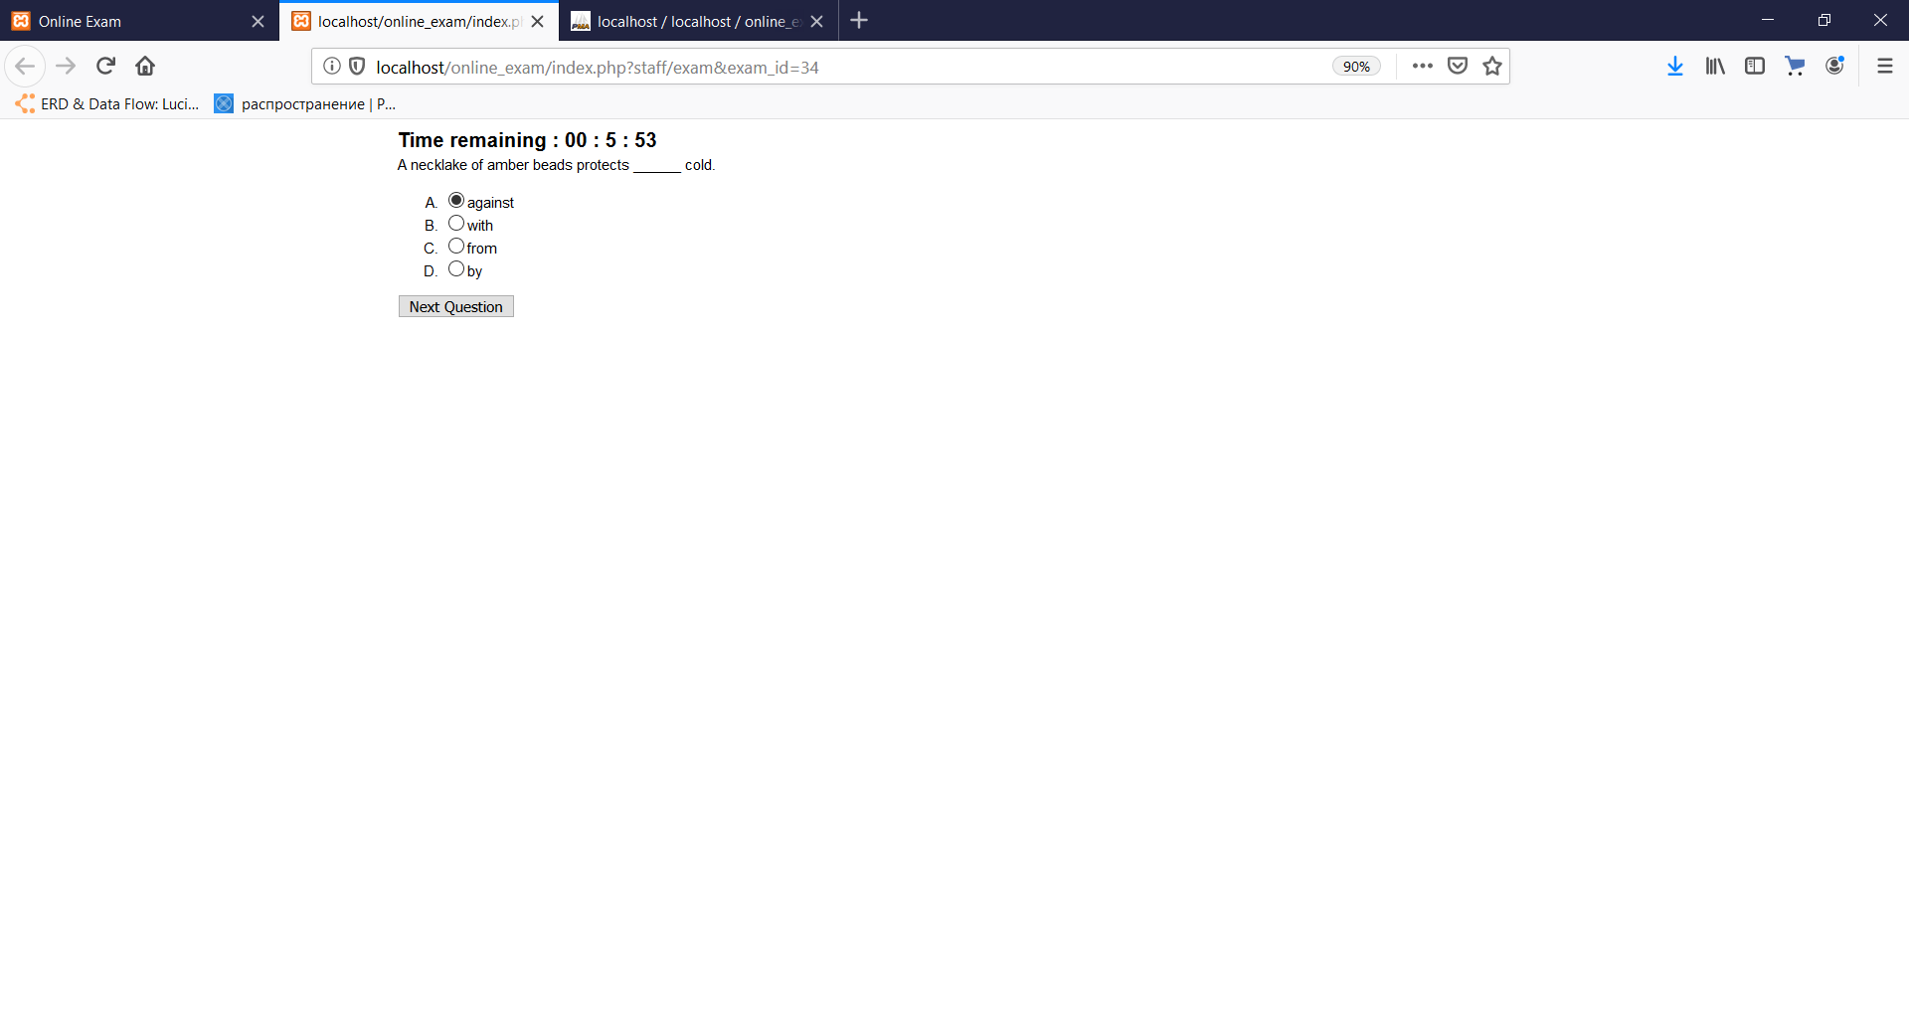

(Figure-125)

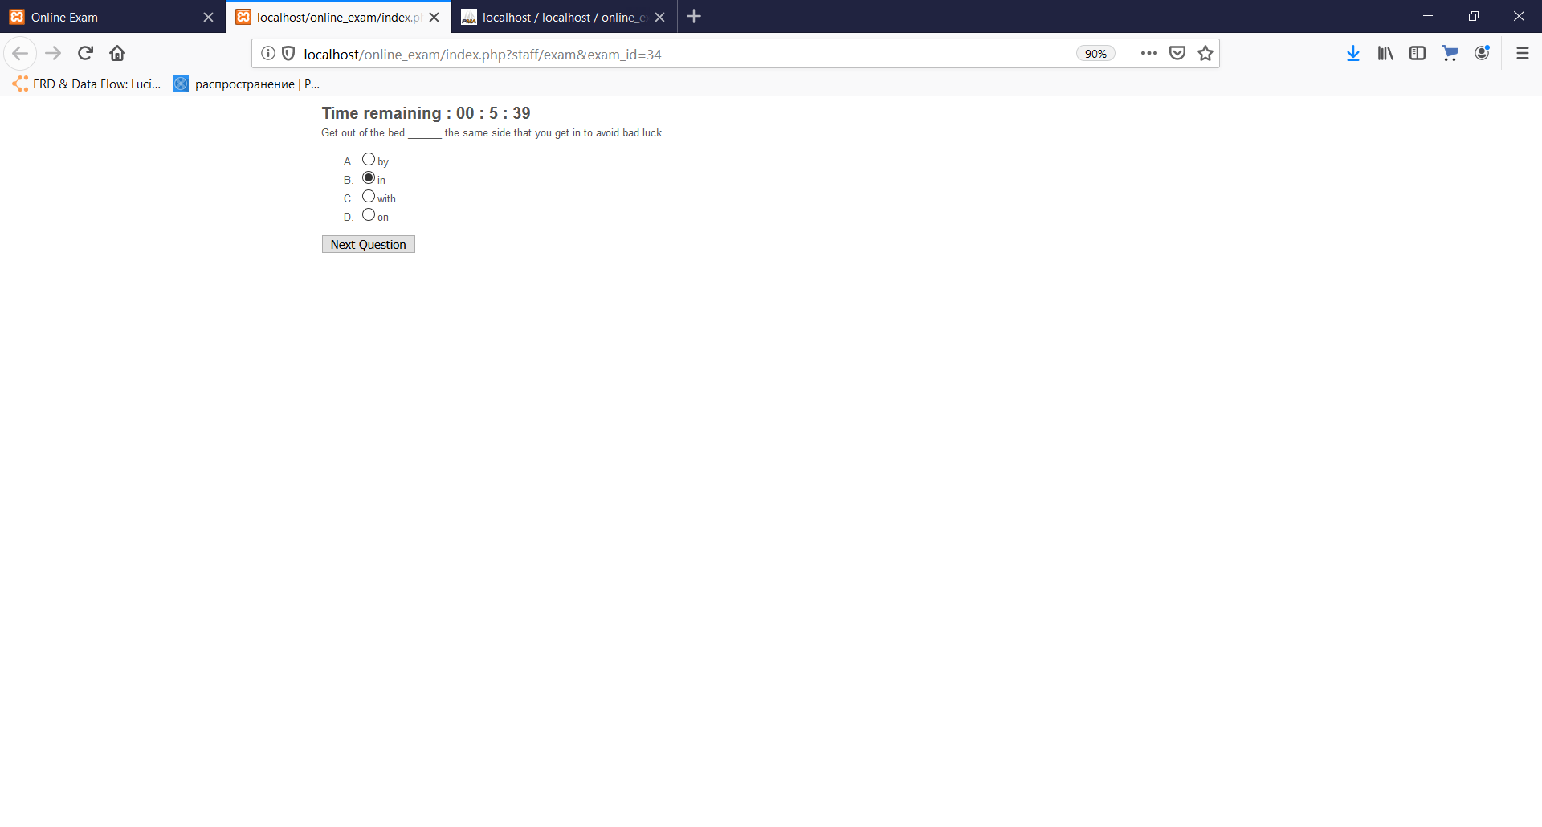

(Figure-126)

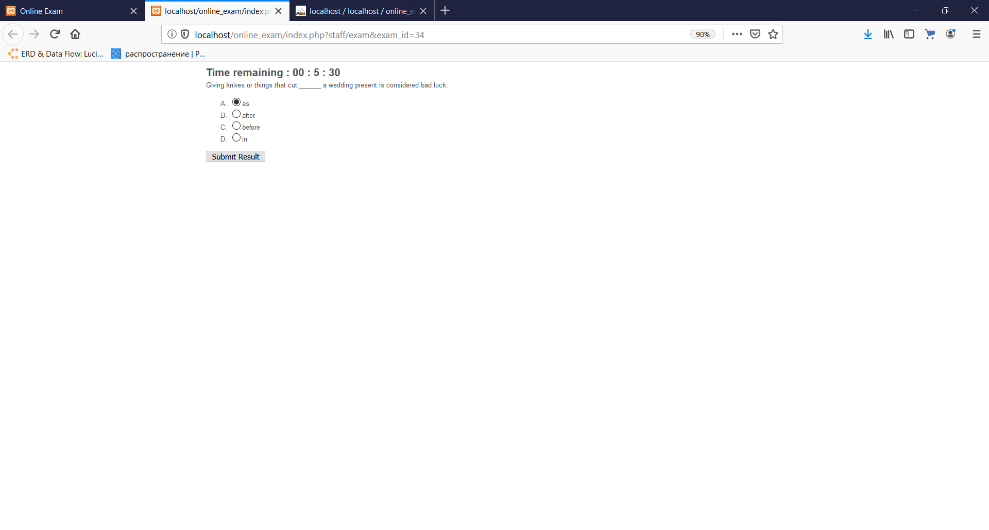

(Figure-127)

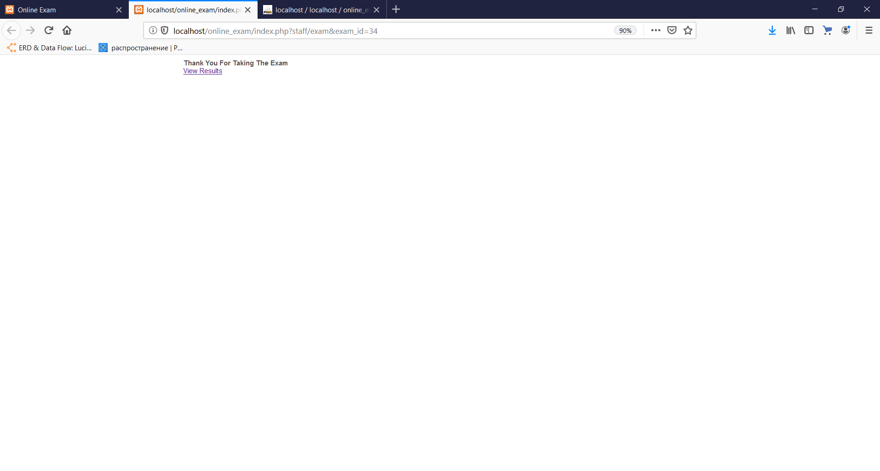

(Figure-128)

2.1. The website alerts a warning message, telling to choose one of the given options to answer the question.

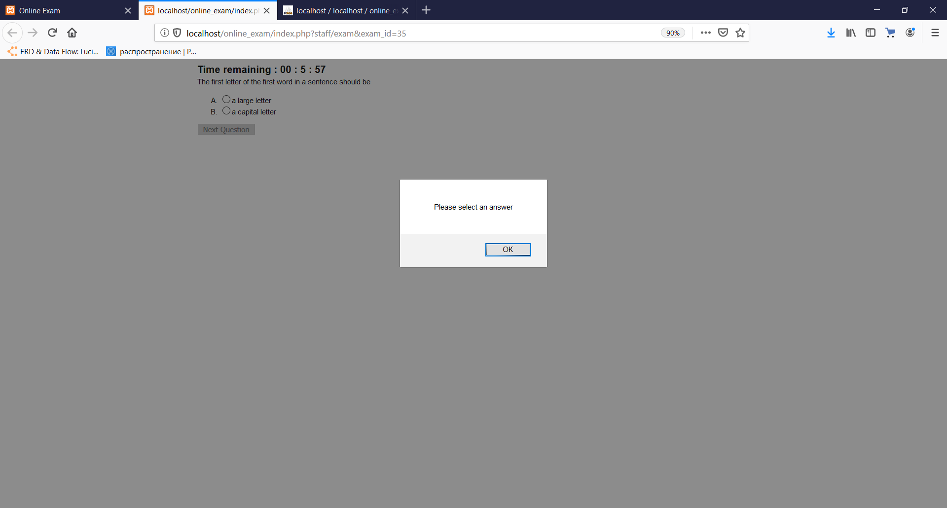

(Figure-129)

**T5**

1.1. New user added into the database when admin adds new user in the system.

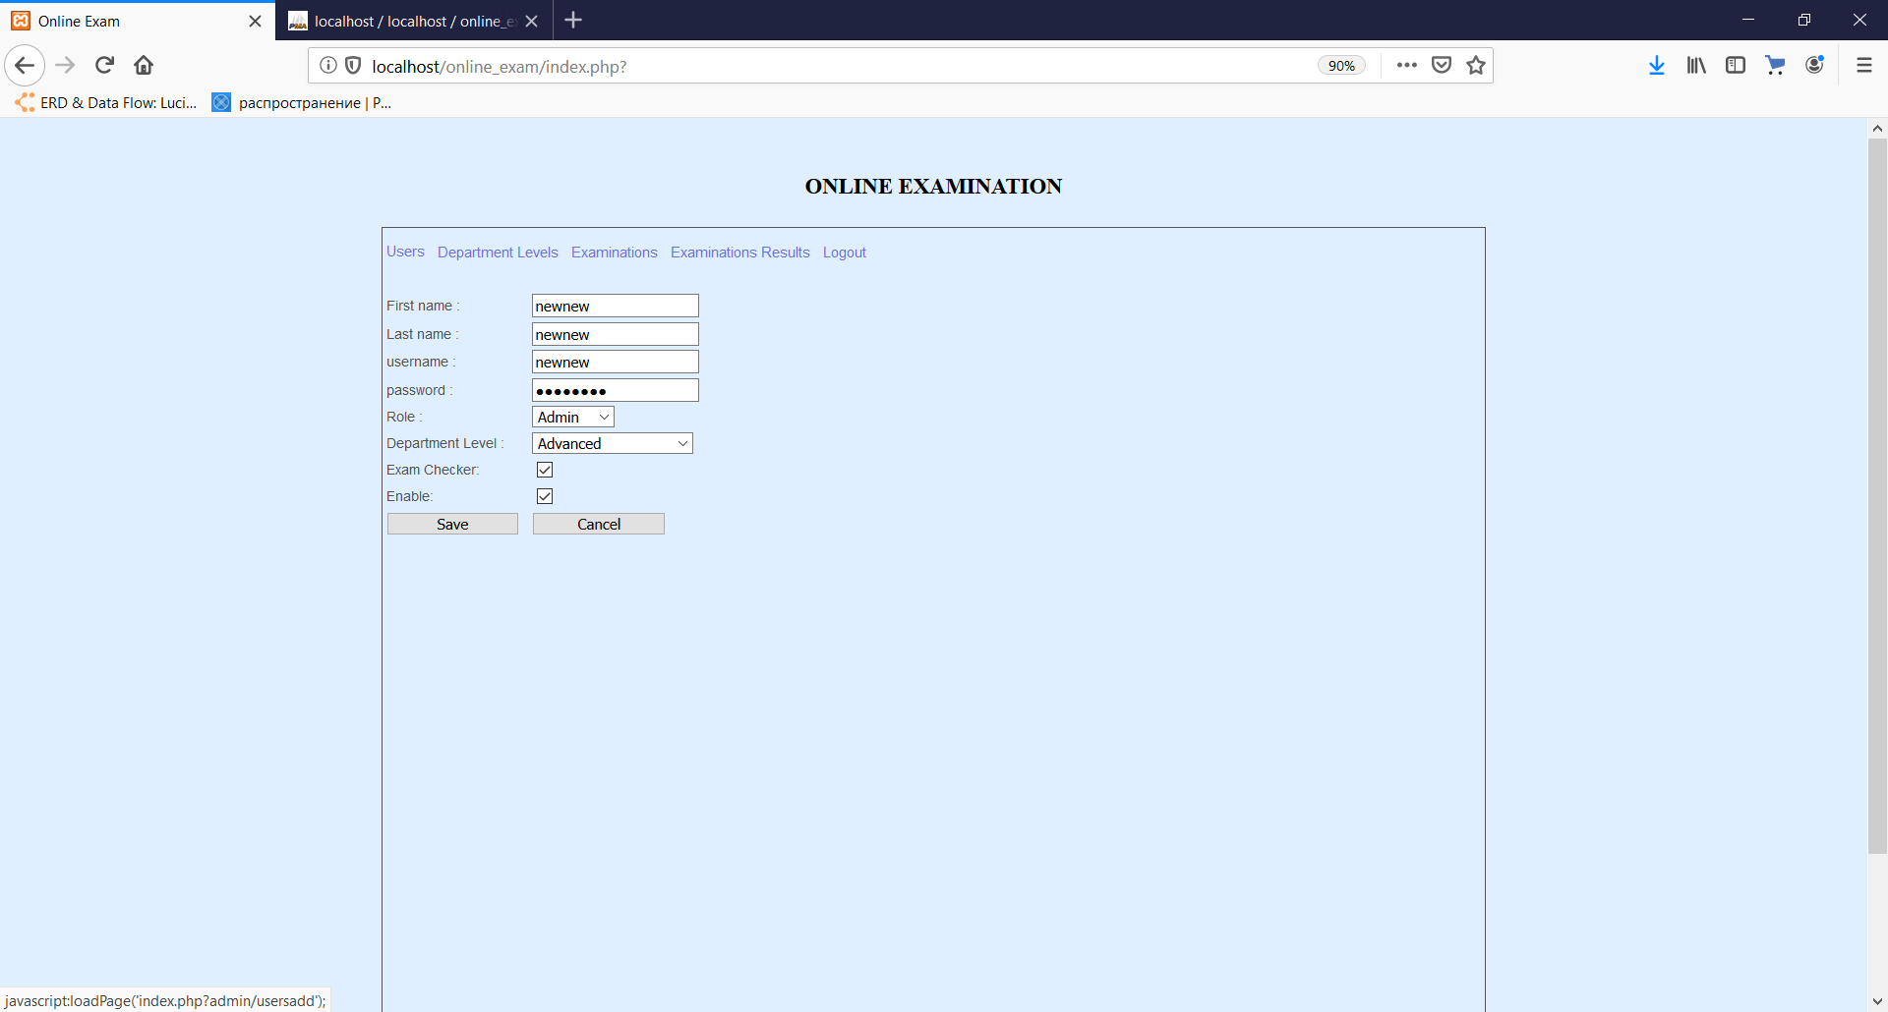

(Figure-130)

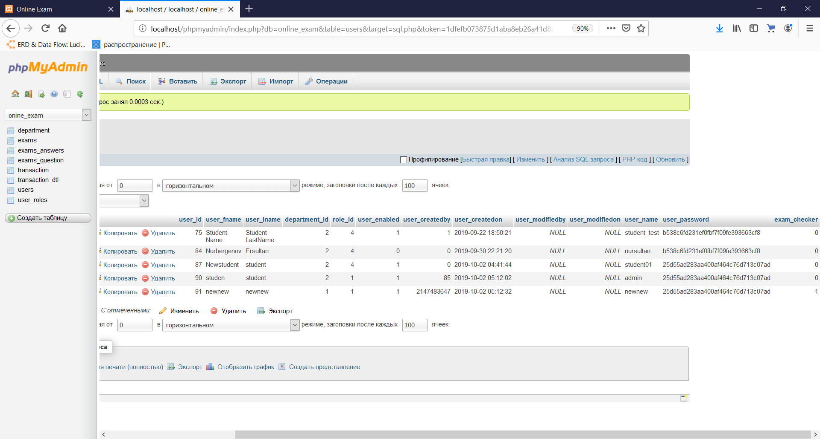

(Figure-131)

2.1 Calling the message that some areas are empty and must be inputted.

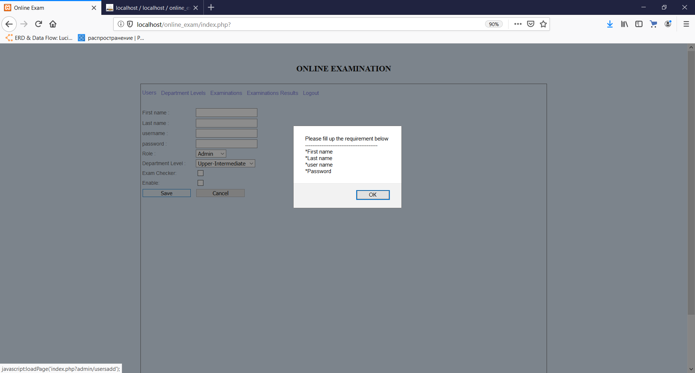

(Figure-132)

**T6**

1.1, 3.1. The details of the user are updated when user submits the form with inputs filled with valid data or values lying on the maximum borders of numbers of characters.

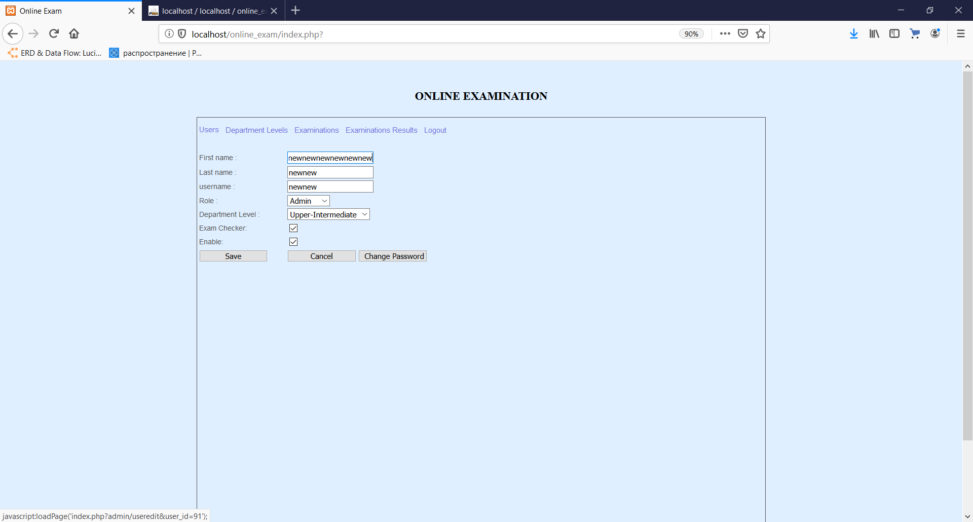 

(Figure-133)

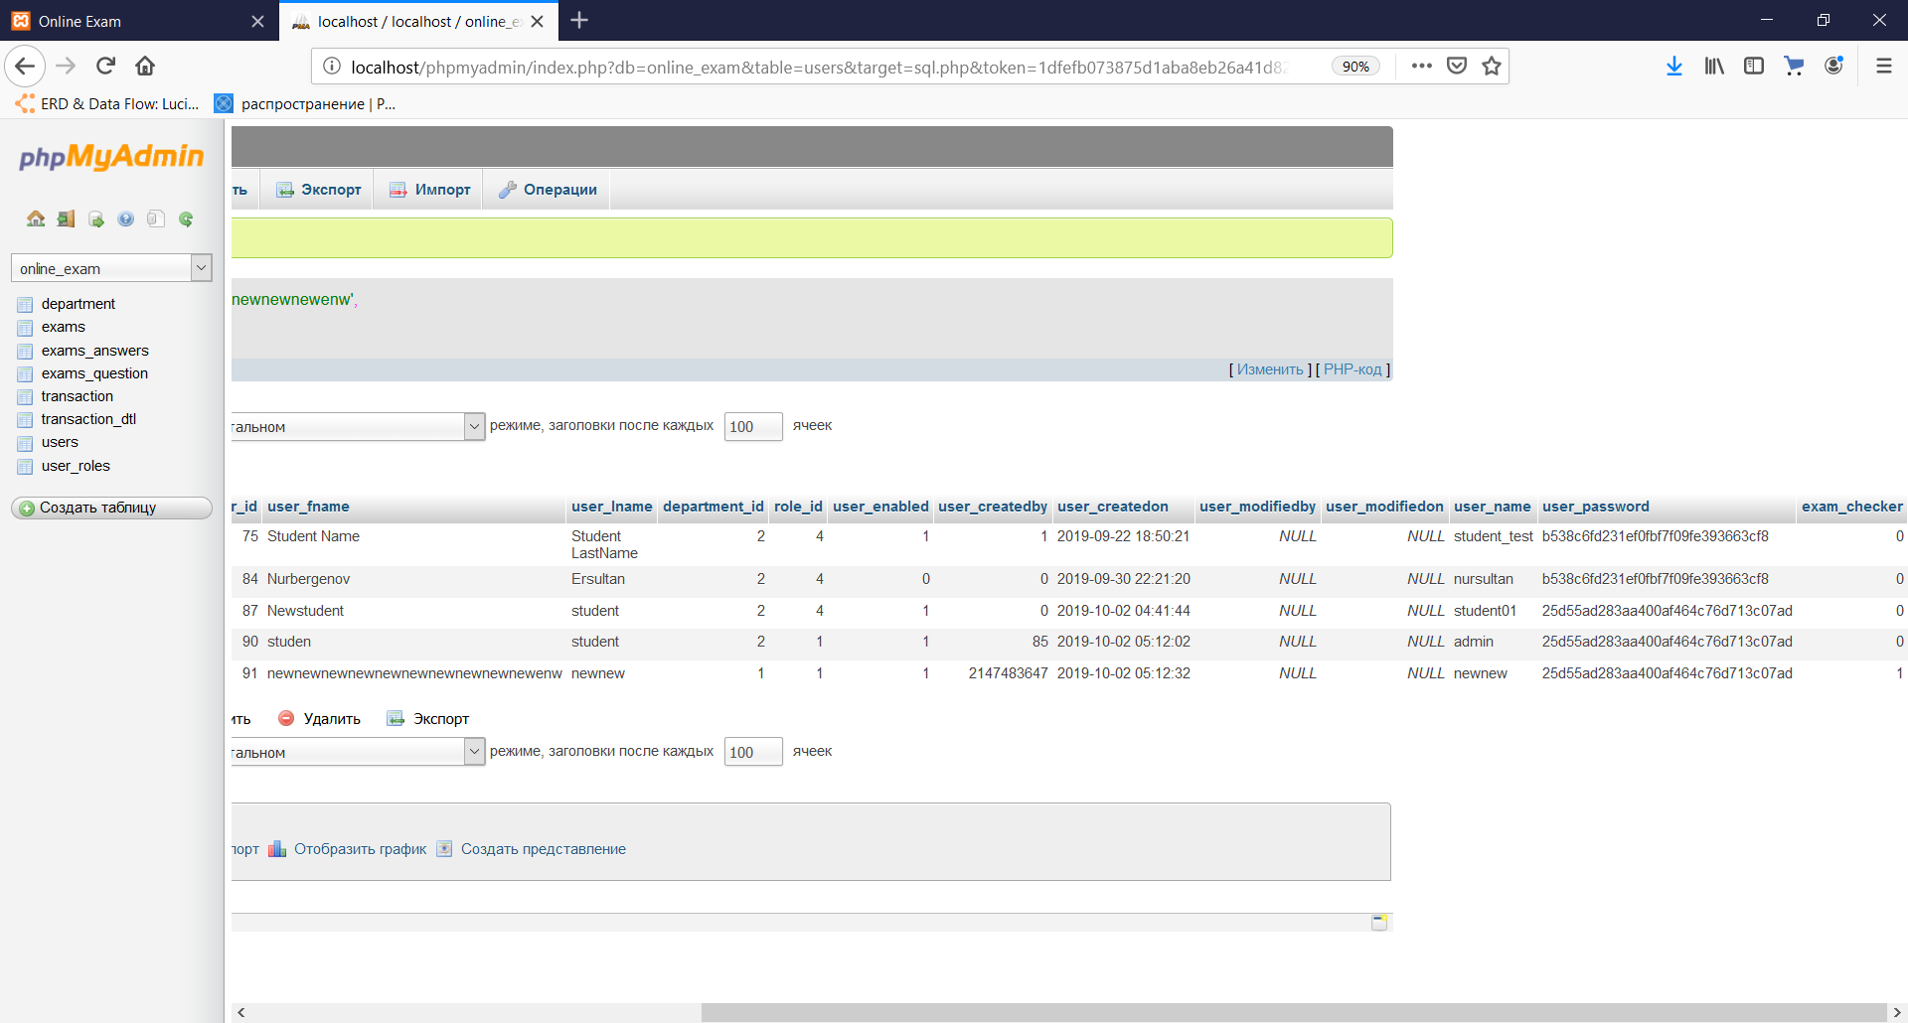

(Figure-134)

2.1. Website shows the warning telling to fill the input fields when user tries to submit the form of editing the user with empty fields

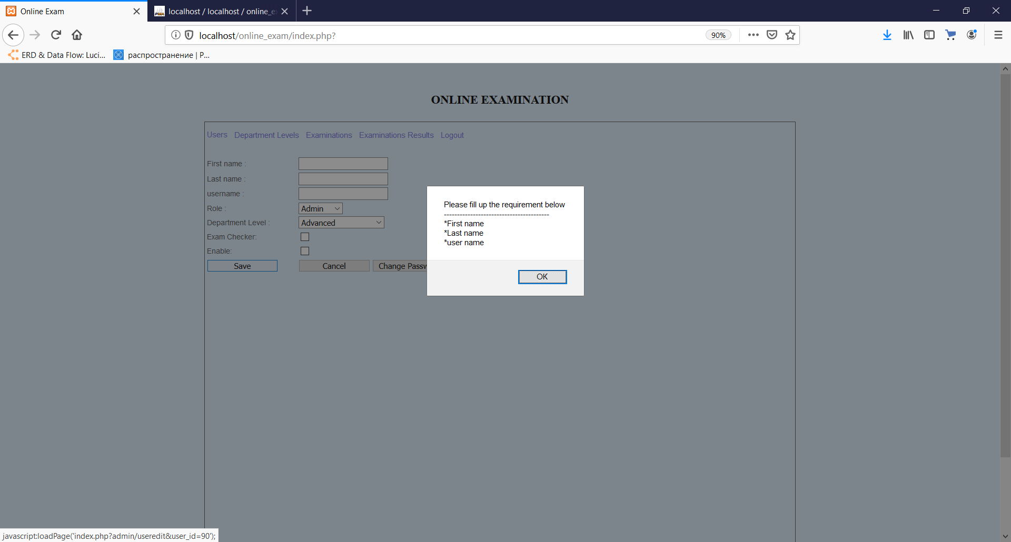

(Figure-135)

**T7**

1.1, 3.1. New department level is added into the database when user submits the form of adding the department level using valid data or values lying on the maximum border of characted numbers.

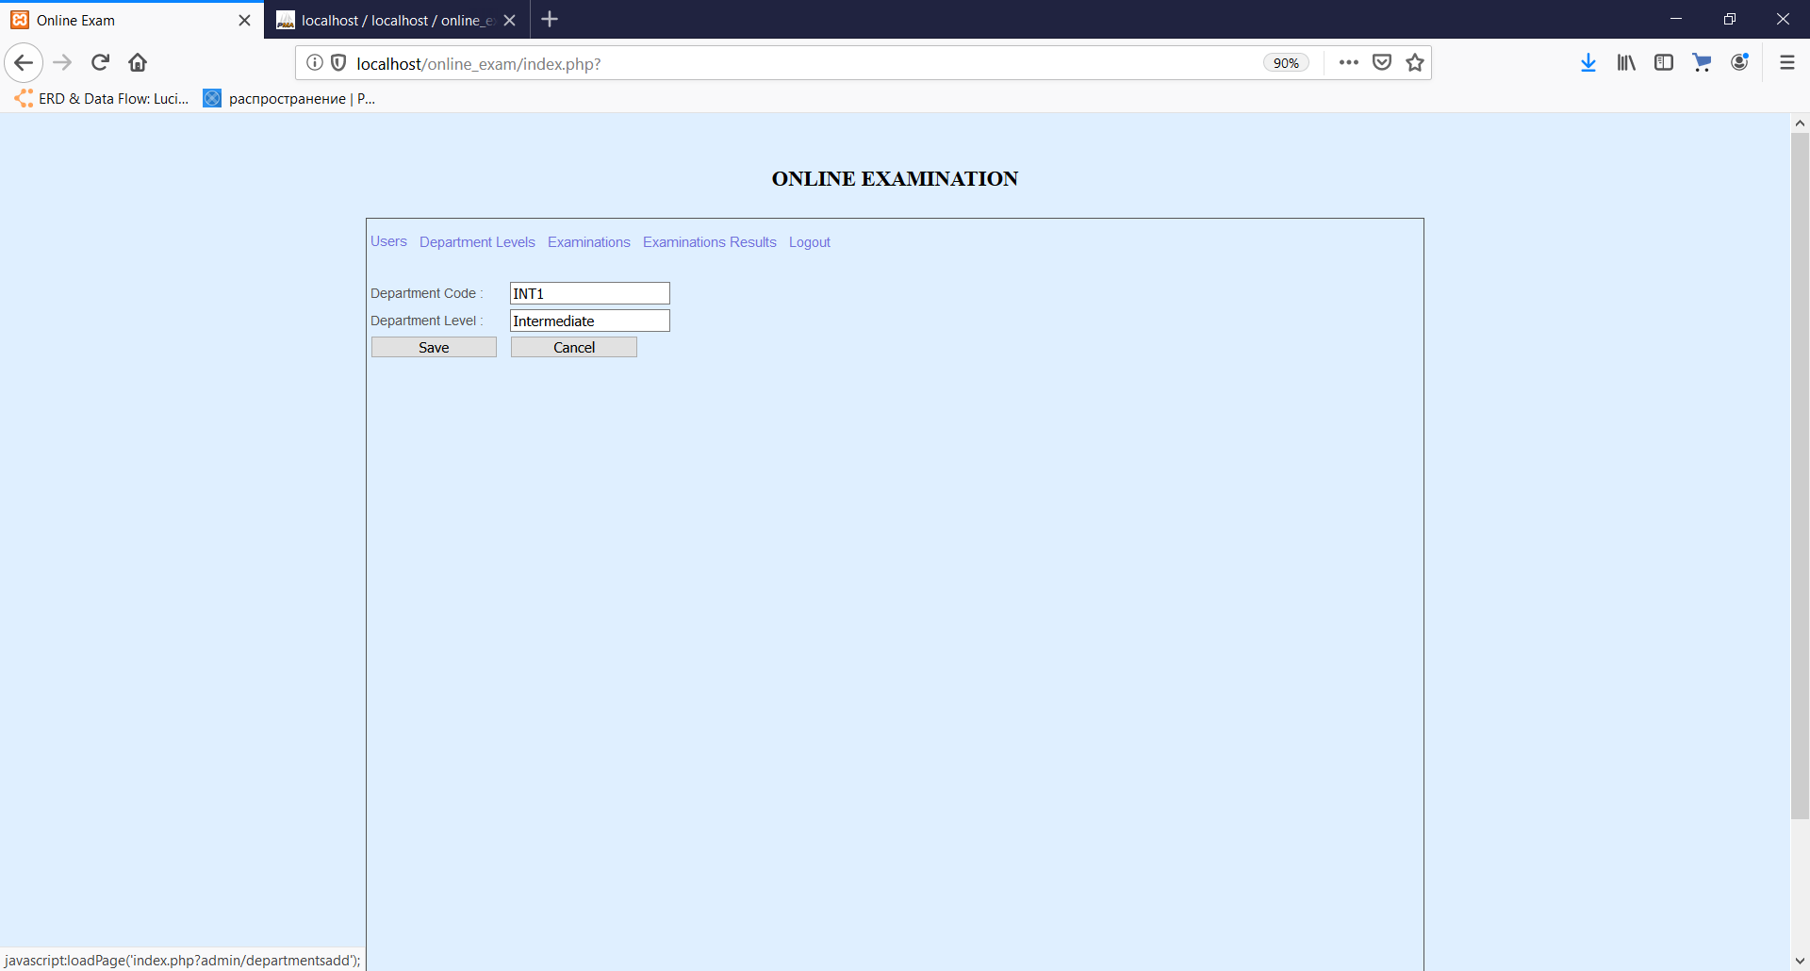

(Figure-136)

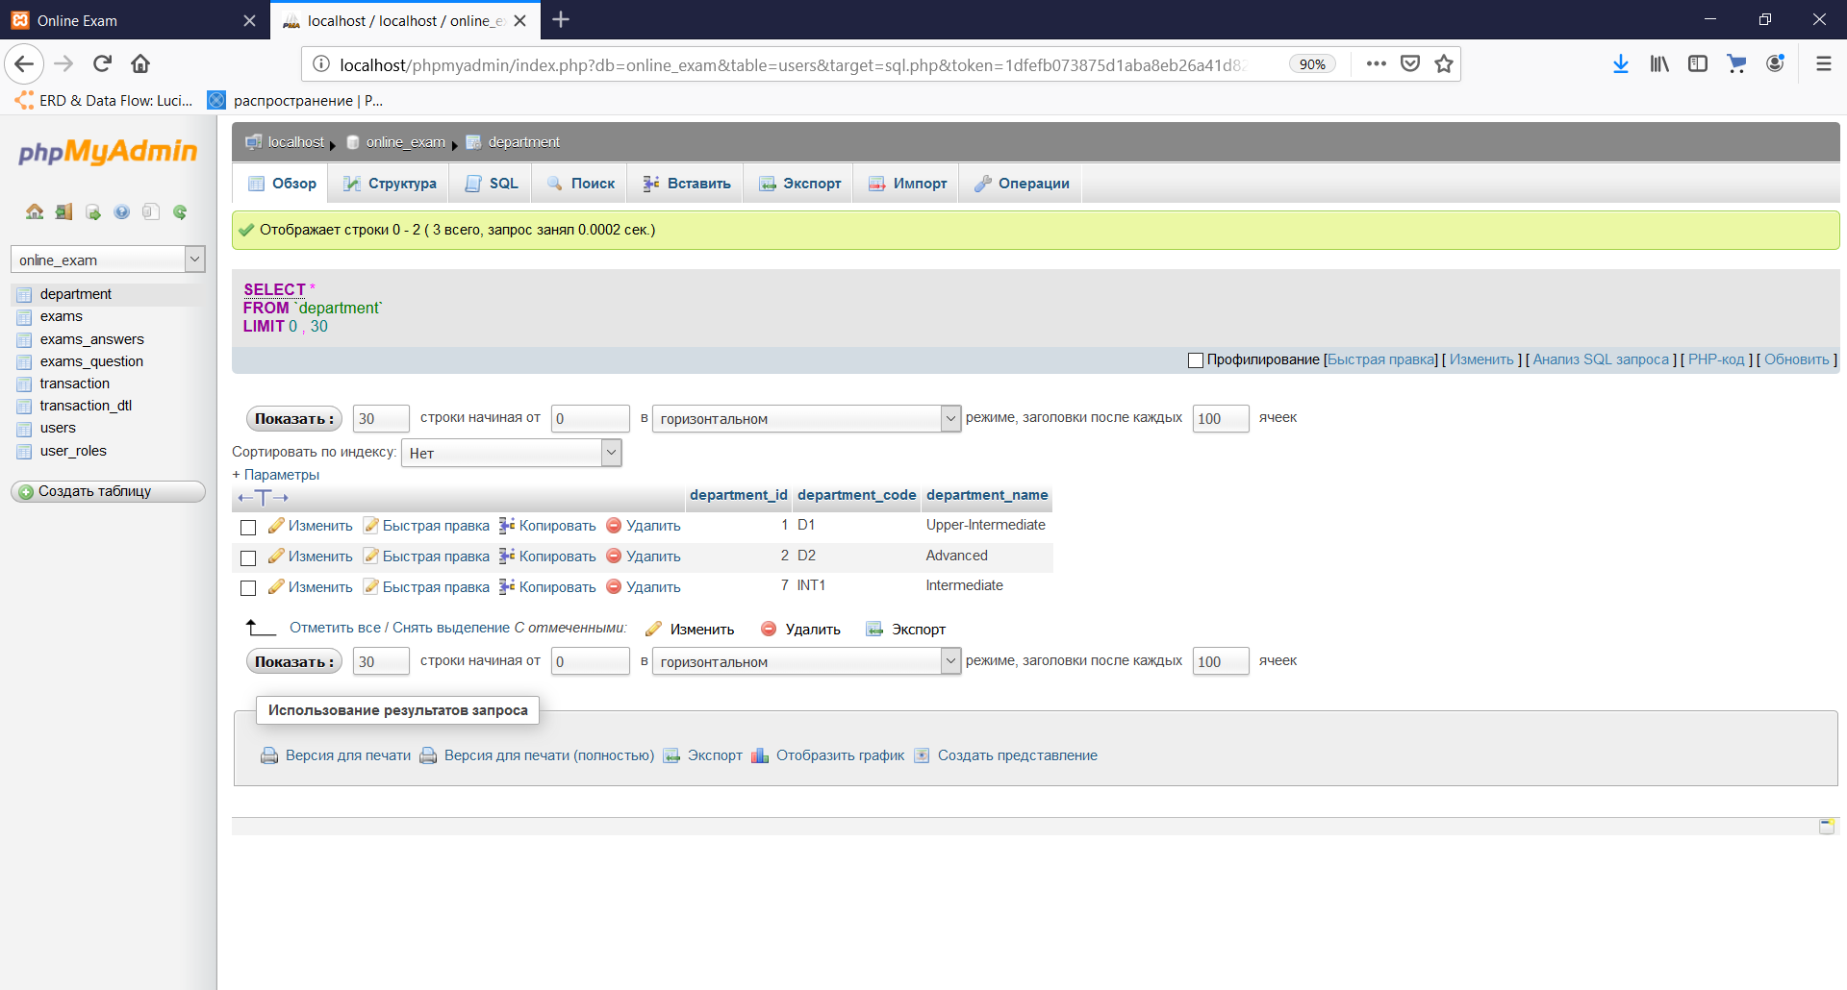

(Figure-137)

2.1. When user tries to submit the form of adding new department level with empty inputs the system shows a message warning that some of fields are empty and asking to fill them.

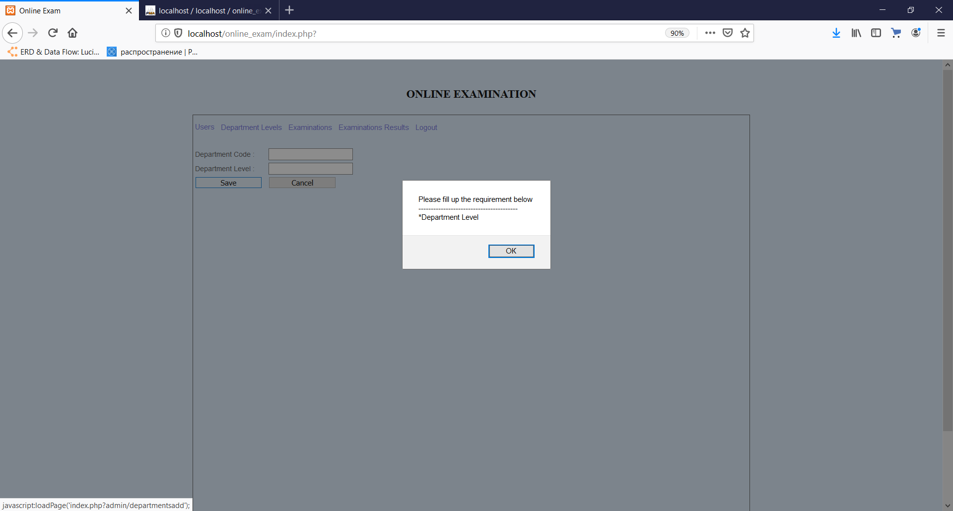

(Figure-138)

**T8**

1.1, 3.1. The details of the certain department level are edited when the valid data or data that lies on the maximum border of character number is entered in the inputs of the editing department level field.

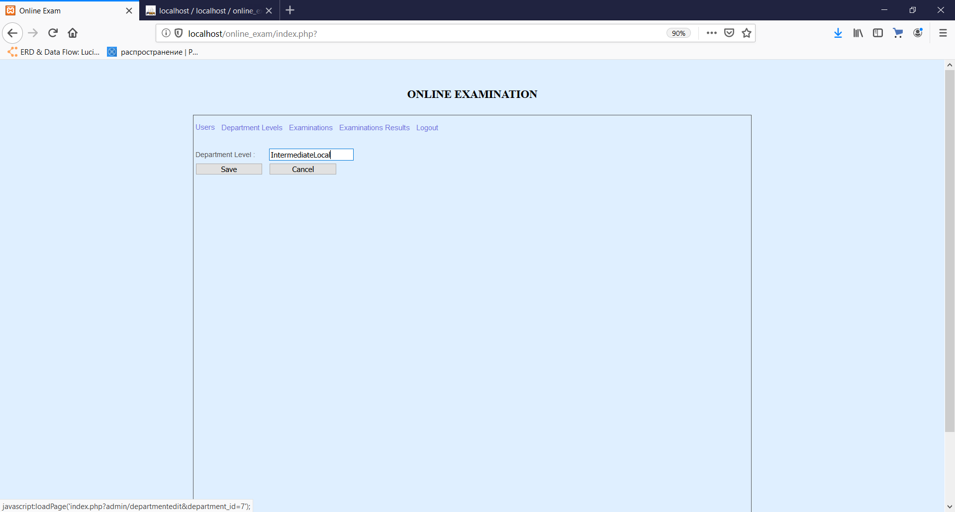

(Figure-139)

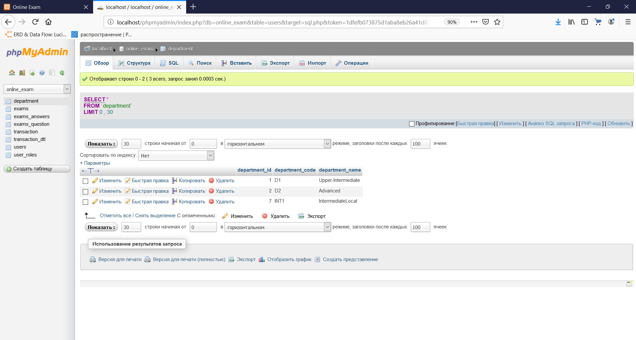

(Figure-140)

2.1. When user tries to submit the form of editing the certain department level with empty inputs the system shows a message warning that some of fields are empty and asking to fill them.

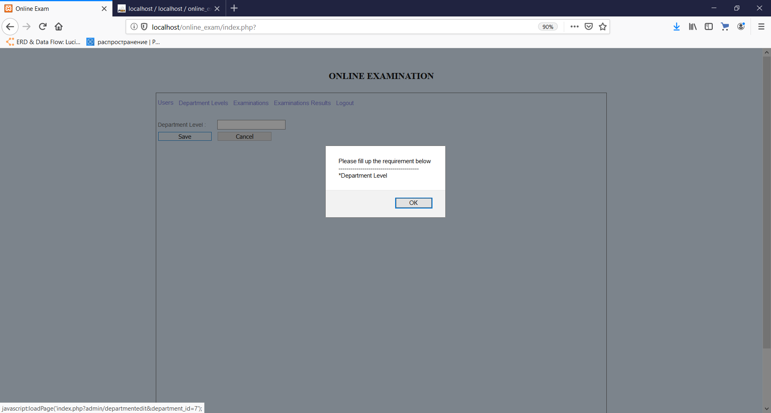

(Figure-141)

**T9**

1.1. New question of a certain exam is added into the database when admin adds new question in the system.

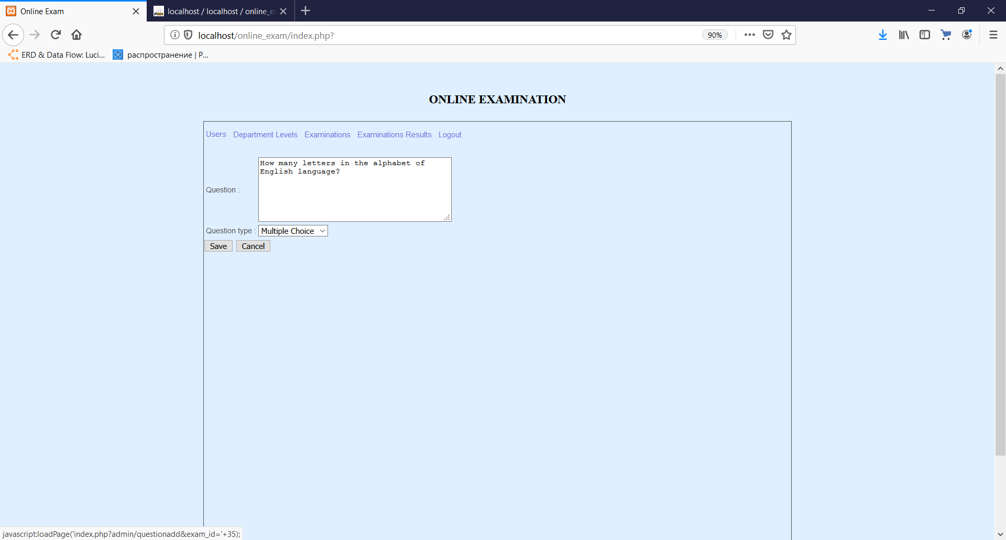

(Figure-142)

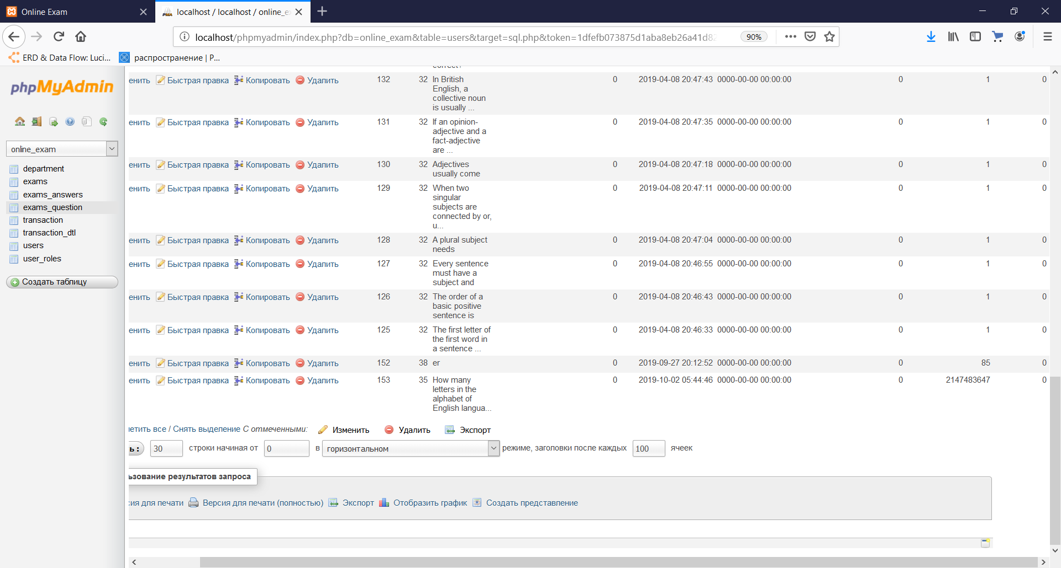

(Figure-143)

**T10**

1.1. The details of a chosen exam are updated when user enters the valid data and submits the form of editing the exam with filled inputs.

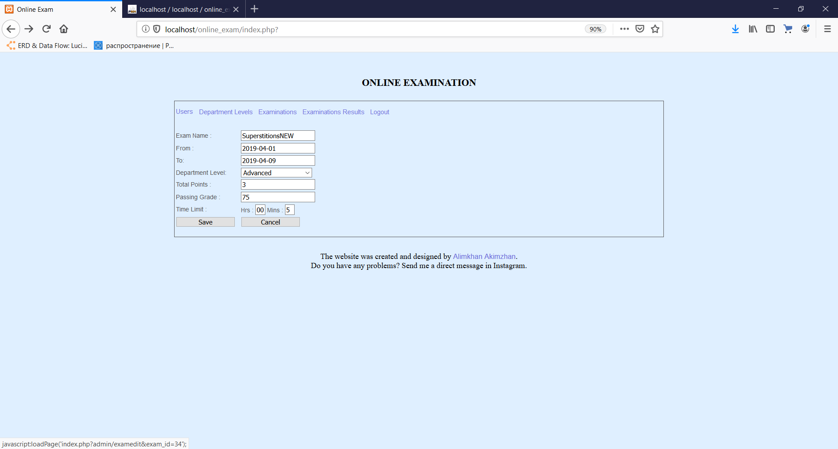

(Figure-144)

2.1. The website shows the warning message that asks to fill in the empty fields in this form

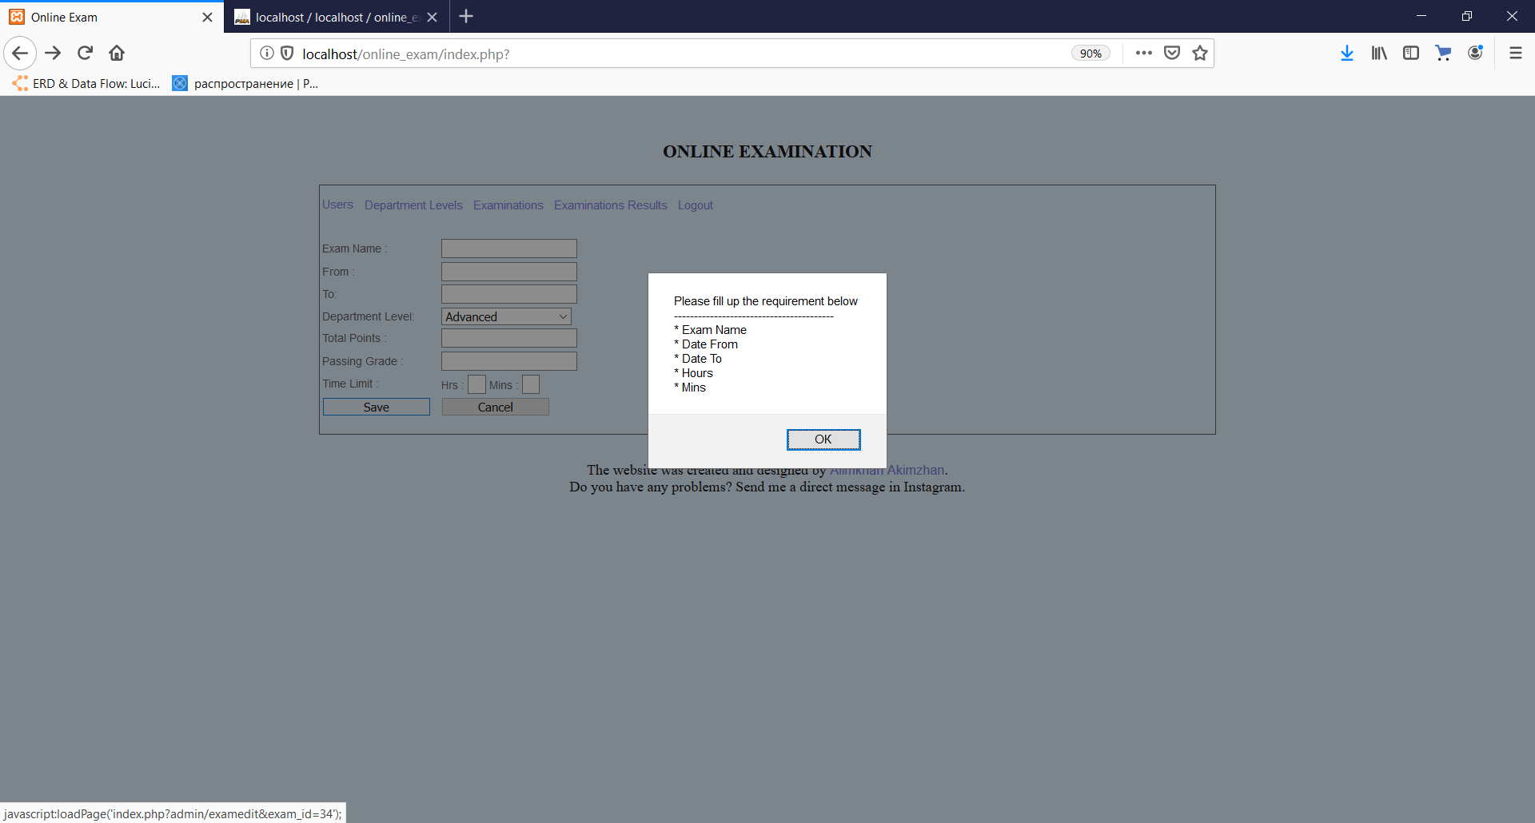

(Figure-145)

**T11**

1.1. New answer for a certain question is added into the database when admin adds new answer in the system.

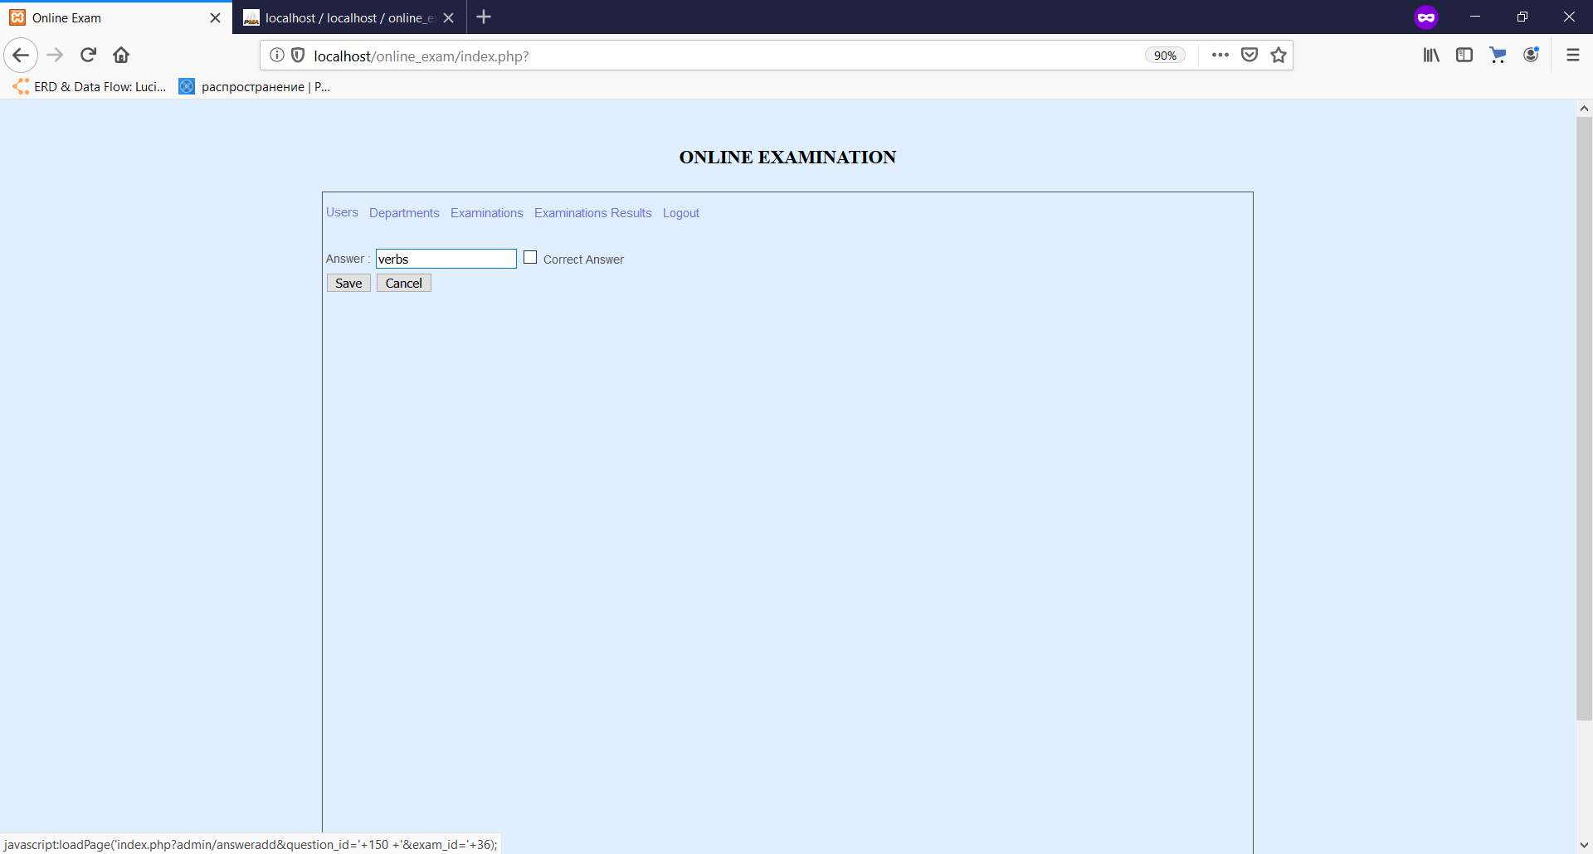

(Figure-146)

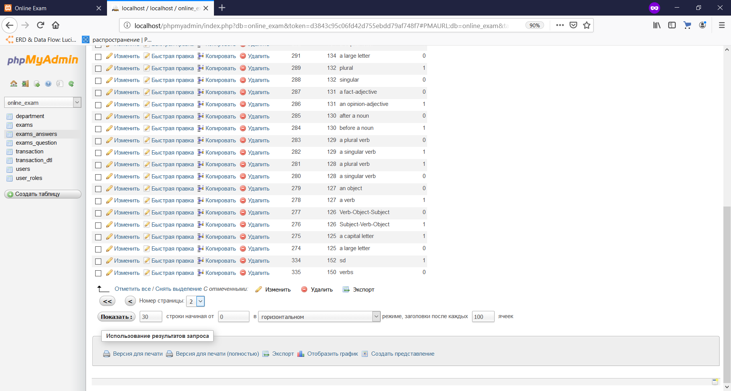

(Figure-147)

**T12**

1.1. The new details of the answer are stored in the database.

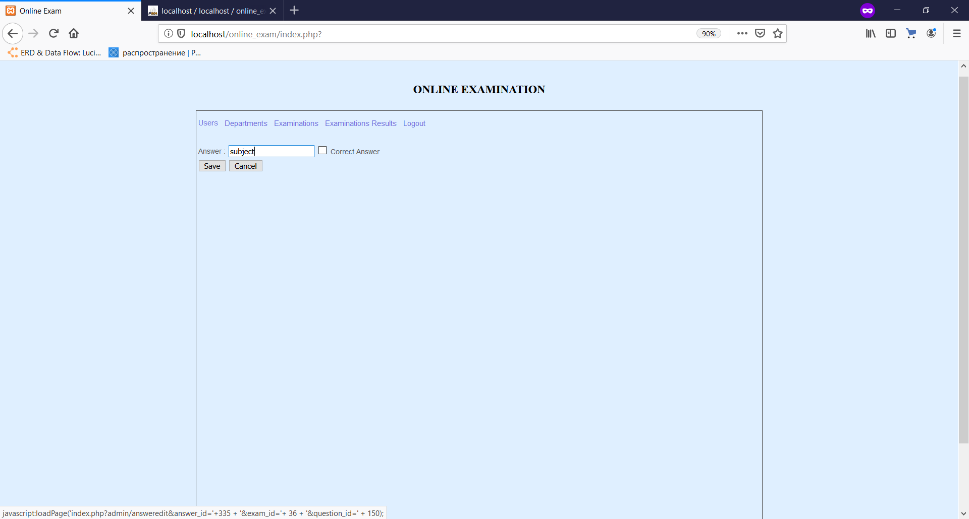

(Figure-148)

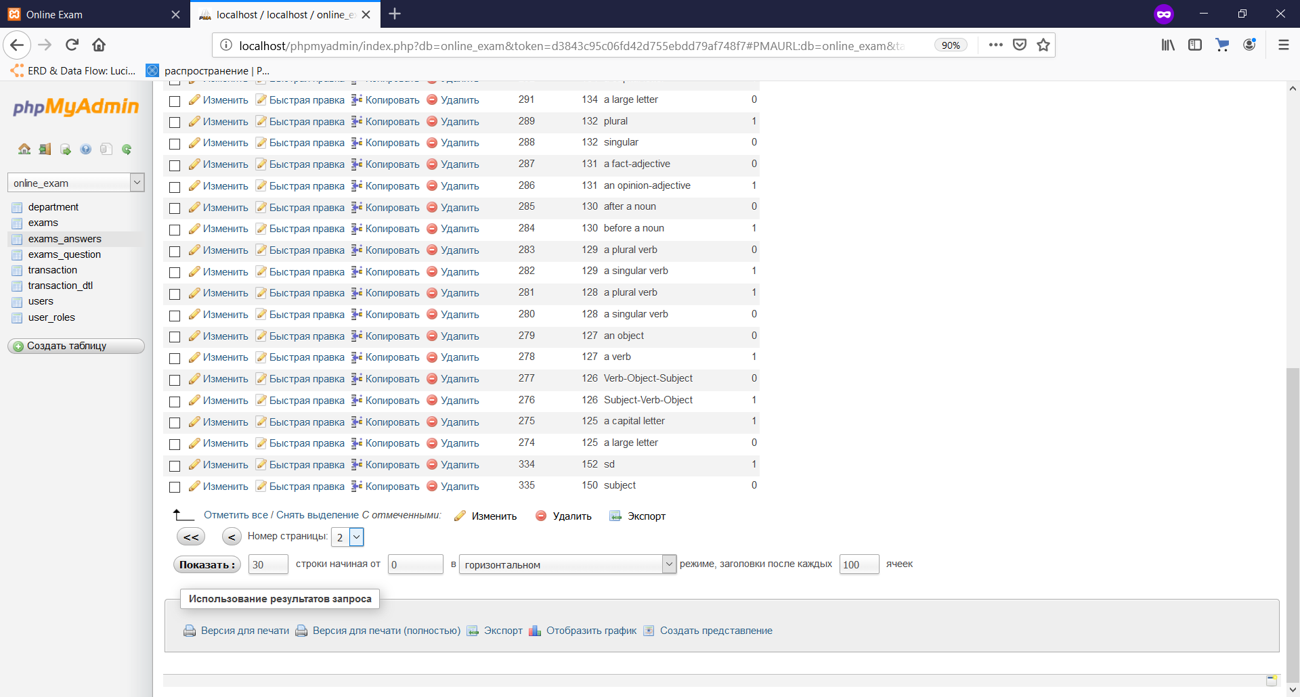

(Figure-149)

**T13**

1.1.1 Error (403) page is opened without any errors, with all styles saved



(Figure-150)

2.1.1 Error (403) page is opened without any errors, with all styles saved



(Figure-151)

3.1.1 Error (404) page is opened without any errors, with all styles saved



(Figure-152)

**T14**

1.1The score of right answers was correctly counted.

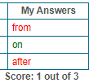

(Figure-153)

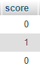

(Figure-154)

2.1 The grade percentage a student has was counted correctly.



(Figure-155)

## (iv) Installation

**Upload of files to the hosting:**

Total Commander desktop application is used as FTP manager to upload the files to the hosting.



The configuration of FTP connections.

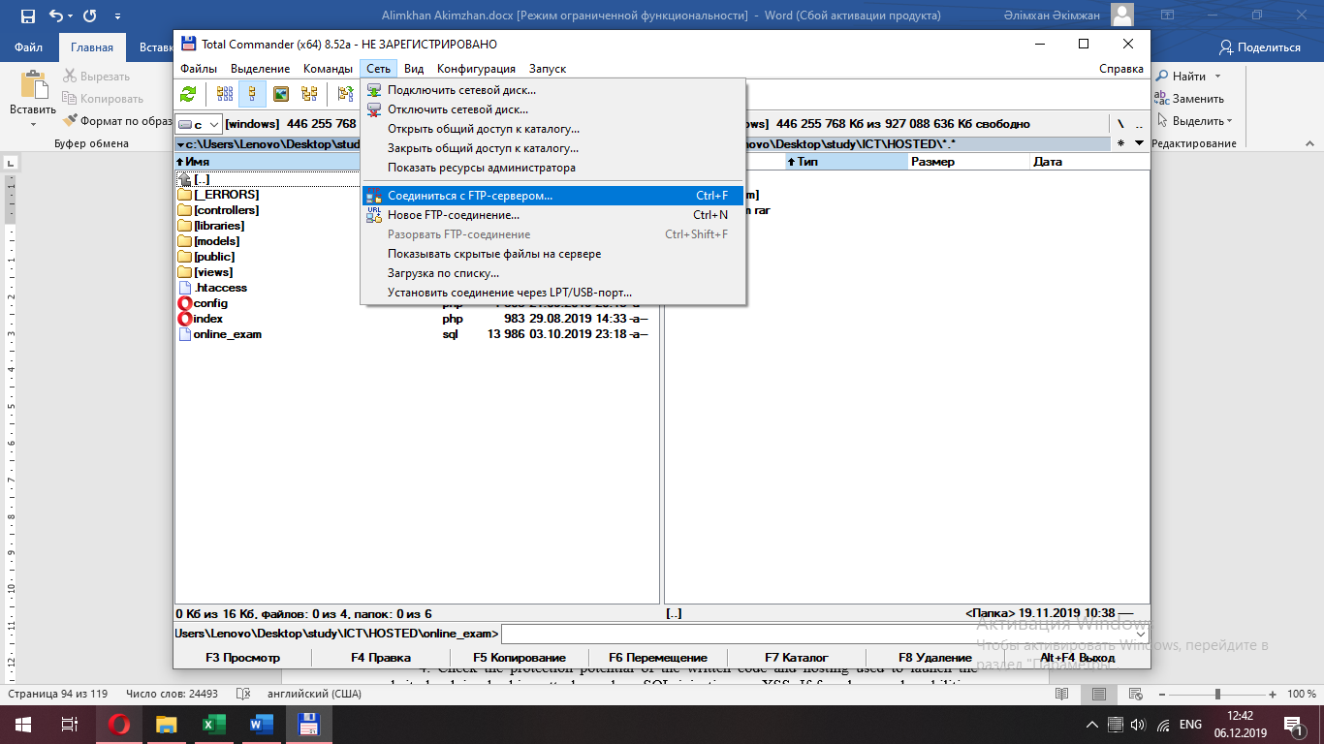

(Figure-156.)

By pressing “Ctrl+F” keys, we open panel of connections.

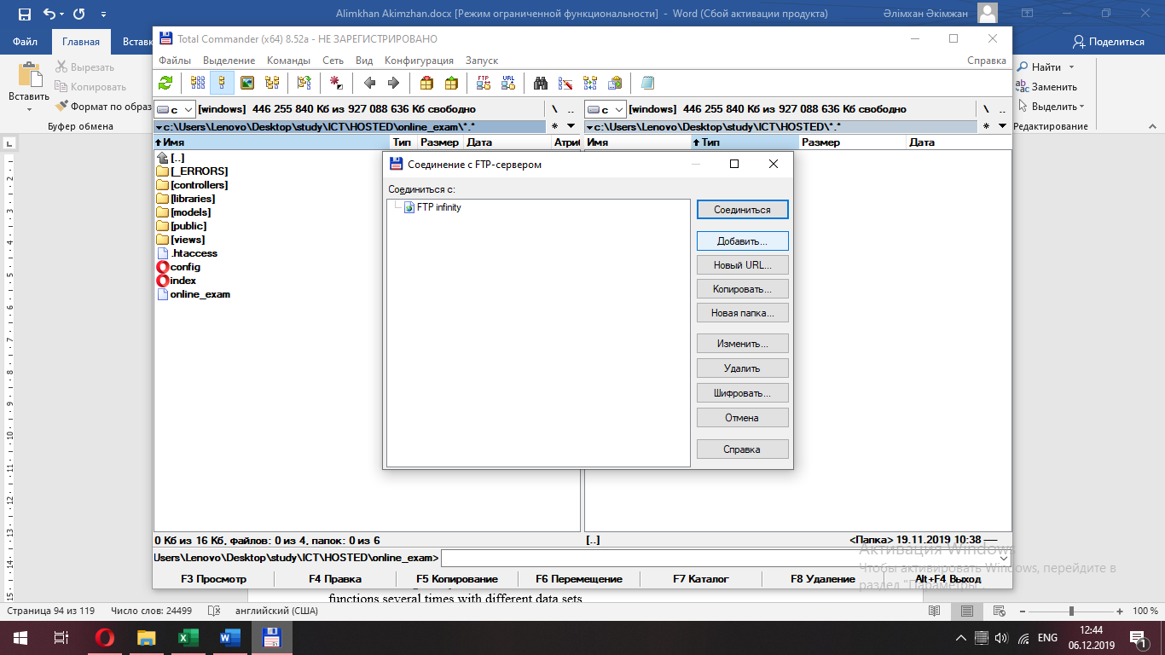  
(Figure-157.)

Here we “Add new connection” and write down our configurations of FTP of hosting and press “Connect”.

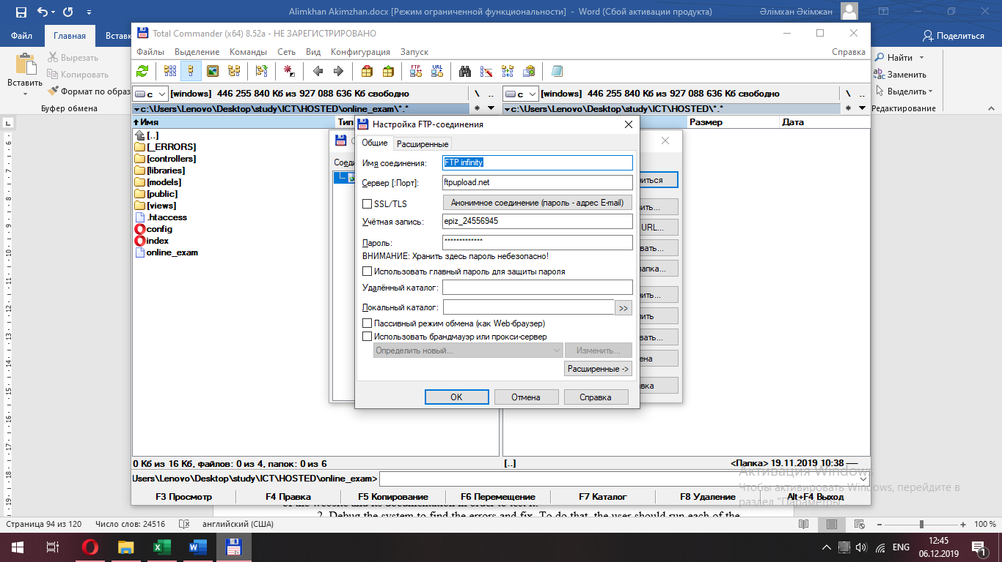 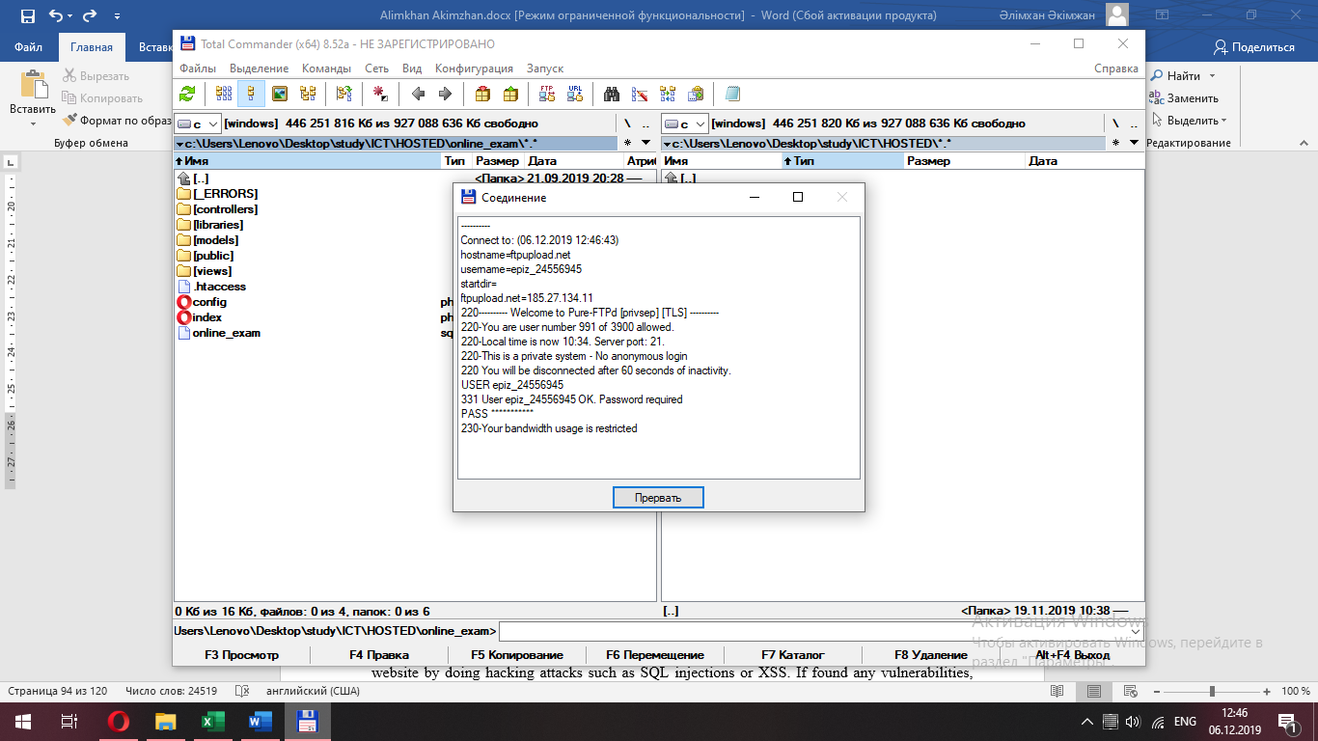

(Figure-158-159.)

Copy our files to the hosting`s tab. All files will be saved on hosting.

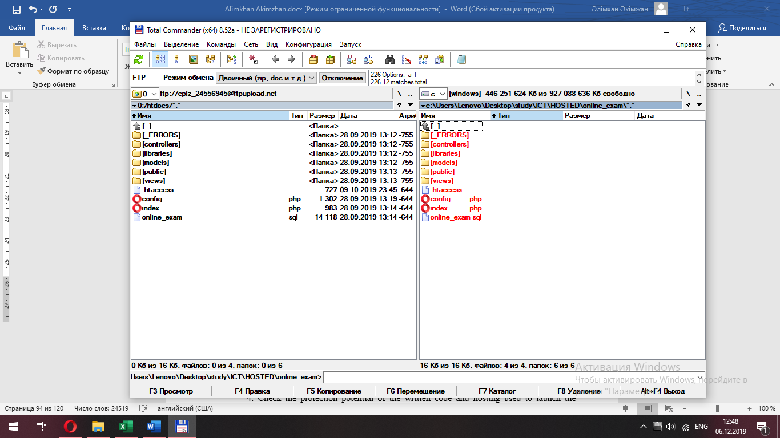

(Figure-160-161.)

The disk space, which should be free on hosting is equal to the file size of archive:

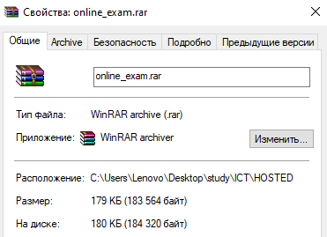

**Installation plan**

The discussion related with the installation will occur during the test of the website by the client. Before that, teacher will test the system for its working capacity, then the client will have the opportunity to use its Beta version.

At the moment the plan of installation consists of the steps given below:

1. Provide the teacher and different IT specialists, web-developers with the Beta version of the website and its documentation in order to test it.

2. Debug the system to find the errors and fix. To do that, the user should run each of the functions several times with different data sets.

3. Take feedback from the first users, who are teacher, IT specialists and web-developers in order to make the system handier and fix the found problems.

4. Check the protection potential of the written code and hosting used to launch the website by doing hacking attacks such as SQL injections or XSS. If found any vulnerabilities, make the system stronger and better against hackers using different methods of protection

5. Provide the user with the project and take a feedback from him to continue the improvement of the system.

6. Promote the website in the different Networks to increase the number of users and interested people, mostly students.

**Training plan**

Suggested date of the action: 21-22 of September, 2019 -31st of May, 2020

Reason: As the system is related with the education, it should be promoted during the academic year, so it will help increase the number of users. This guarantees high demands and brilliant popularity among students.

Suggested method: As the main users are students, so the auditory is youth, who are the main users of the Social Network systems, such as Vkontakte, Facebook and Instagram. The advertisements should be published in these platforms to expand the auditory, this gives a great opportunity to increase the number of users rapidly.

**System implementation plan**

Method of implementation: Direct implementation

Reason: The website has to be implemented as soon as possible, because the academic year has started and the client has to be in time. Also, the features of the system that it is user-friendly and simple provides the opportunity to implement with no problems and to use direct implementation,

Suggested Implementation date: 25th of September, 2019

Reason: the website should work several days before the promotion, because if there problems connected with the technical part, they has to be fixed and this period is useful to do some test on the system.

**Evidence of user testing**

The client has planned a meeting on 20th of September on the weekend. The date was chosen, so that user was able to test the final version of a website very carefully and check for any errors. Then during the meeting the client can look at the plans of installation and implementation. Also, to get the feedback about the work of the system the questionnaire will be given to him, this is used to get the opinion of a user of the system. It contains the main questions, that are connected with the basic functions of the system. This is done in order to have the future vision in the improvements on the website. Below is the feedback document to which the client responded:

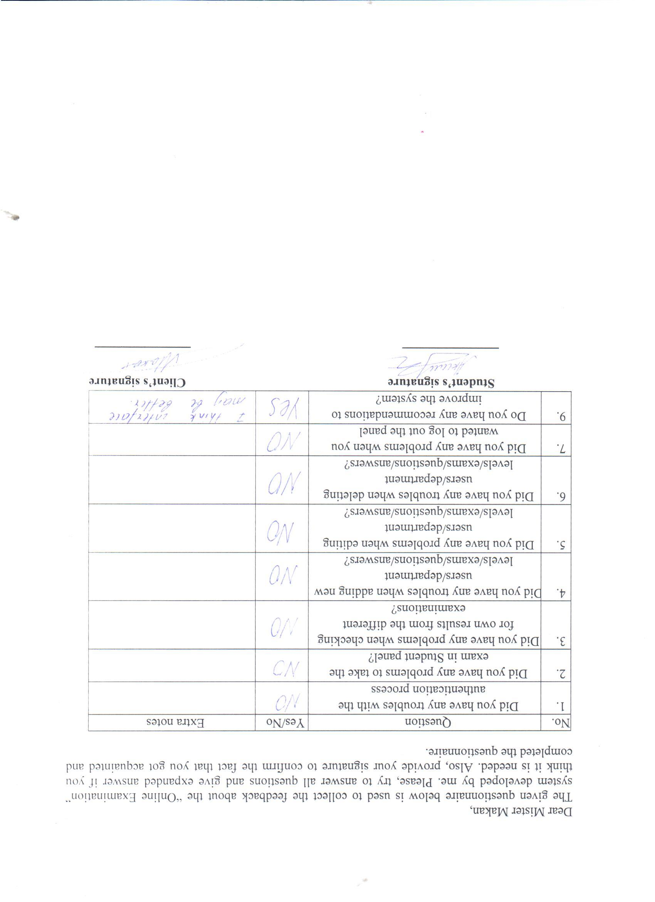

(Picture-9)

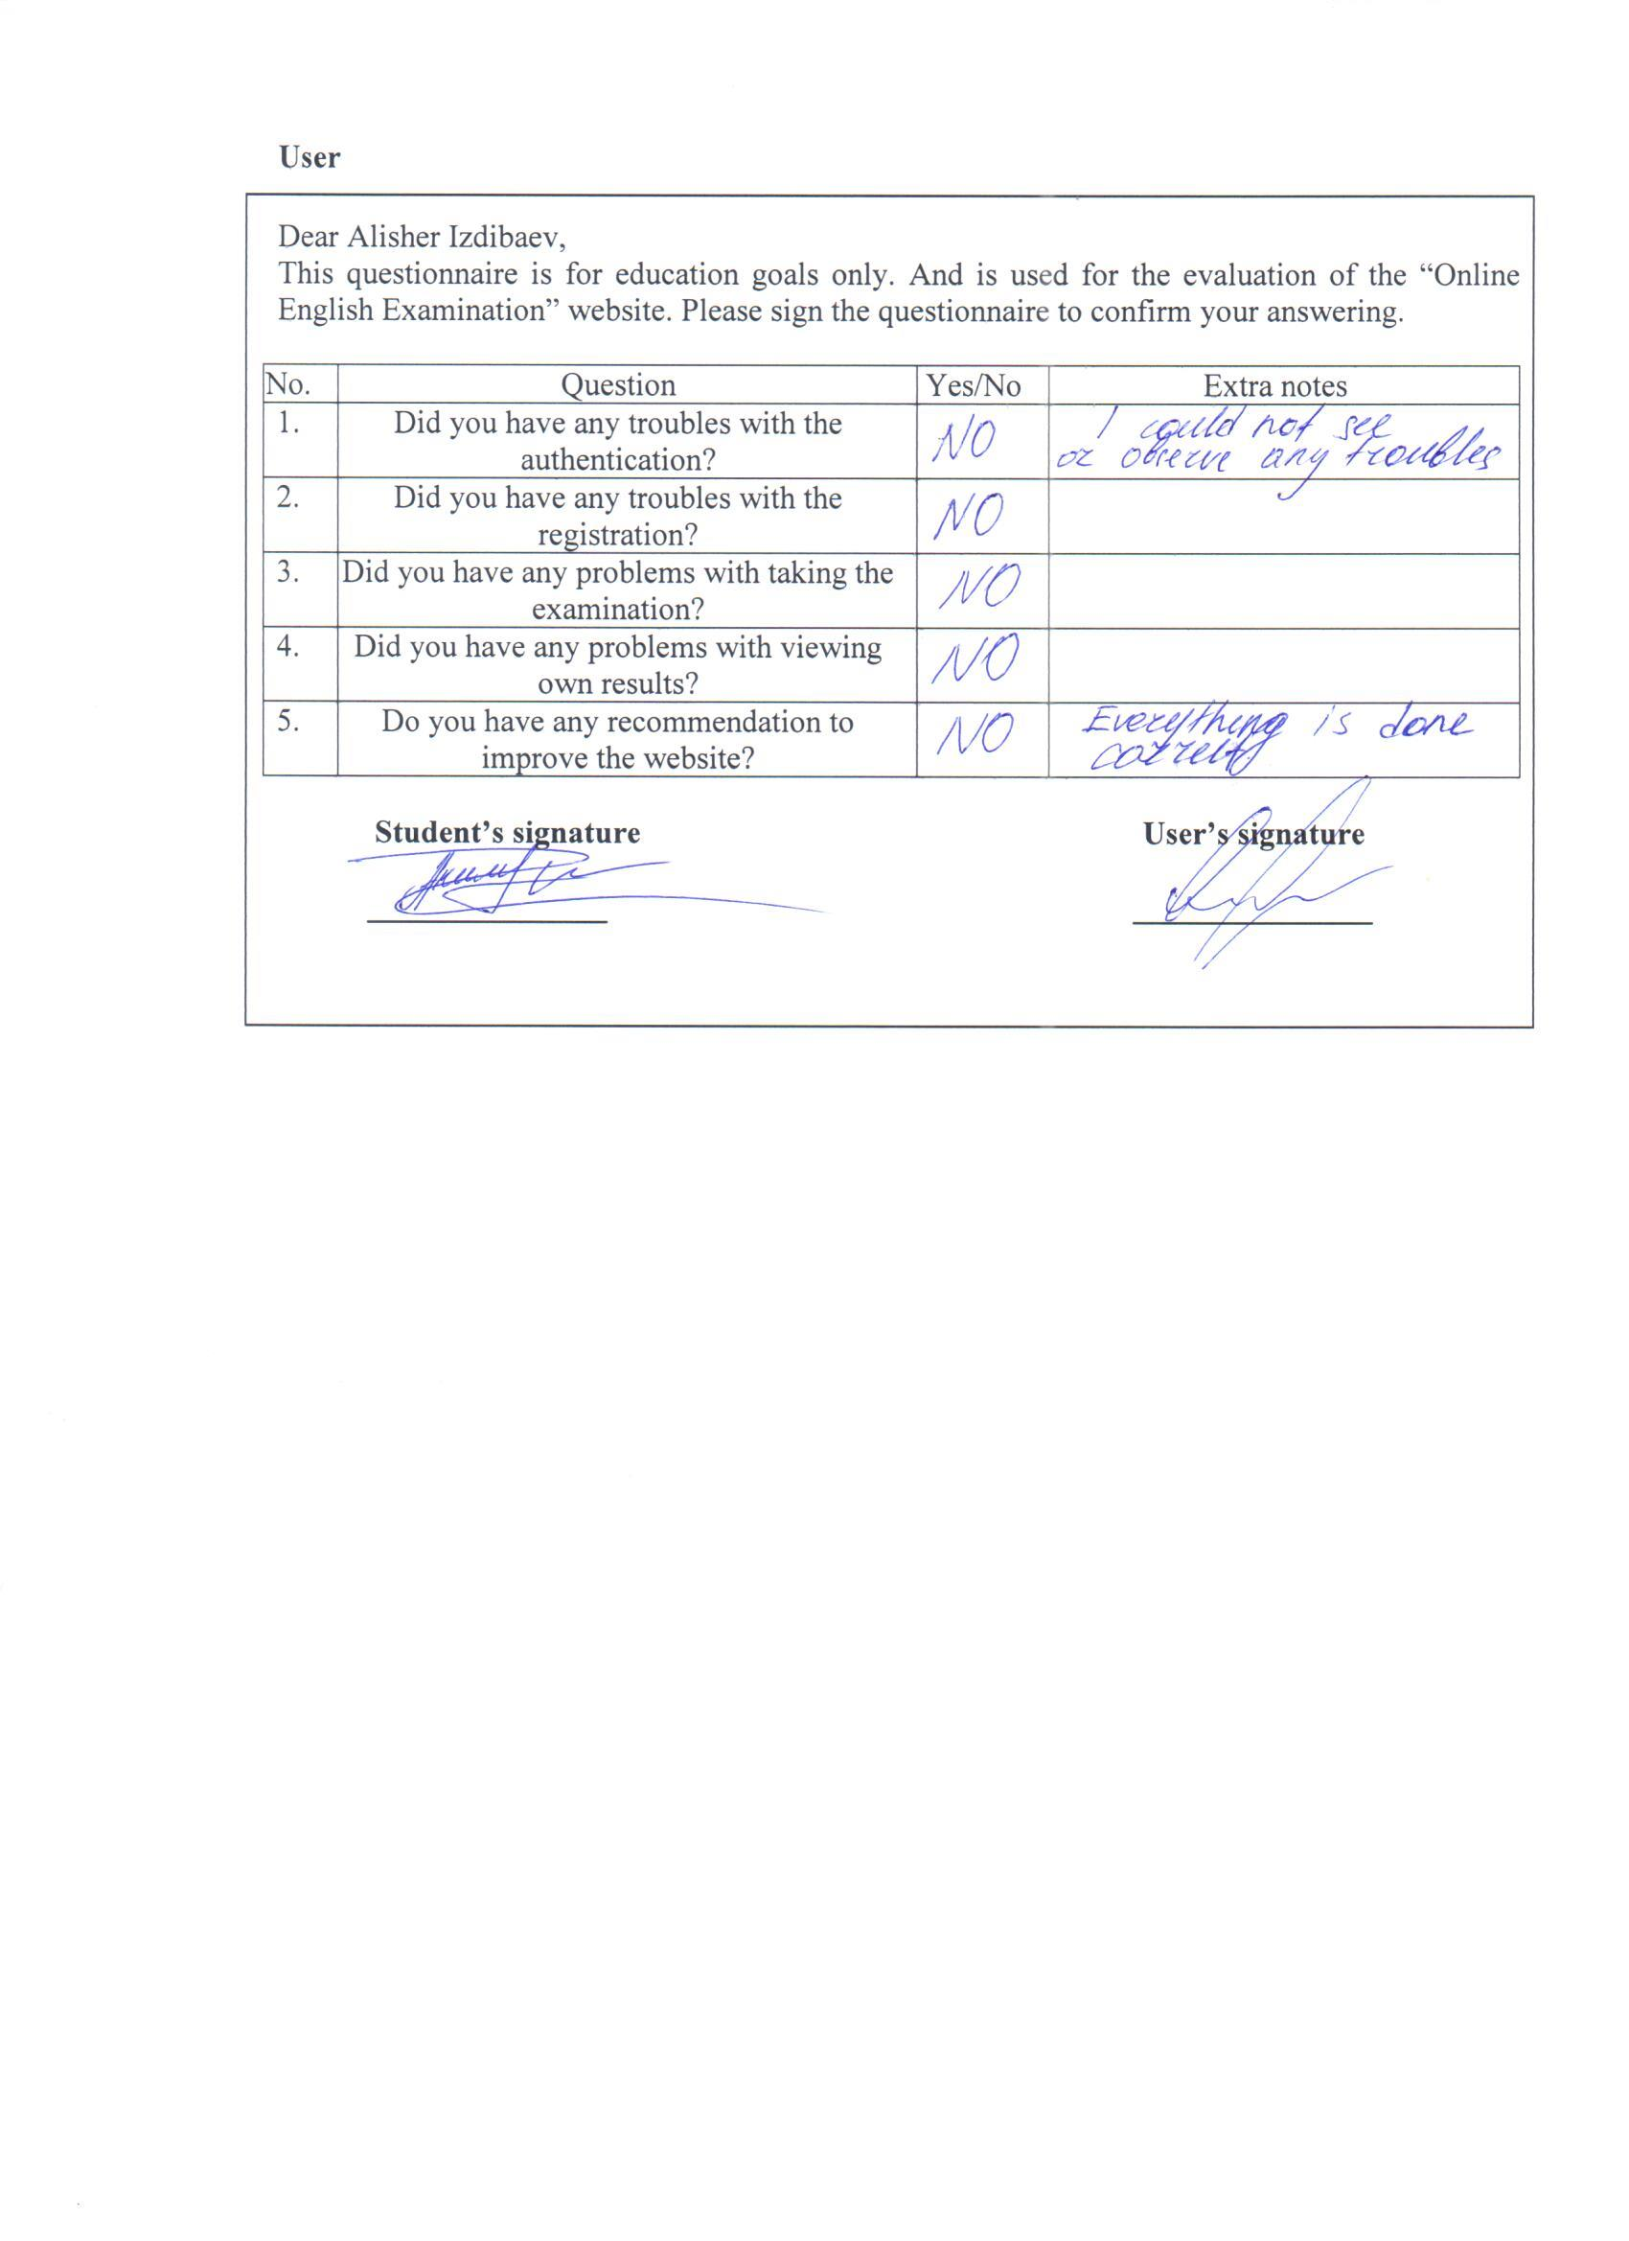

(Picture-10)

# (E) DOCUMENTATION

## (i) System maintenance manual

**Data dictionary**

**Div elements**

Table-17

|  |  |
| --- | --- |
| **Div name** | **Use** |
| wrapper | Aligns the content of the website to the center and displays the main information given in it |
| bodycontainer | The child of “wrapper” div, looks like a box and contains of the main window of the website |
| Left_menu | Has a function of a navigation bar |
| contentcontainer | Displays the main content given in the page, such as data taken from the database or forms and etc. |
| Right_menu | The child of “contentcontainer”, displays the main content given in the page, such as data taken from the database or forms and etc. |
| Body_data | The child of “right_menu”, displays the main content given in the page, such as data taken from the database or forms and etc. |
| fbpage | Has a function of a footer of the website |
| exam | Displays the exams stored in the database |

**Forms**

Table-18

|  |  |
| --- | --- |
| **Form name** | **Use** |
| Answer-add.php | Adds the answers for a certain question of a certain exam. Stores the data in the database. |
| Answer-edit.php | Updates the existing answers in the database |
| checkresult.php | Sets the flag of check for the result |
| Departments-add.php | Adds new department level in the system and stores it in the database |
| Departments-edit.php | Updates the existing department level in the database |
| Exams-add.php | Adds new exam in the system and stores it in the database |
| Exams-edit.php | Updates the existing exam in the database |
| Questions-add.php | Adds new question in the system and stores new data in the database |
| Questions-edit.php | Updates the existing question in the database |
| Sign-up.php | Adds new user in the database by registration process, stores the details about him in the database |
| Users-edit.php | Updates the existing user in the database |
| usersadd.php | Adds new user in the system and stores him in the database |

**Main tags**

Table-19

|  |  |  |
| --- | --- | --- |
| **Object name** | **Type** | **Use** |
| link | Text/css | Connects the PHP and HTML file with the CSS in order to make the website more organized |
| div | Division/box | Used to organize the content of the website pages in order to make it more comfortable to understand |
| a | link | Used to redirect to the different pages |
| table | table | Used to display the data loaded from the database |
| p | text | Used to show the different texts in the pages |
| br | text | Used to product the line break in the text |

**Input Objects**

Table-20

|  |  |  |
| --- | --- | --- |
| **Object name** | **type** | **Use** |
| input | Text | Used to enter the data such as the username, first and last name, exam name, department level and etc.  Used in all add and edit forms. |
| input | password | Used to enter the password during authentication (login and sign-up) and changing password. |
| select | selector | Used to select the department level and user role in different forms |
| input | date | Used to set the deadline period of the exam and to show the exams in the chosen period of time |
| optionbutton | button | Used to choose the answer for the question when taking the exam |
| button | submit | Used to submit the forms in order to perform function and sometimes to go back |

**Variables**

Table-21

|  |  |  |  |
| --- | --- | --- | --- |
| **Name** | **Type** | **Form** | **Use** |
| route | varchar | index.php | Initializing the router for the server |
| session | varchar | index.php | Intializing the sessions and store the data when user logged in |
| segments | varchar | index.php | Stores the result of urlRoute function of $route |
| admin | varchar | adminController.php | Stores the admin model |
| staff | varchar | staffController.php | Stores the staff model |
| User_fname | varchar | adminController.php | Stores the first name of the user |
| User_lname | varchar | adminController.php | Stores the last name of the user |
| User_name | varchar | adminController.php | Stores the username of the user |
| User_password | varchar | adminController.php | Stores the encrypted password of the user |
| Role_id | integer | adminController.php | Stores the id of role of the user |
| Department_id | integer | adminController.php | Stores the id of department level of the user |
| enabled | integer | adminController.php | Stores if the user enabled or not |
| ischecker | integer | adminController.php | Stores if the user exam checker or not |
| User_id | integer | adminController.php | Stores the id of user |

**Tables**

Table-22

|  |  |
| --- | --- |
| **Table name** | **Use** |
| Users | Stores different data related with the users of the system, such as their names, usernames, passwords and etc. |
| Department | Stores the details of the department level, such as its code, id and level itself |
| Еxams | Stores different data about the exams created by the teachers and used in the system |
| Exams_answers | Stores the answers for the multiple-choice questions of the certain exams |
| Exams_question | Stores the questions used in the exams of the system |
| Transaction | Stores the data about the students and their result in the different exams |
| Transaction_dtl | Stores the data about the studenta and their results for different questions of the certain exams |
| User_roles | Stores the roles used in the system |

**Table users**

Table-23

|  |  |  |
| --- | --- | --- |
| **Field name** | **Data type** | **Use** |
| user_id | int | The identification number of the user |
| user_fname | varchar | First name of the user |
| user_lname | varchar | Last name of the user |
| department_id | int | Id of the department level which user belongs to |
| role_id | int | Id of the role of the user |
| user_enabled | int | Indicator showing if user enabled or not |
| user_createdby | Int | Id of user who created the user |
| user_createdon | Timestamp | Date and time when user is created |
| user_modifiedby | Int | Id of user who modified the user |
| user_modifiedon | datetime | Date and time when the user is modified |
| user_name | varchar | Username of the user |
| user_password | Varchar | Password of the user |
| exam_checker | int | Indicator showing if user is exam checker or not |

**Table department**

Table-24

|  |  |  |
| --- | --- | --- |
| **Field name** | **Data type** | **Use** |
| department_id | int | The identification number of the department level |
| department_code | varchar | The code of the department level |
| department_name | varchar | The name of the department level |

**Table exams**

Table-25

|  |  |  |
| --- | --- | --- |
| **Field name** | **Data type** | **Use** |
| exam_id | int | The identification number of the examination |
| exam_name | varchar | The name of the examination |
| exam_from | date | The date from which the exam is available |
| exam_to | date | The last date when the exam is available |
| passing_score | int | The passing score |
| exam_date_created | timestamp | The date and time when the exam is created |
| exam_created_by | int | Id of user who created the exam |
| exam_modified_by | Int | Id of user who modified the exam |
| exam_time_limit | int | The time limit to take the exam |
| isdeleted | int | Indicator showing if exam is deleted |
| passing_grade | int | Minimum grade to pass the exam |
| department_id | int | Id of the department level |

**Table exams_answers**

Table-26

|  |  |  |
| --- | --- | --- |
| **Field name** | **Data type** | **Use** |
| answer_id | int | The identification number of the answer |
| question_id | int | The identification number of the question |
| answer_name | Varchar | The name of the answer |
| answer_flag | int | Flag showing if the answer is correct or not |

**Table exams_question**

Table-27

|  |  |  |
| --- | --- | --- |
| **Field name** | **Data type** | **Use** |
| question_id | int | The identification number of the question |
| exam_id | int | The identification number of the exam |
| question_name | varchar | The name of the question |
| question_code | Varchar | The code of the question |
| question_type | Int | The type of the question |
| question_date_created | Timestamp | Date and time when the question is created |
| question_date_modified | Datetime | Date and time when the question is modified |
| question_modified_by | Int | Id of user who modified the question |
| question_created_by | Int | Id of user who created the question |
| essay_points | int | The essay points for the question |

**Table transaction**

Table-28

|  |  |  |
| --- | --- | --- |
| **Field name** | **Data type** | **Use** |
| transaction_id | int | The identification number of the transaction |
| transaction_date | date | The date of the transaction |
| transaction_code | Varchar | The code of the transaction |
| user_id | int | The id of user whose transaction is it |
| exam_id | int | Id of examination |
| time_consumed | int | Time consumed to take the exam |
| check_status | int | Indicator showing if exam is checked or not |

**Table transaction_dtl**

Table-29

|  |  |  |
| --- | --- | --- |
| **Field name** | **Data type** | **Use** |
| transaction_dtl_id | int | The identification number of the transaction details |
| user_id | Int | The identification number of the user who answered |
| question_id | int | The identification number of question |
| transaction_answer_id | Int | The identification number of answer |
| exam_id | Int | The identification number of examination |
| essay | Varchar | The answer given as an essay |
| transaction_code | Varchar | The code of the transaction |
| transaction_question_type | Int | The type of the question |
| score | Int | The score given to the answer |
| israted | Int | Indicator showing if the answer is rated or not |
| checked_by | int | The identification number of user who checked the exam |

**Table user_roles**

Table-30

|  |  |  |
| --- | --- | --- |
| **Field name** | **Data type** | **Use** |
| role_id | int | The identification number of the role |
| role_name | varchar | The name of the role |

**Section references**

Most of the sections required for the system maintenance documentation are already occur previously in this document.

Table-31

|  |  |
| --- | --- |
| **Section** | **Page reference** |
| Flow-chart of taking exam | (b) DEFINITION, INVESTIGATION AND ANALYSIS ii) Analysis |
| Inputs, Processes and Outputs of Current System | (b) DEFINITION, INVESTIGATION AND ANALYSIS ii) Analysis |
| Software and hardware requirements | (c) DESIGN i) Nature of solution |
| Entity relationship diagram | (c) DESIGN i) Nature of solution |
| Inputs, Processes and Outputs of New System | (c) DESIGN i) Nature of solution |
| Data Structure | (c) DESIGN i) Nature of solution |
| Data Flow Diagram of the Taking exam | (b) DEFINITION, INVESTIGATION AND ANALYSIS ii) Analysis |
| Data Flow Diagram of the New System | (c) DESIGN i) Nature of solution |
| Array |  |
| Menu and module design | (c) DESIGN i) Nature of solution |
| Input/Output Design | (c) DESIGN i) Nature of solution |
| Flowcharts (for user and admin) | (c) DESIGN i) Nature of solution |
| System Component Breakdown Diagram | (d) SOFTWARE DEVELOPMENT, PROGRAMMING, TESTING AND INSTALLATION (i) Development |
| Annotated System Listing (code) | (d) SOFTWARE DEVELOPMENT, PROGRAMMING, TESTING AND INSTALLATION (ii) Programming |

**Possible Adaptive Maintenance**

To improve the system in the future the next steps can be done:

* Adding the rating system of the student. For example, who has a better results among all student that have been in the learning centre. Based on these points the rating is made.
* Adding the system of texting to other users to make the system simple and remove the processes as calling and etc.
* Add media to the app by putting images, more attractive background or other elements.
* Change the design of the website

**Back-up Procedure**

The website is kept on the online server hosted by “InfinityFree.net” with subdomain “epizy.com” (1 level) and uses the databases provided by it, therefore the back-ups are done with no intervention of a user of the website and the computer does it by itself automatically. All files used in the website are stored in the FTP server of the same hosting and can be managed by the file manager in a control panel of the website. So, user does not need any extra storage space in order to open the website and use its functions. Everything is loaded using the Internet via online procedures.

If the website`s server will be crashed, the reserved copy is anyway has been saved on Google Drive Cloud, also if it would be crashed too, the original filed are saved on flash card. Managers can manually export information from the SQL database. For this you need to open phpMyAdmin via my file manager at Control Panel of the website.

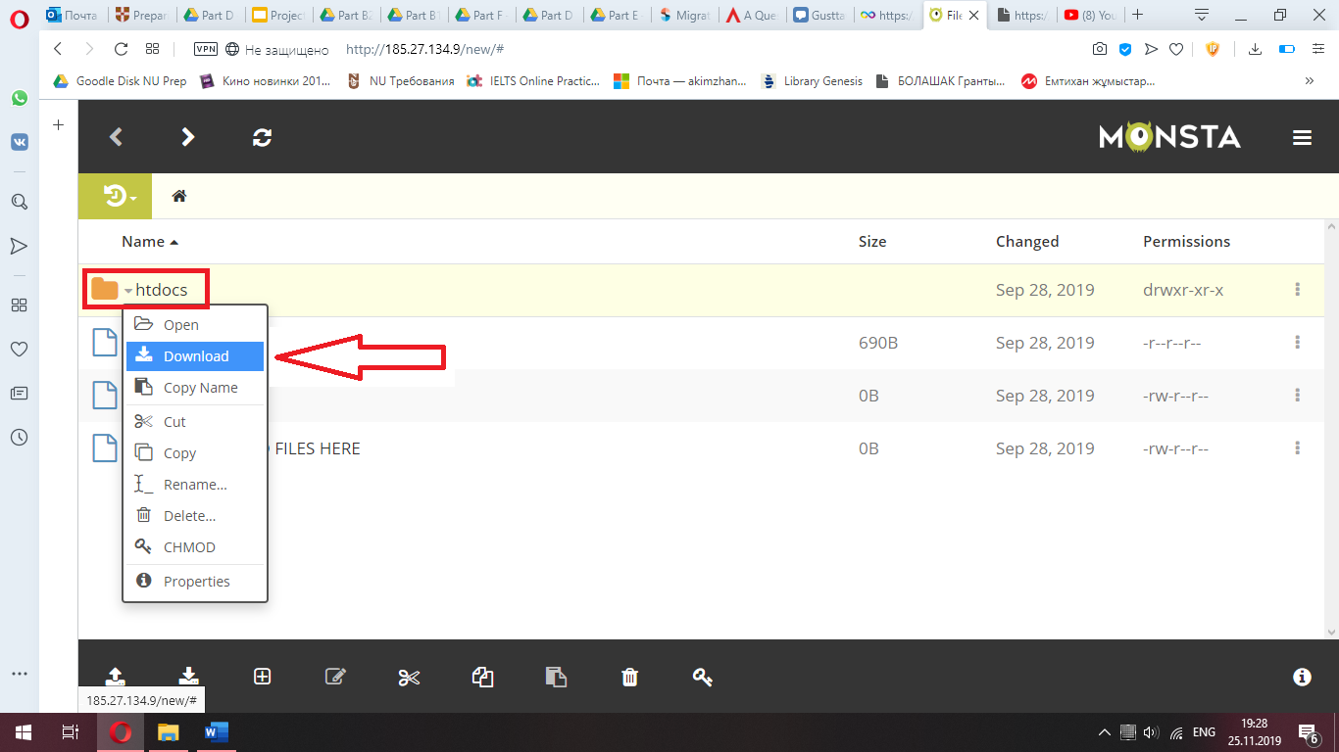

Picture-11. Picture of Buck-up in hosting

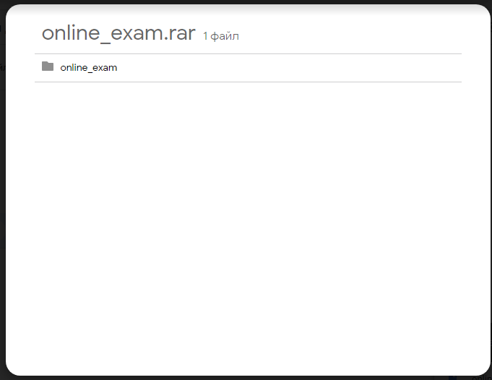

Picture-12.Back-up on Google Drive

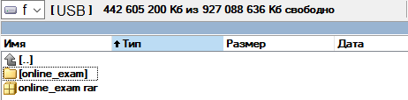

Picture-13. Back-up on Flash Card

**Storage Media Use**

It was mentioned above that the online hosting service does back-ups automatically. This means that the specialist who does the similar things in some periods of time is not needed in this system. This is done without intervention of human several times a day by the programmed service.

## (ii) User manual

**Entering the website**

Type online-examination.epizy.com to enter the website of the examination system in the link field of the browser. Then the website is loaded. The very first window that user sees is the login page, so to use the features of the system user has to authenticate the system.

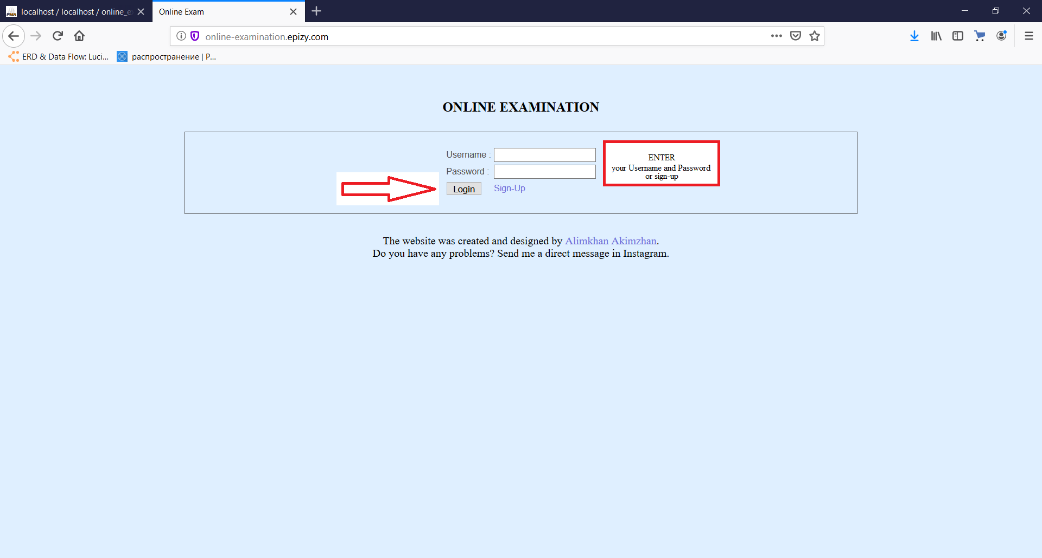

(Figure-162)

**Login**

If you already have an account you can enter your username and password in the appropriate fields and click on “login” button and go to the Admin (teacher) or Student panel

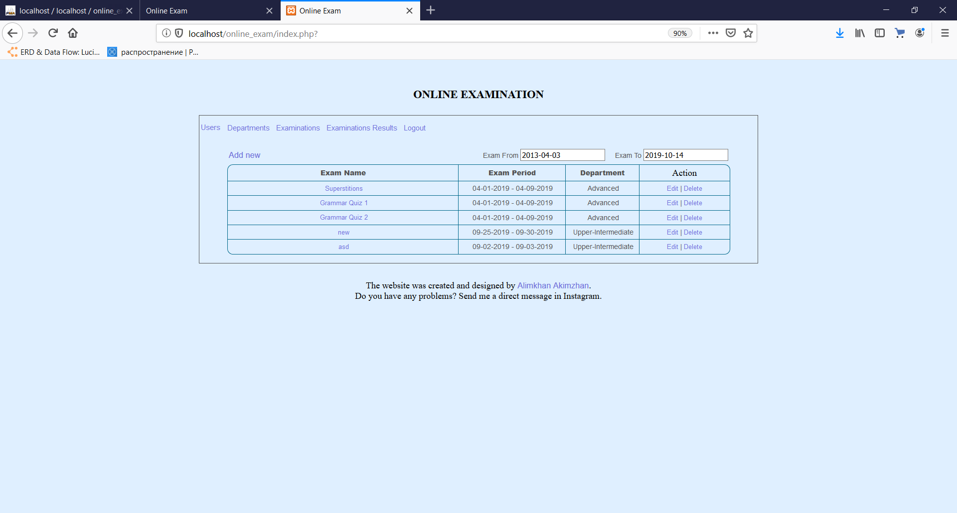

Admin (teacher) panel

(Figure-163)

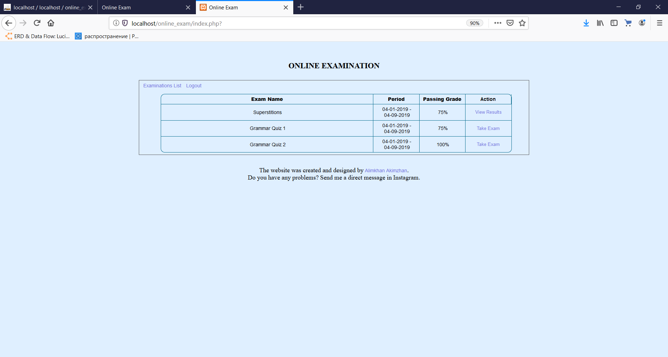

Student panel

(Figure-164)

**Registering**

If you have not any account in the system you can created own one. To do that go to “sign-up” link in the first page and enter the asking data in the appropriate fields, then submit the form. But you will not get the access to the panel as soon as you sign-up, you have to wait until the admin of the system activates it.

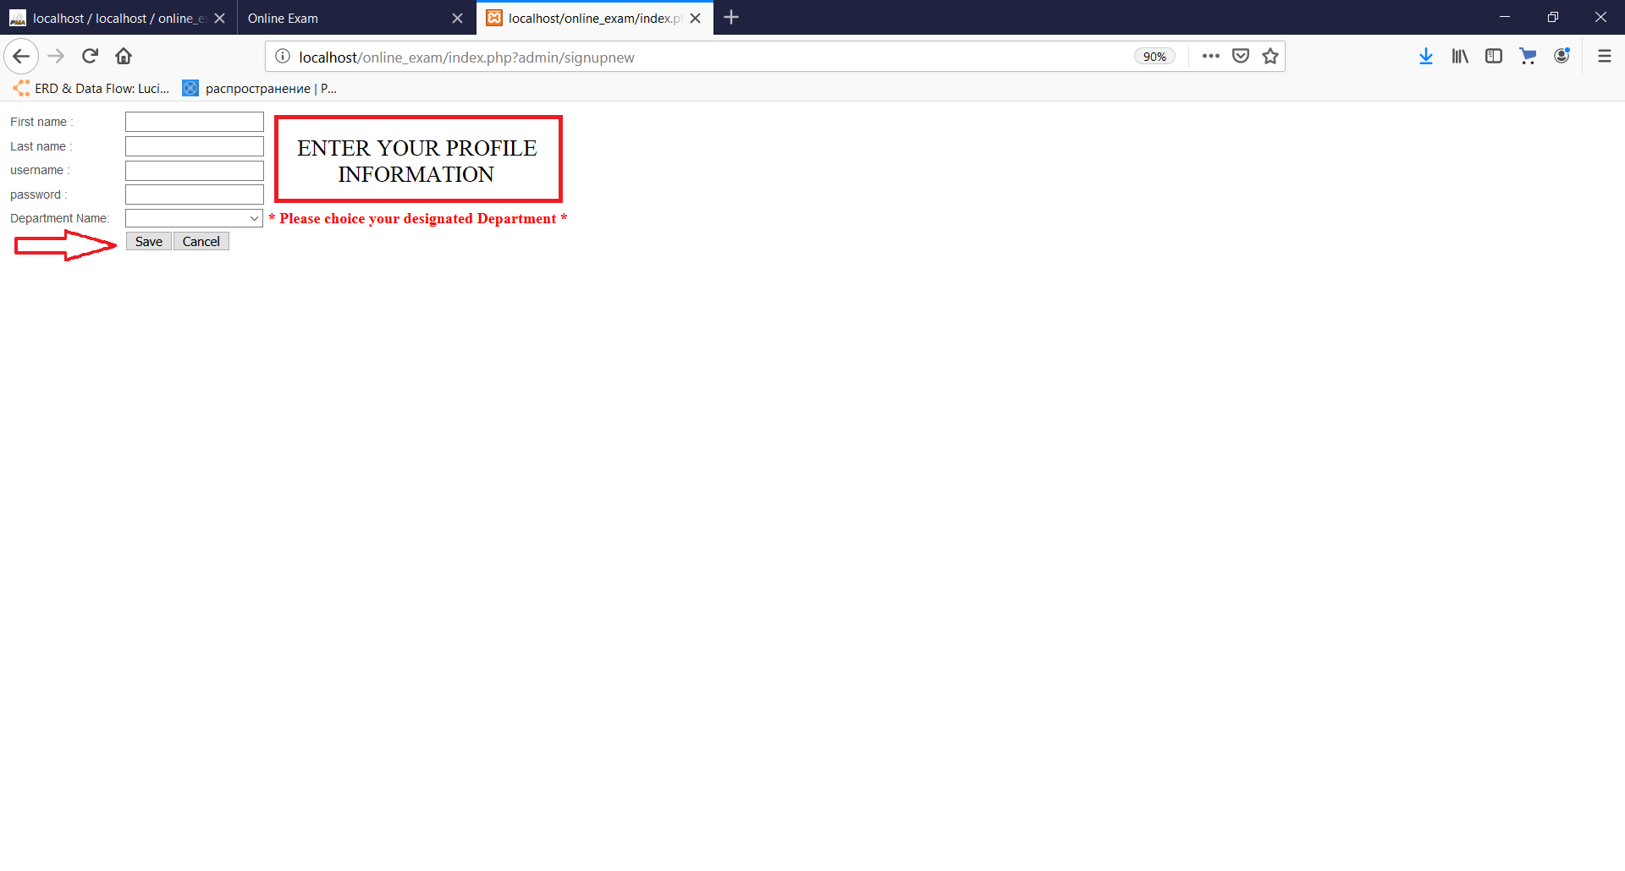

(Figure-165)

***Student panel:***

**Taking an examination**

If the user is a student, he can take an examination. To do that the user has to choose the certain exam among the available ones by clicking “Take Exam” link. In the opened window, the user can see the question with option answers and the remaining time. The user has to choose one of the given options and click on “Next Question” to move to the next one. As far as all of the questions are answered the user gets a message telling that this is the end of the exam.

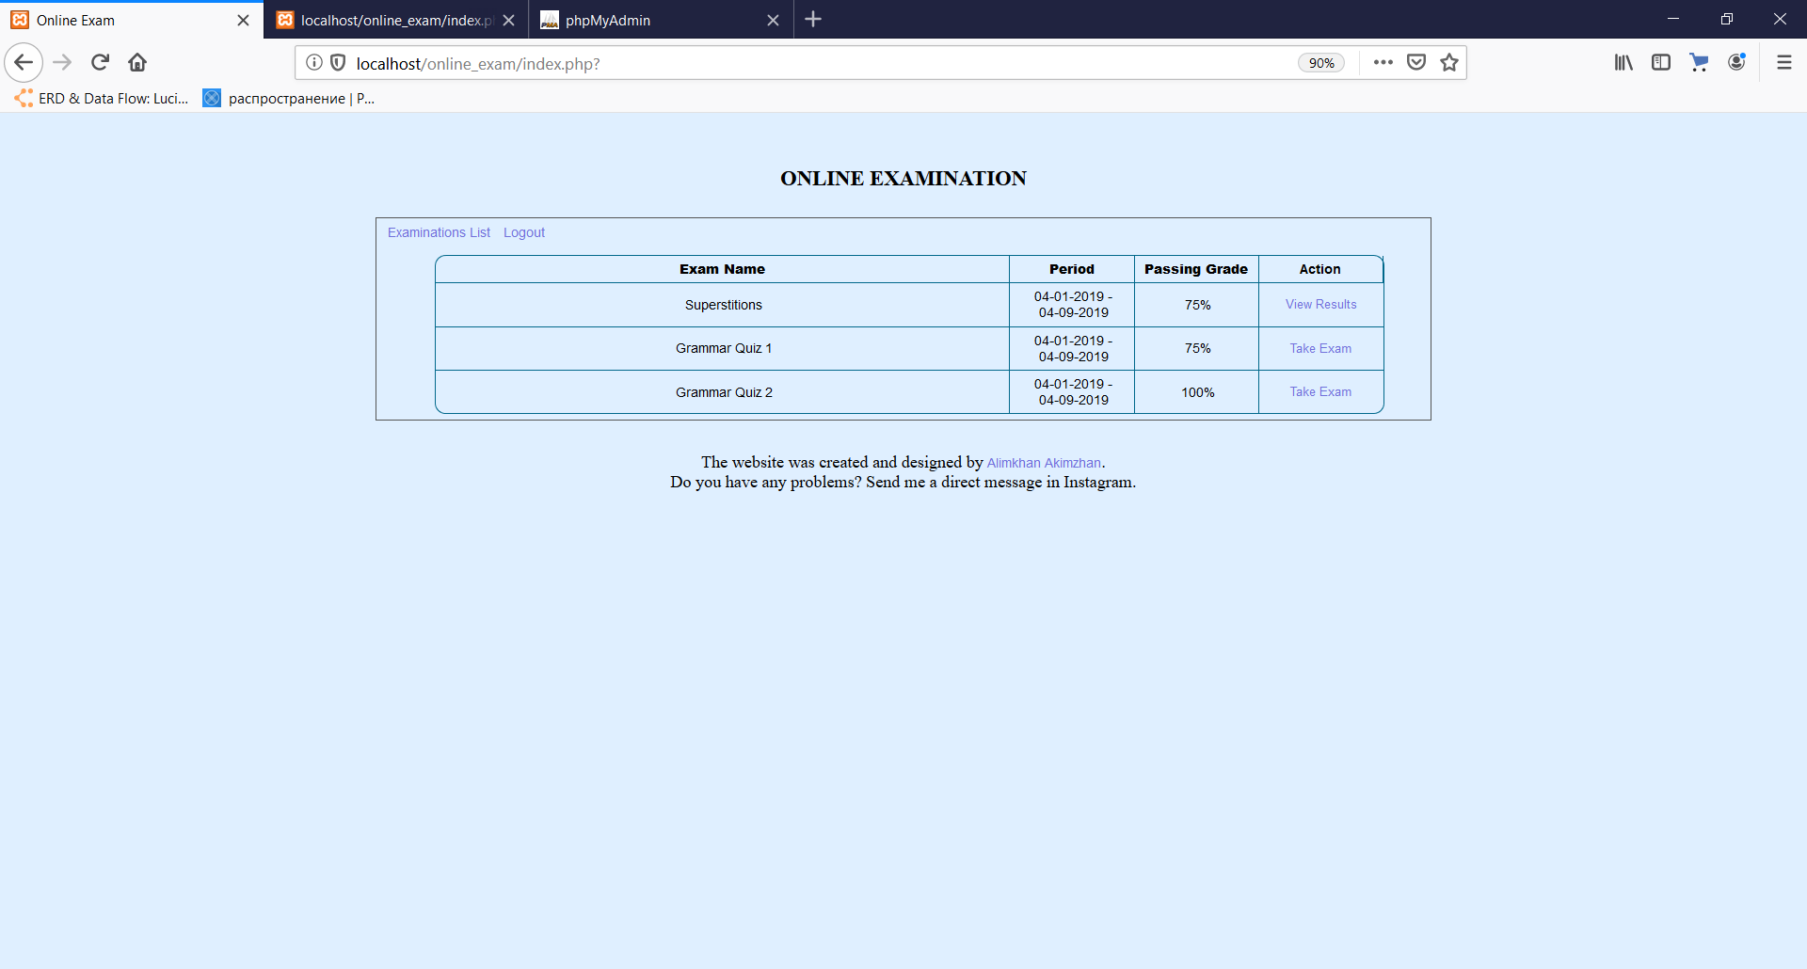

(Figure-167)

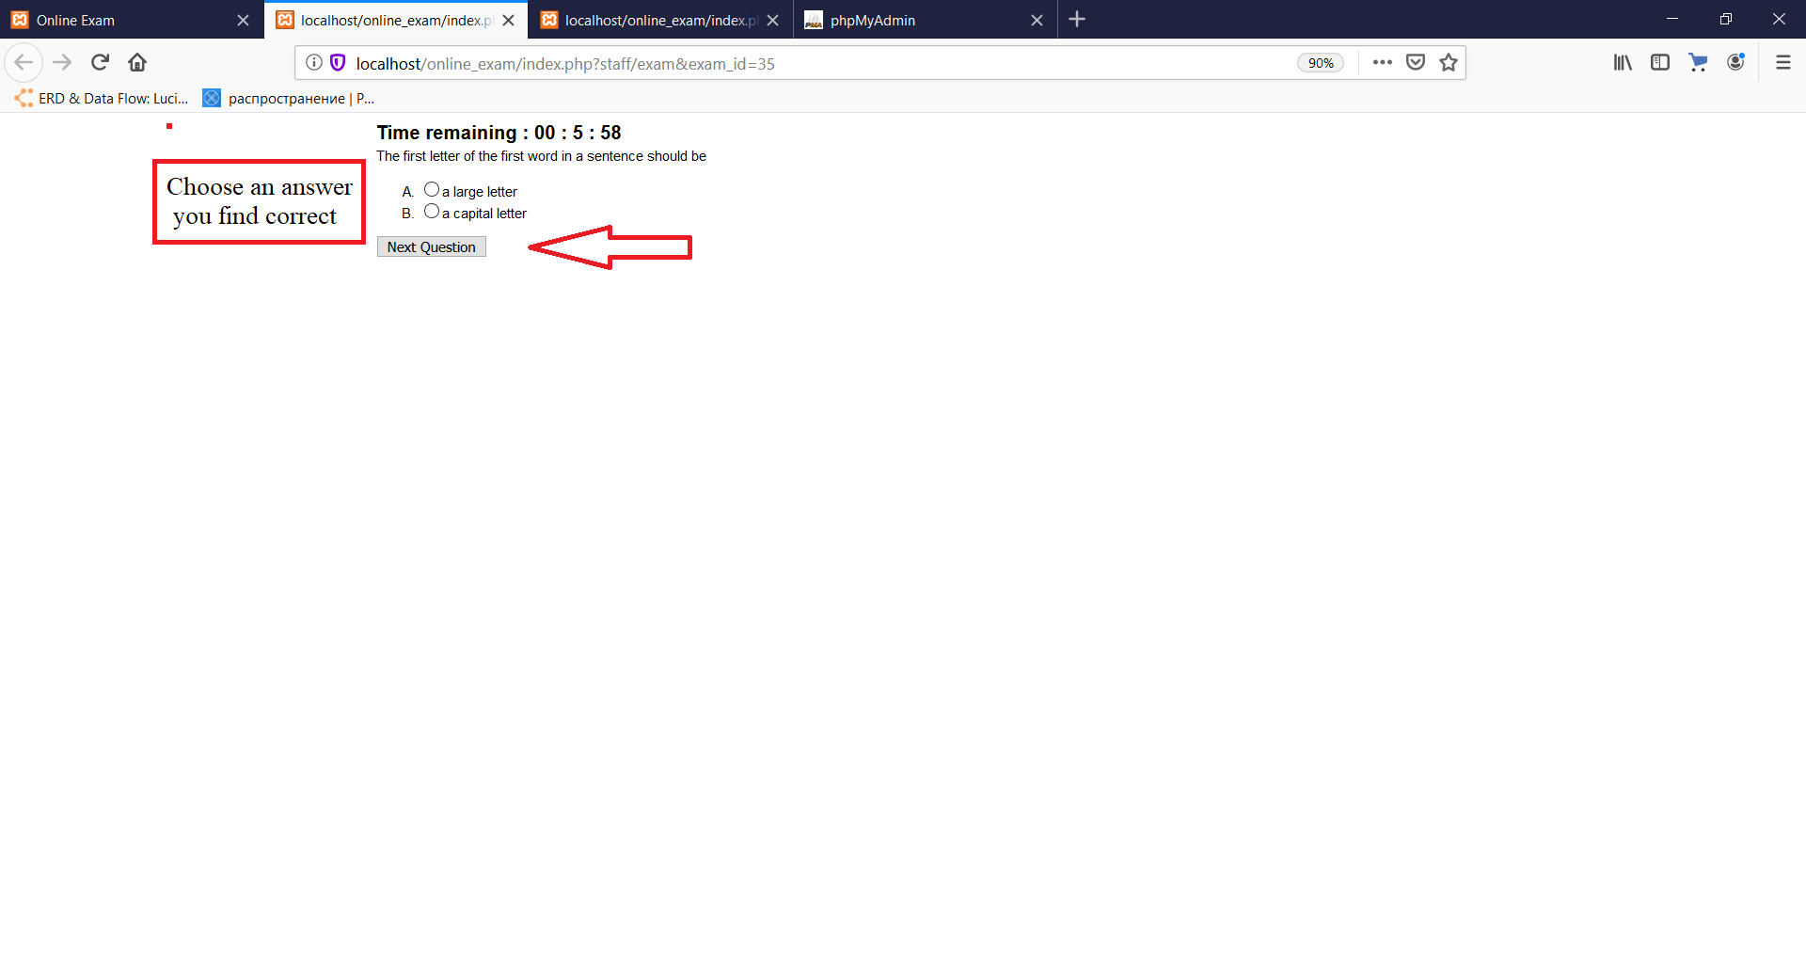

(Figure-168)

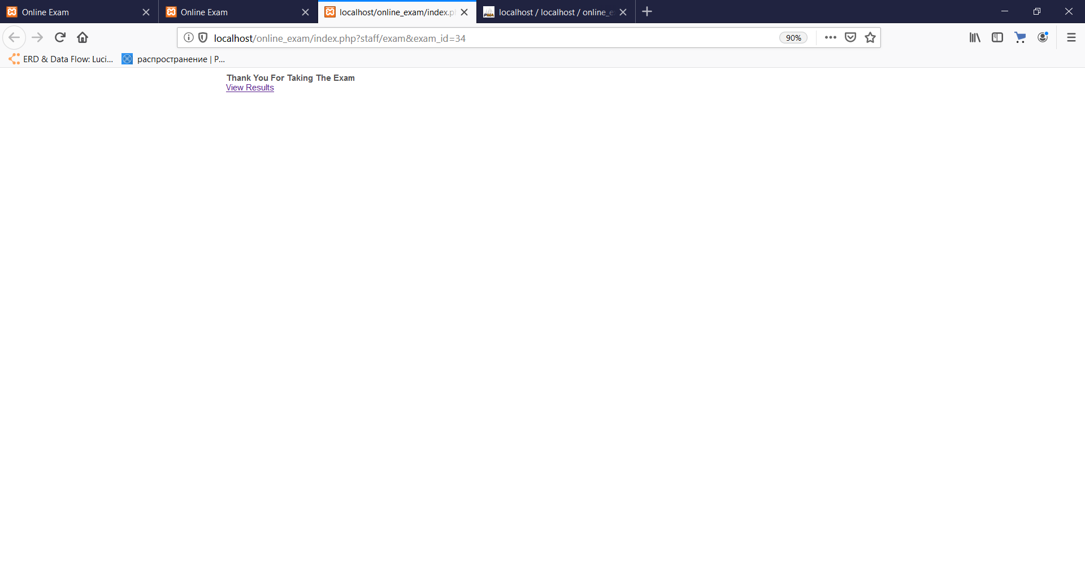

(Figure-169)

**View results of the examinations**

If the user is a student, he can view own results from the exams. To do that the user has to choose the certain exam among the available ones by clicking “View Results” link. In the opened window, the user can see the questions and own answers for them, also the score, grade and remark are given in this window. According to the passing grade of the examination, the remark is “Failed” or “Passed”.

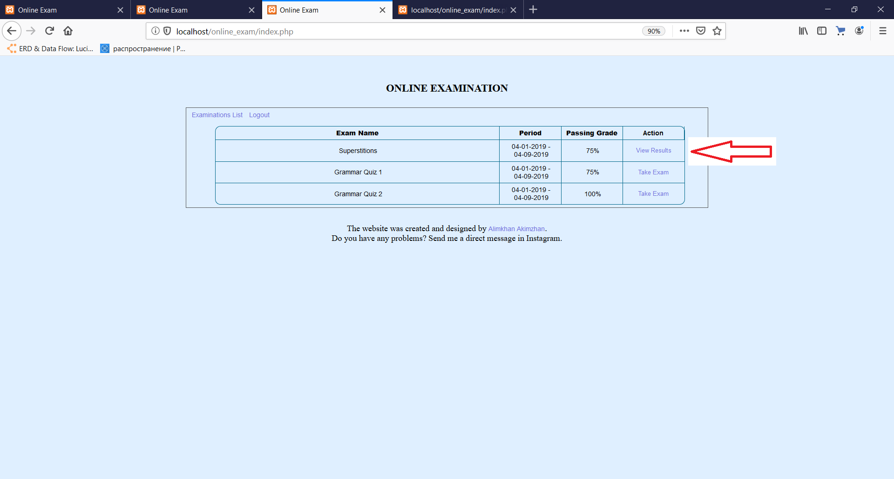

(Figure-170)

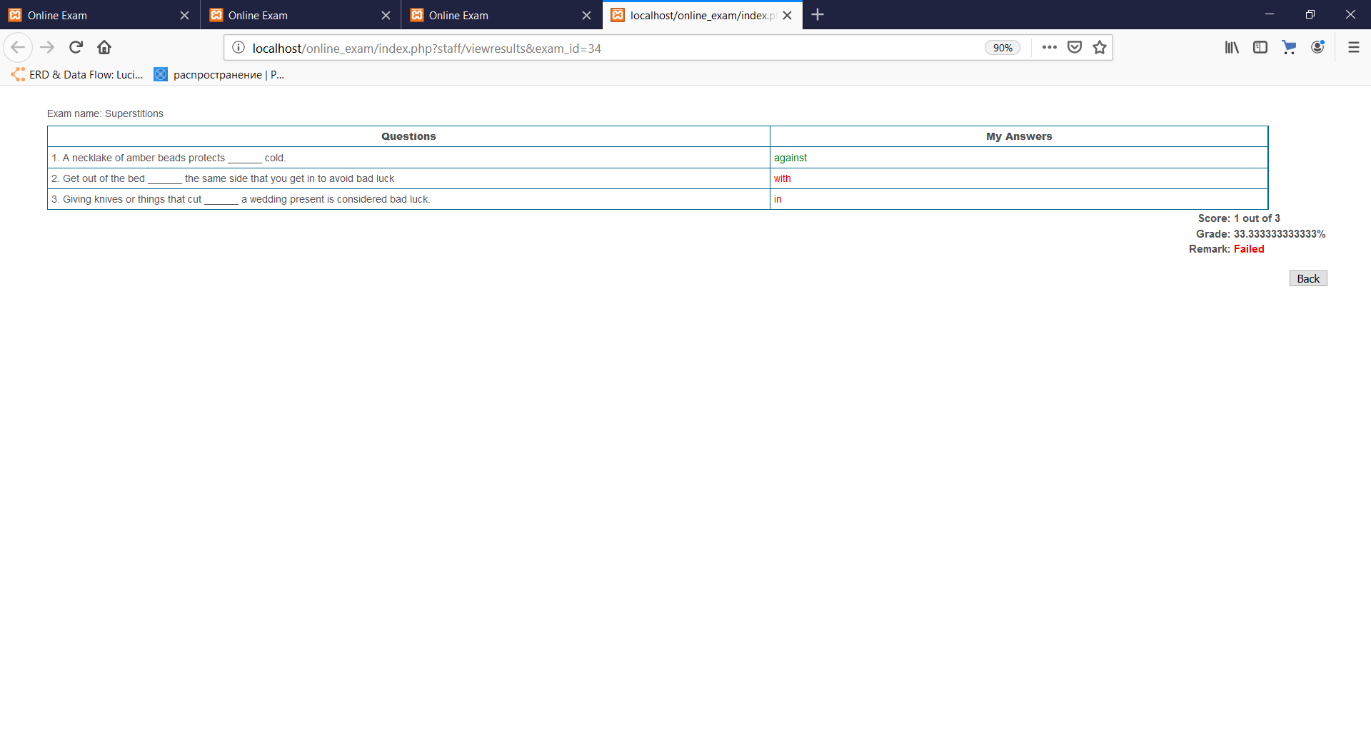

(Figure-171)

***Admin (teacher) panel:***

**Adding new examination**

Teachers can create new exams by clicking “Add new” link in the “Examinations” tab. In the appeared window, user has to fill all input fields and submit the form by clicking on “Save” button or he may cancel it by clicking on “Cancel” button.

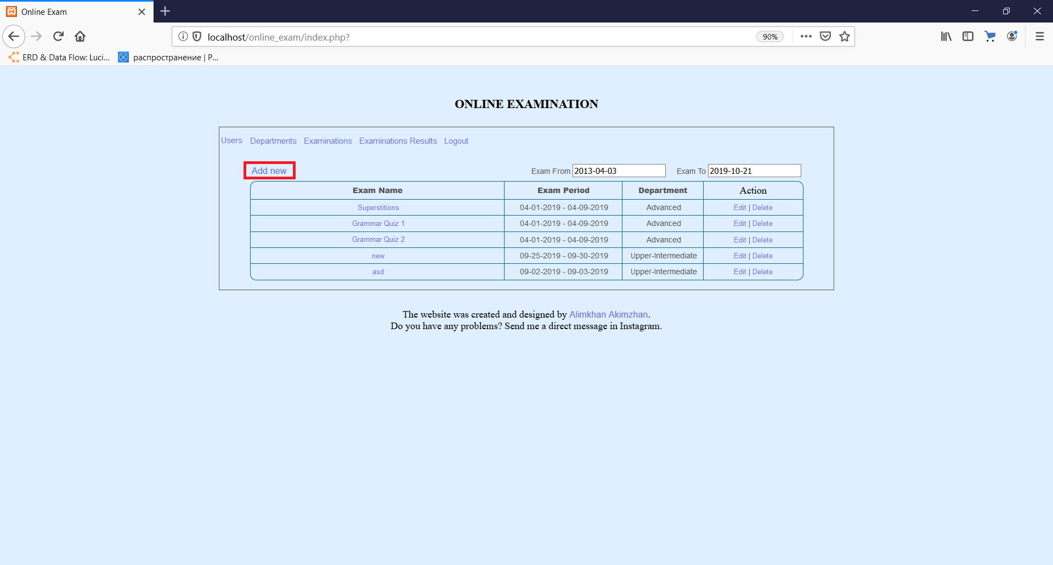

(Figure-172)

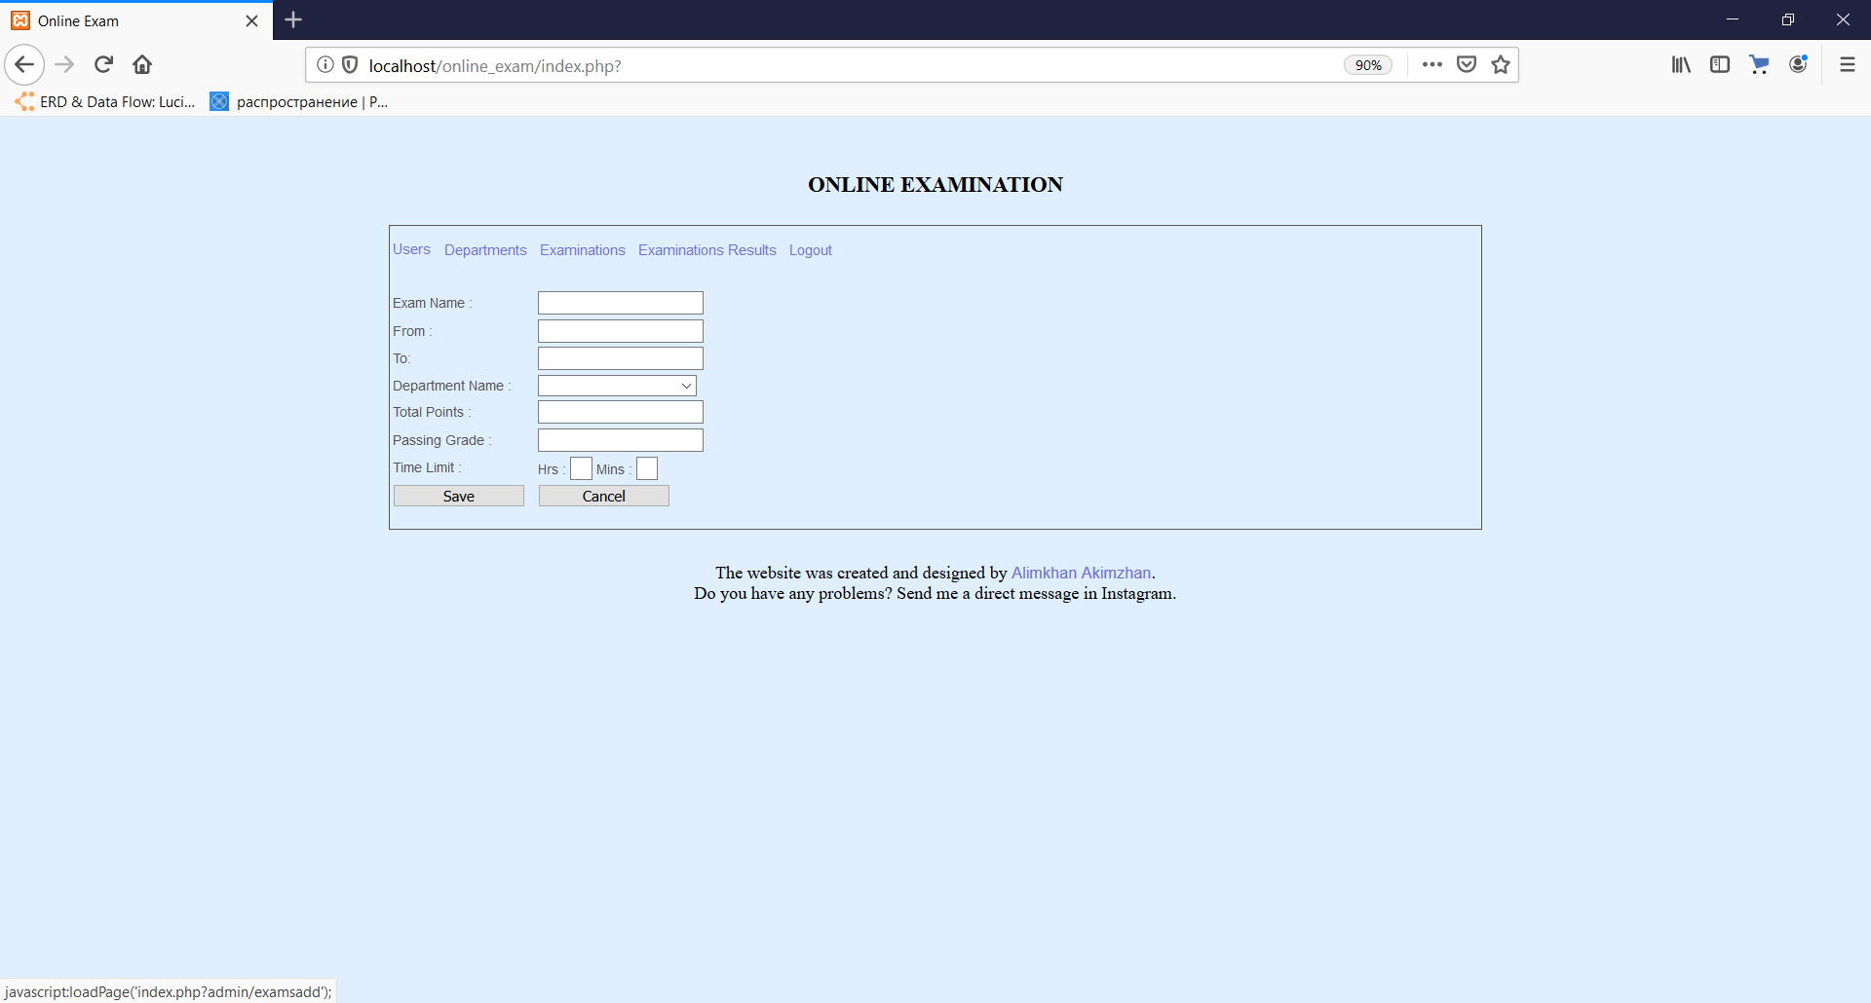

(Figure-173)

**Adding new department level**

Teachers can create new department levels by clicking “Add new” link in the “Departments” tab. In the appeared window, user has to fill all input fields and submit the form by clicking on “Save” button or he may cancel it by clicking on “Cancel” button.

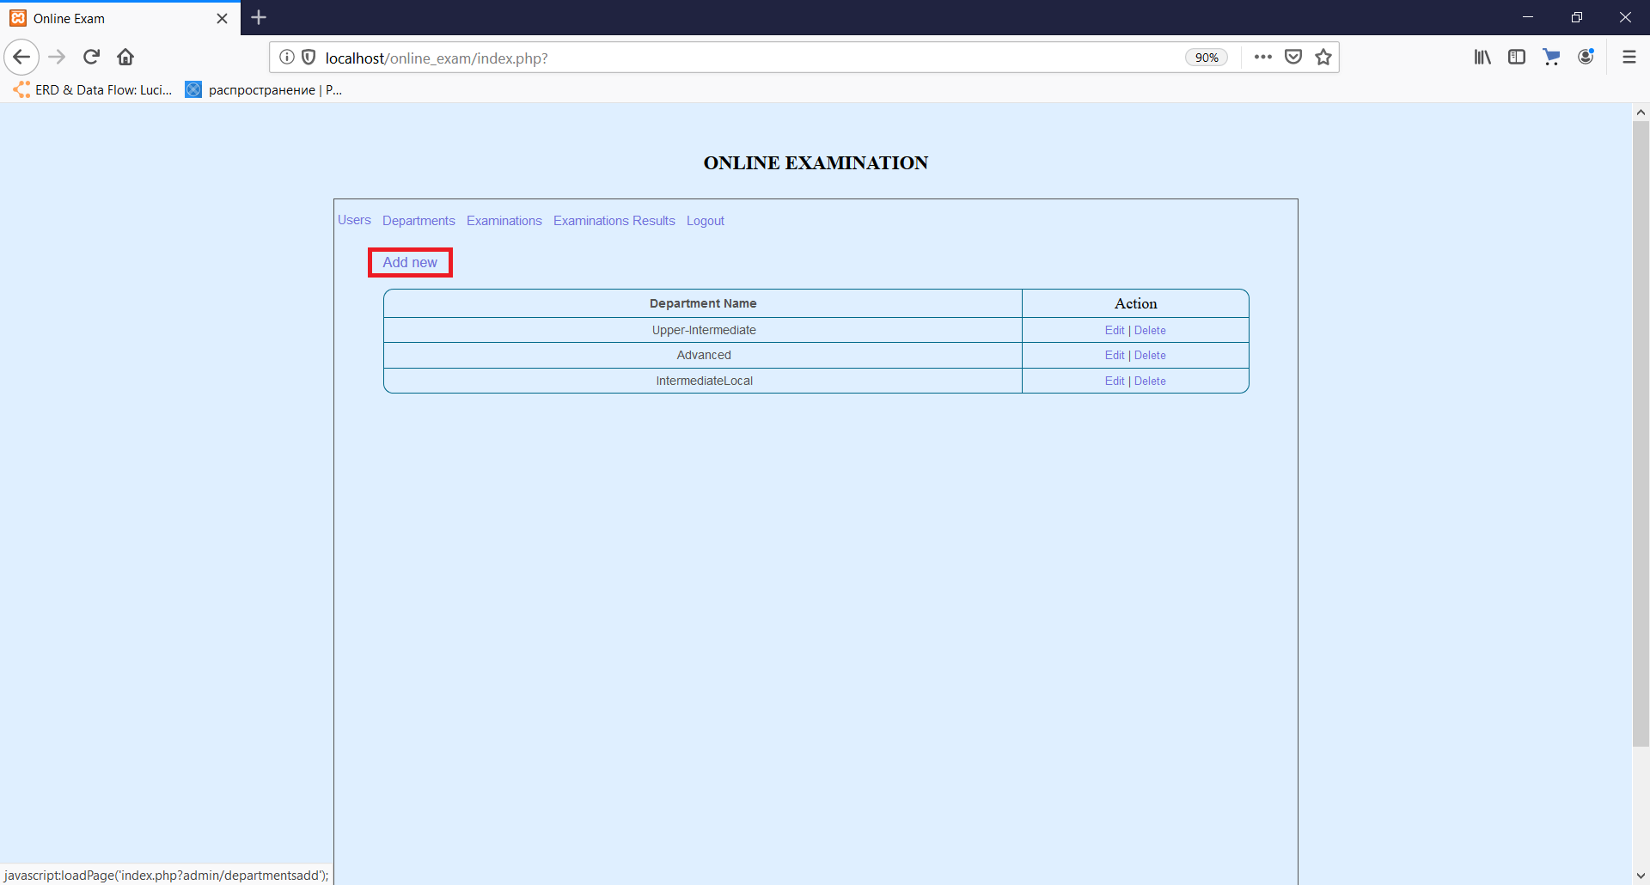

(Figure-174)

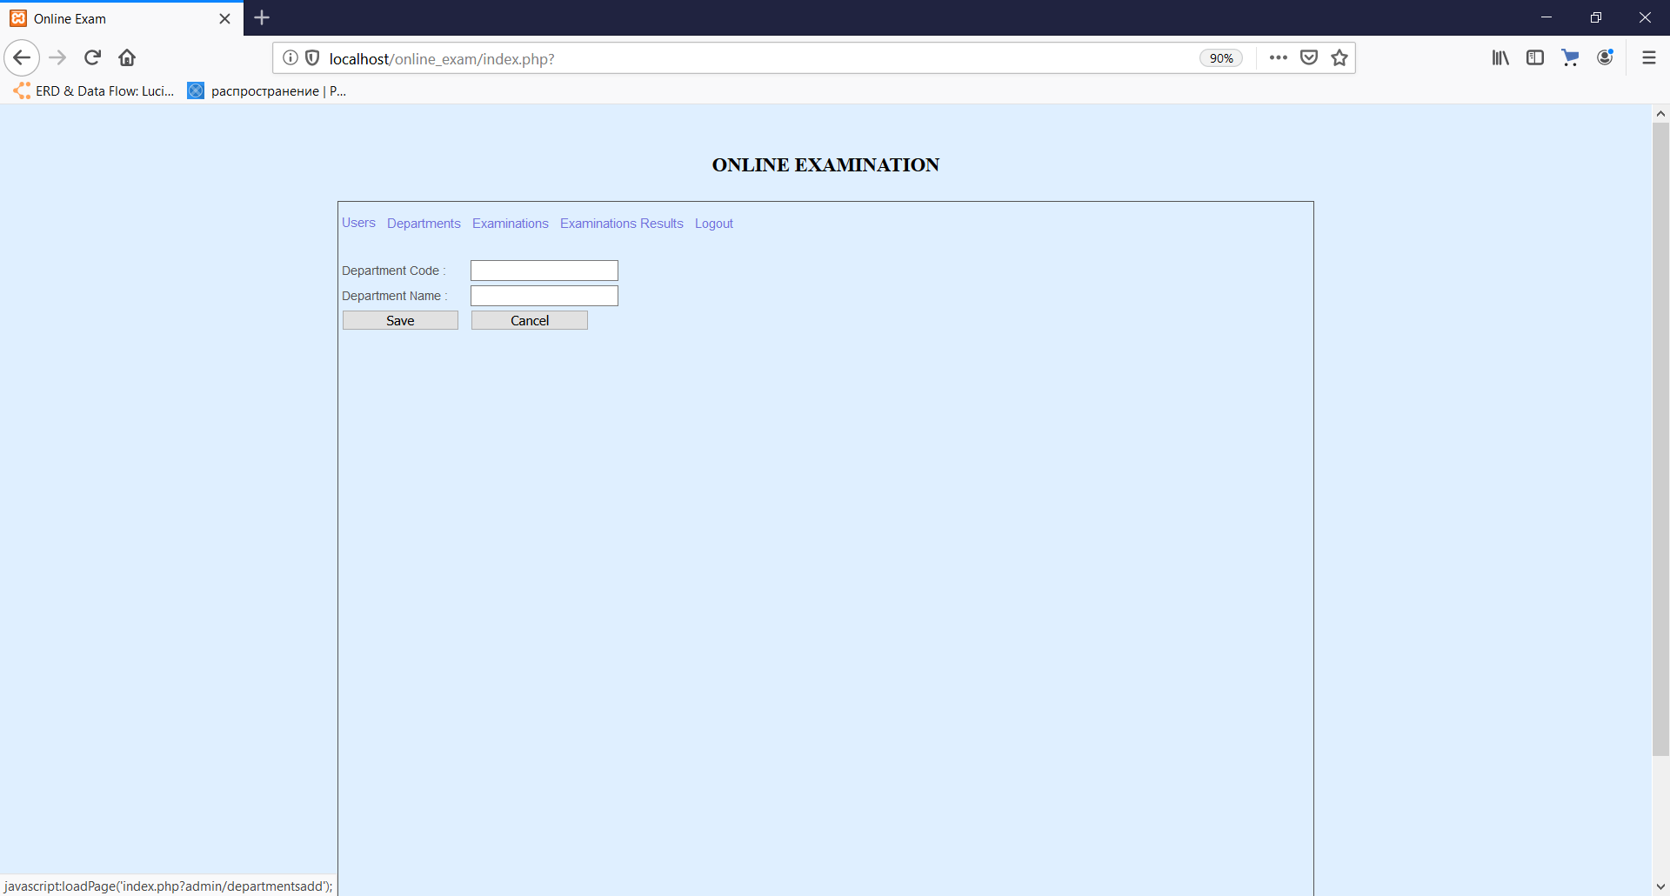

(Figure-175)

**Adding new user**

Teachers can add new users by clicking “Add new” link in the “Users” tab. In the appeared window, teacher has to fill all input fields and submit the form by clicking on “Save” button or he may cancel it by clicking on “Cancel” button.

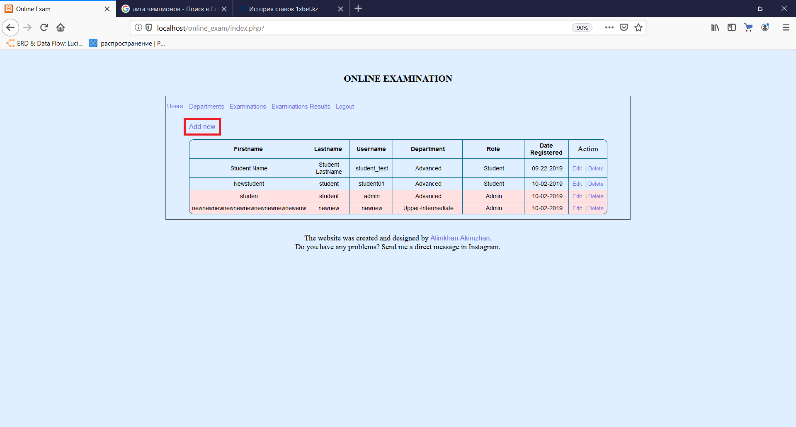

(Figure-176)

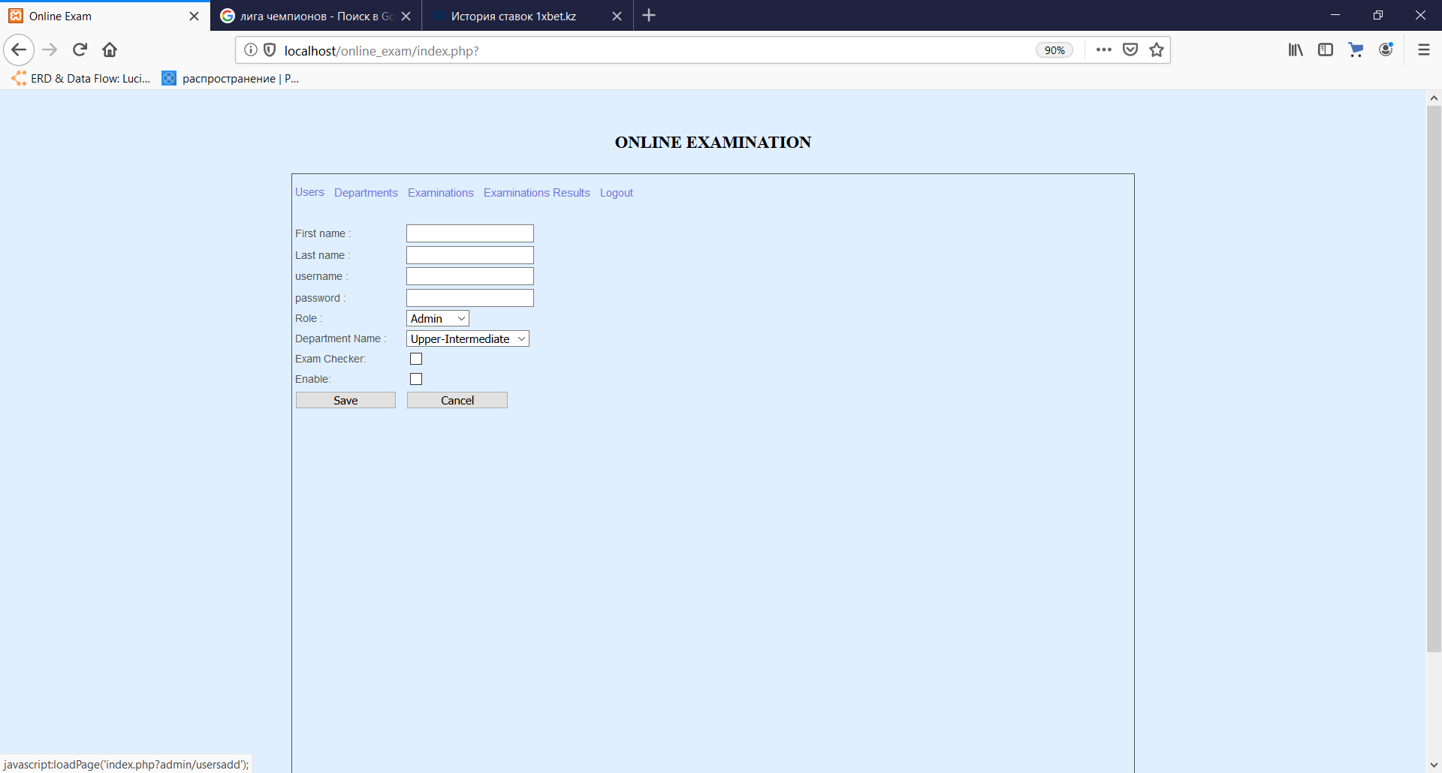

(Figure-177)

**Adding new question**

Teachers can add new questions by clicking “Add new question” link in the “Examination” tab after choosing the certain exam. In the appeared window, teacher has to fill all input fields and submit the form by clicking on “Save” button or he may cancel it by clicking on “Cancel” button. If the type of the question is “Essay” the extra input field is displayed which is used to enter the total essay points for the answer given as a composition.

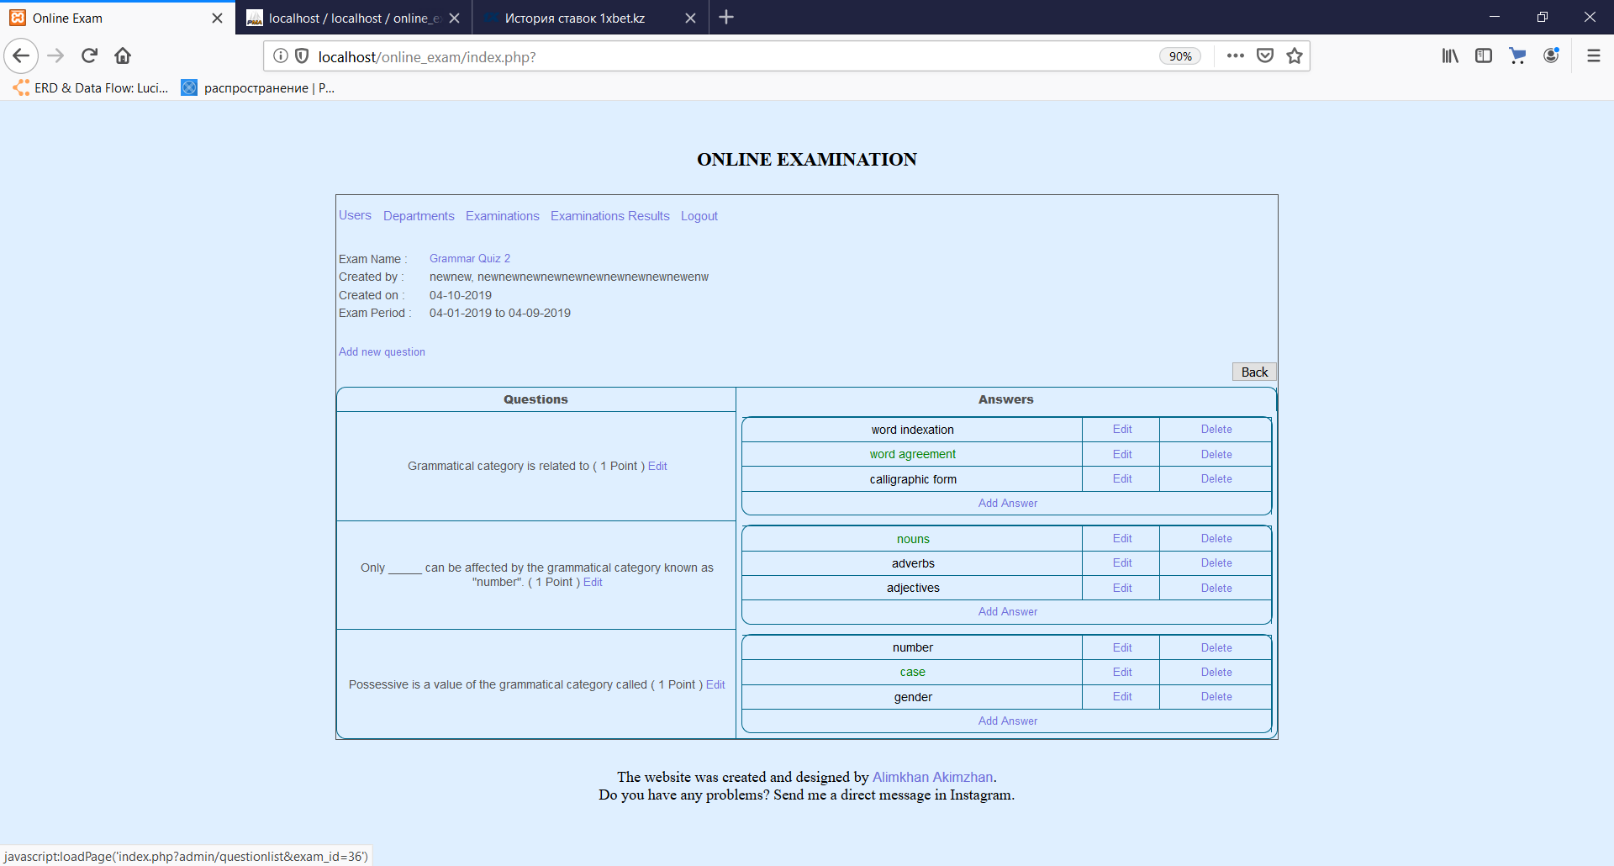

(Figure-178)

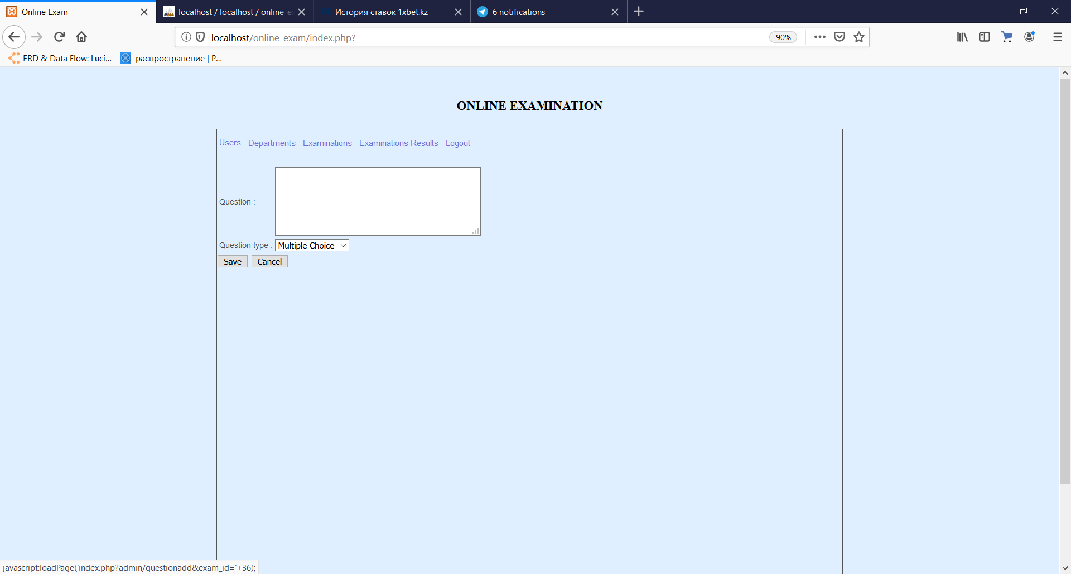 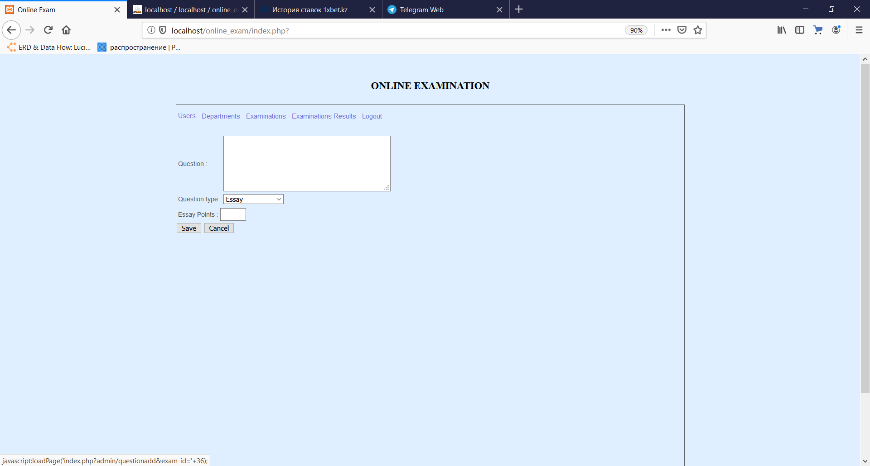

(Figure-179)

**Adding new answer**

Teachers can add new answers for a certain question by clicking “Add Answer” link in the “Examination” tab after choosing the certain exam. In the appeared window, teacher has to fill all input fields and submit the form by clicking on “Save” button or he may cancel it by clicking on “Cancel” button. If the answer is correct for the question, teacher should check the box with labe “Correct Answer”.

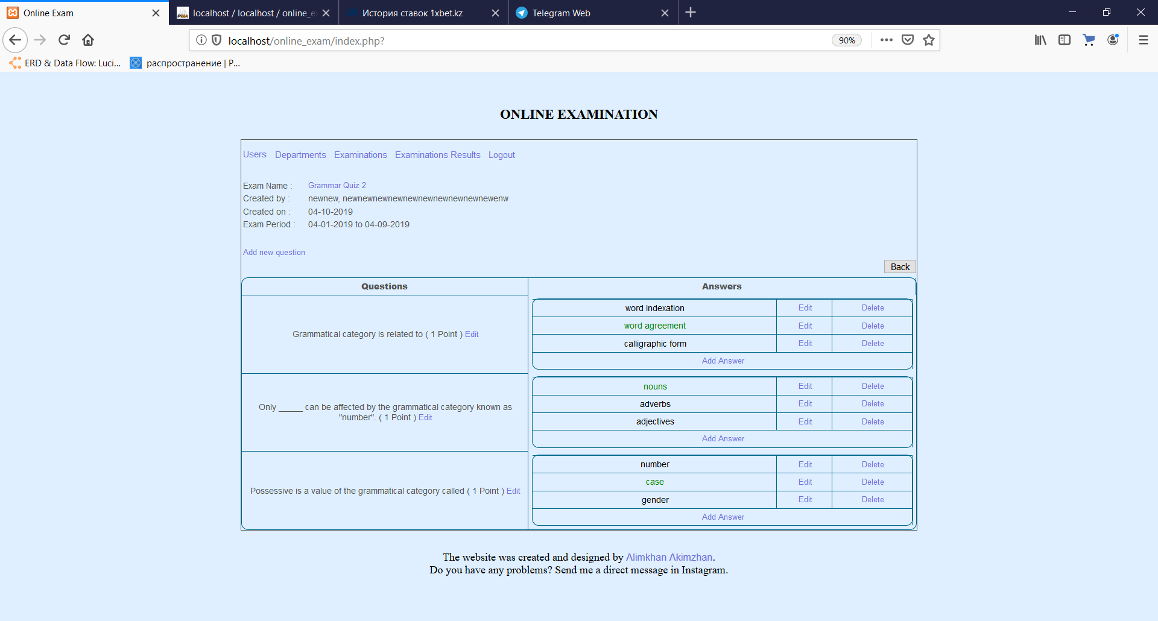

(Figure-180)

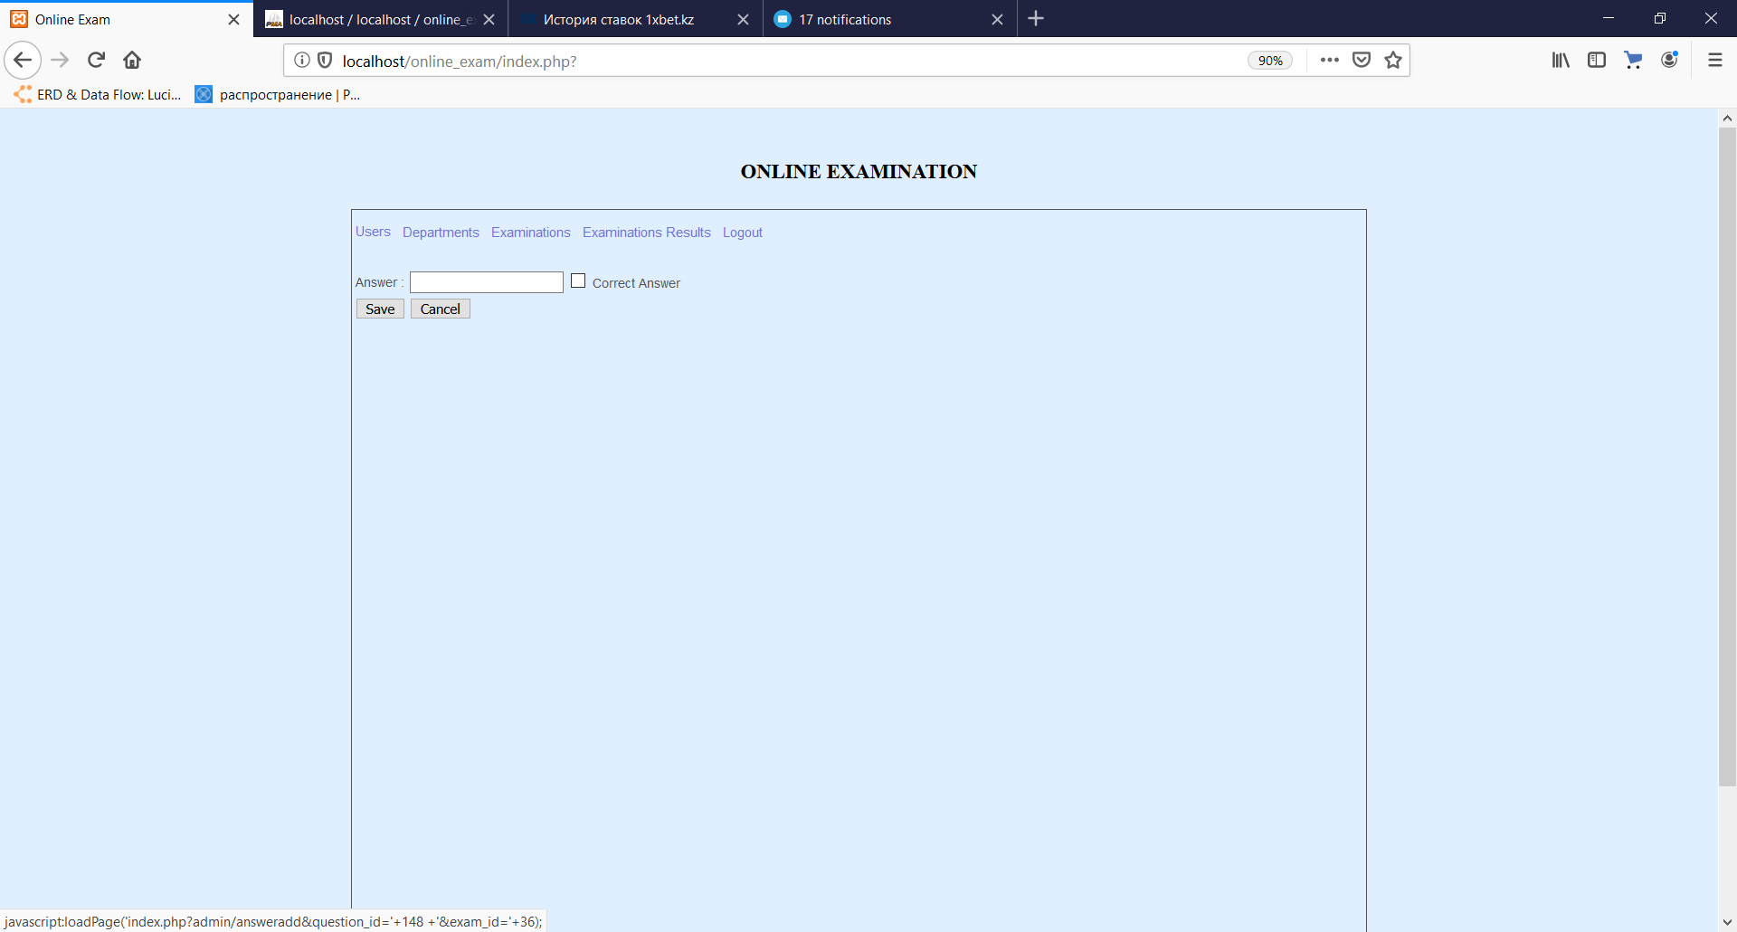

(Figure-181)

**Editing the examination**

Teachers can edit the existing exams by clicking “Edit” link in the “Examination” tab. In the appeared window, teacher can edit some details in the input fields and submit the form by clicking on “Save” button or he may cancel it by clicking on “Cancel” button.

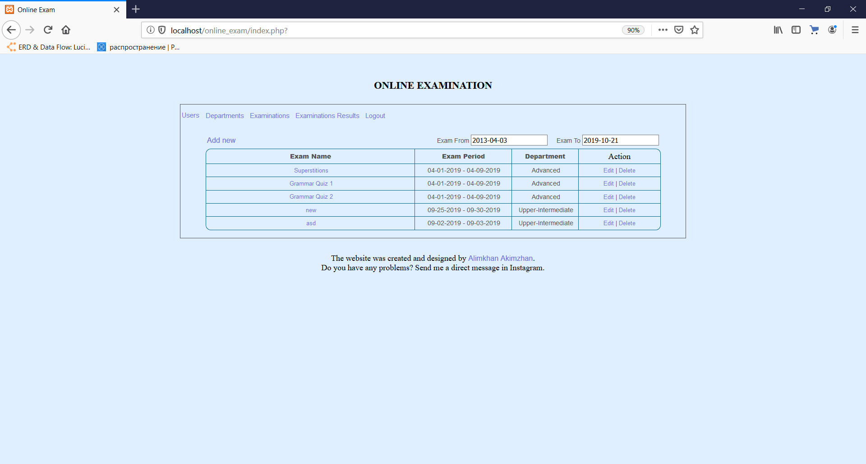

(Figure-182)

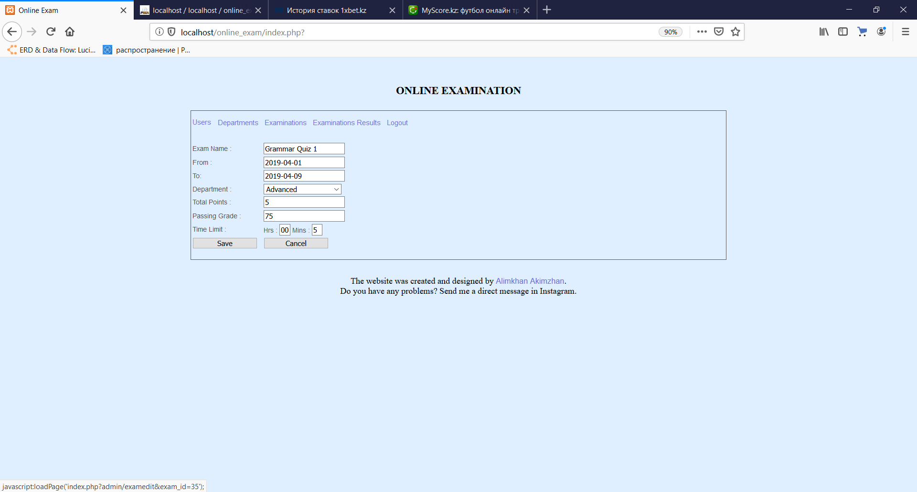

(Figure-183)

**Editing the user accounts**

Teachers can edit the existing users’ details by clicking “Edit” link in the “Examination” tab. In the appeared window, teacher can edit some details in the input fields and submit the form by clicking on “Save” button or he may cancel it by clicking on “Cancel” button.

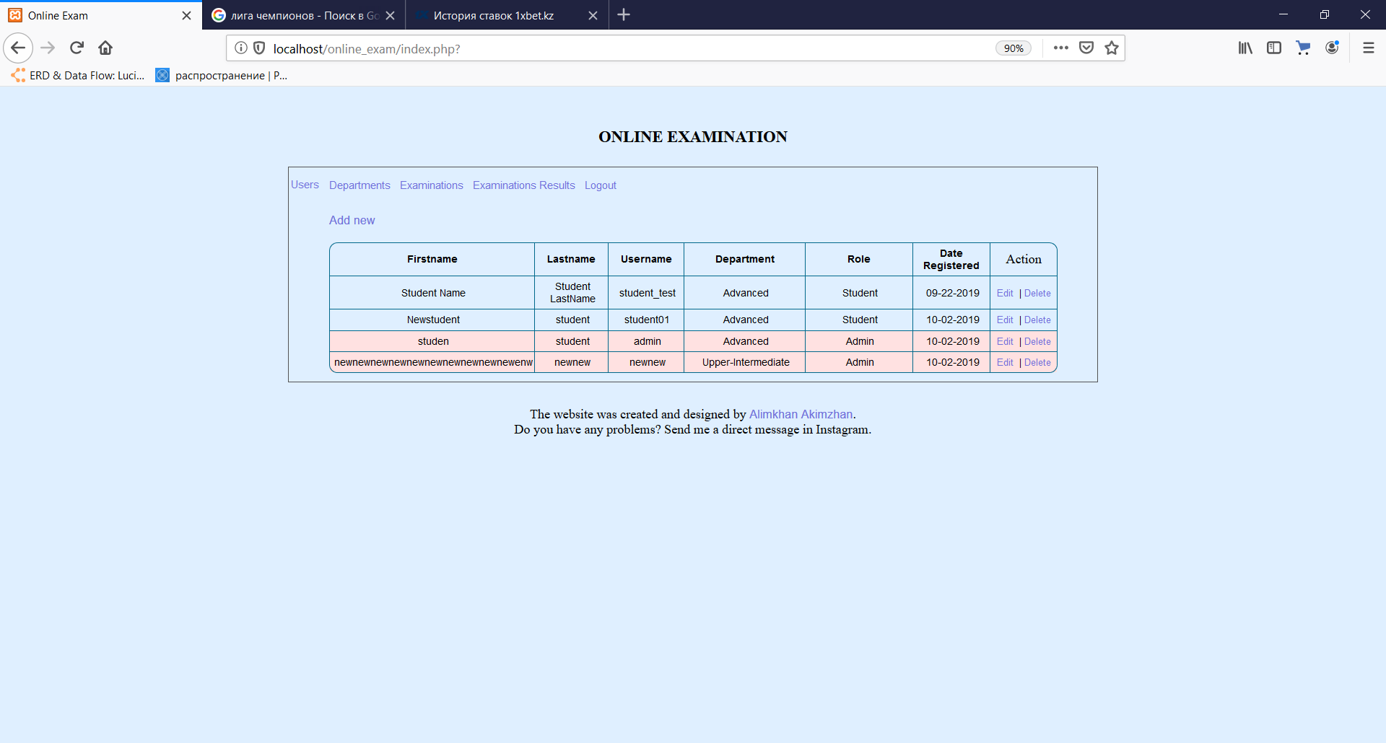

(Figure-184)

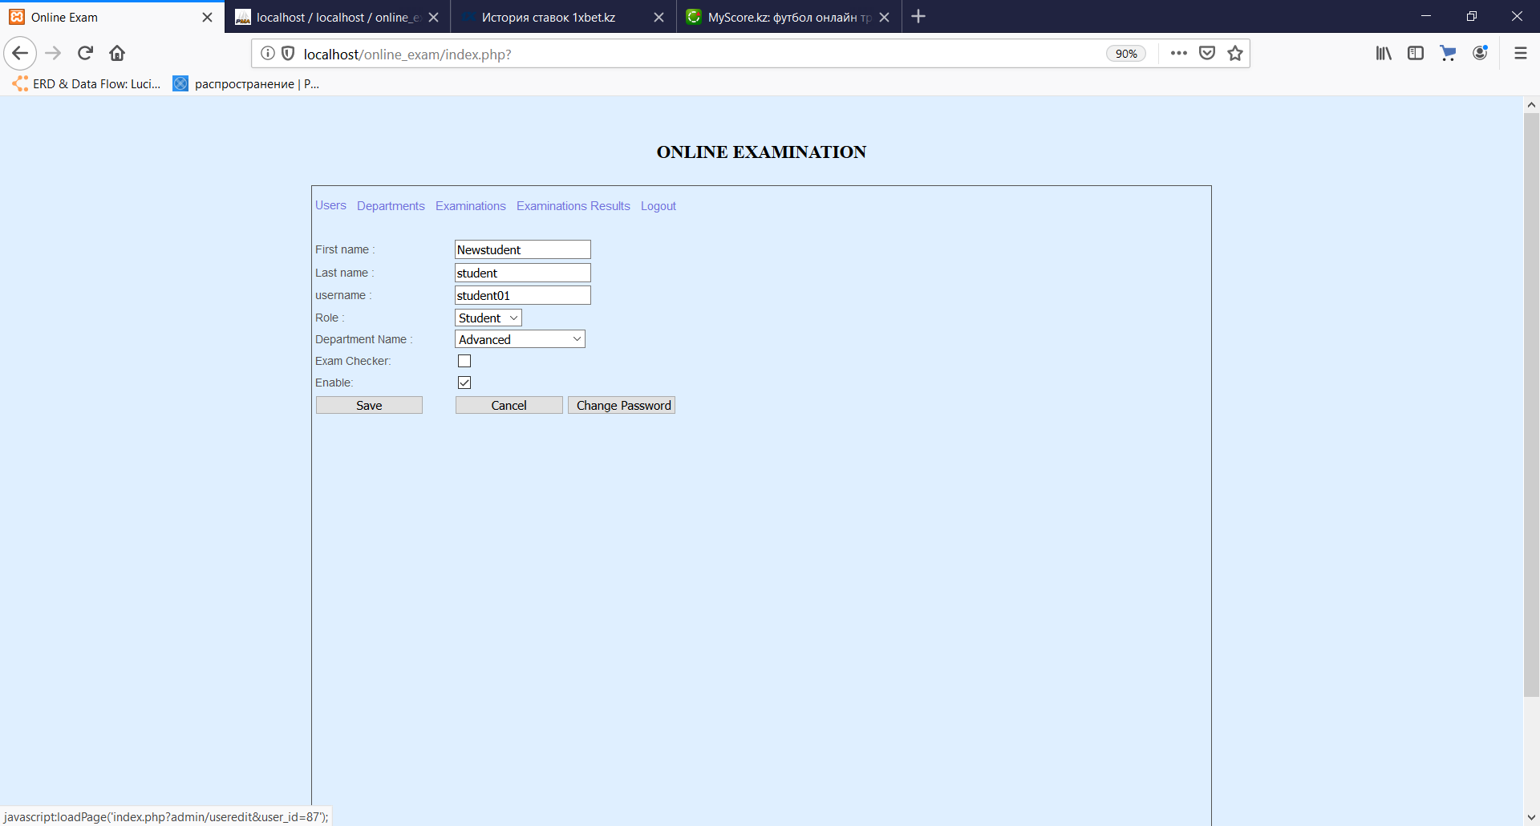

(Figure-185)

**Changing password**

Teachers can change the password of the existing users by clicking “Change Password” button in the “Edit” window. In the appeared window, teacher should enter the new password two times and submit the form by clicking on “Save” button or he may cancel it by clicking on “Cancel” button.



(Figure-186)

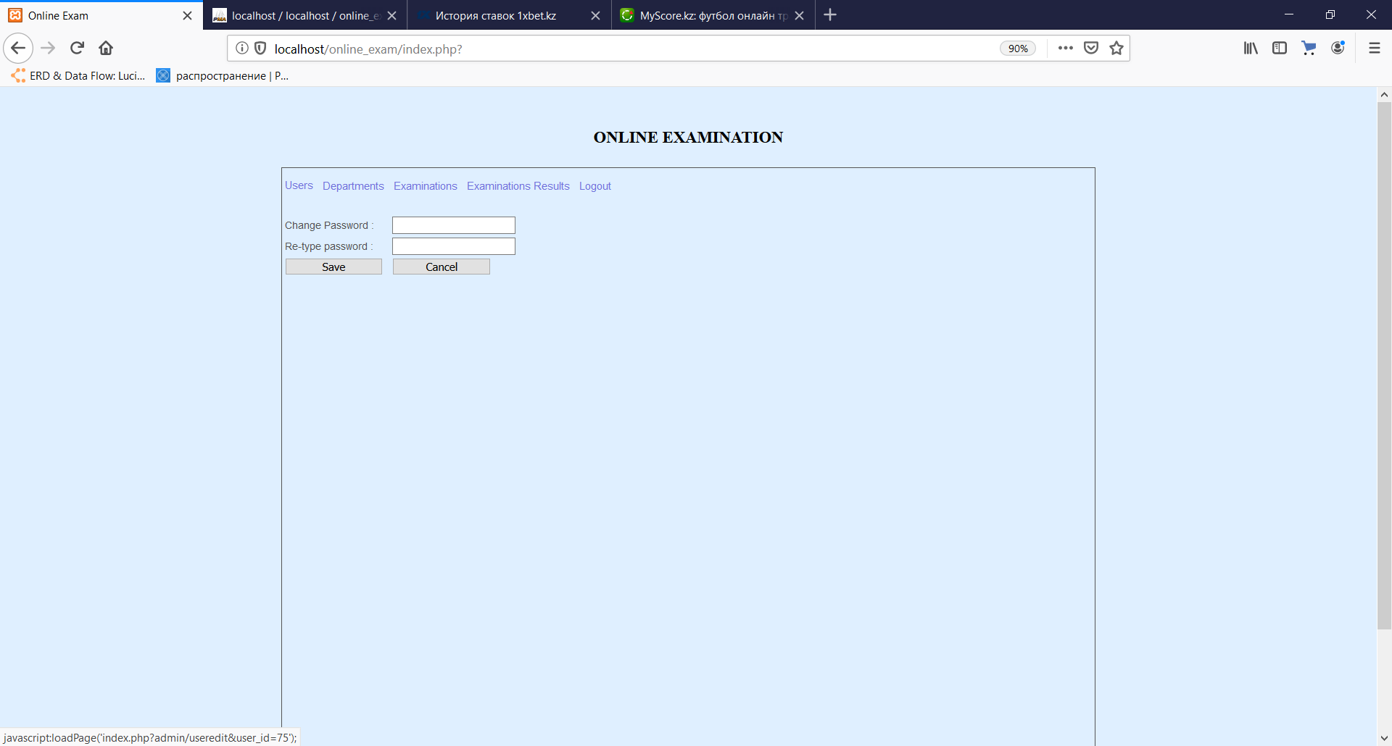

(Figure-187)

**Editing the department level**

Teachers can edit the existing department levels by clicking “Edit” link in the “Examination” tab. In the appeared window, teacher can edit some details in the input fields and submit the form by clicking on “Save” button or he may cancel it by clicking on “Cancel” button.

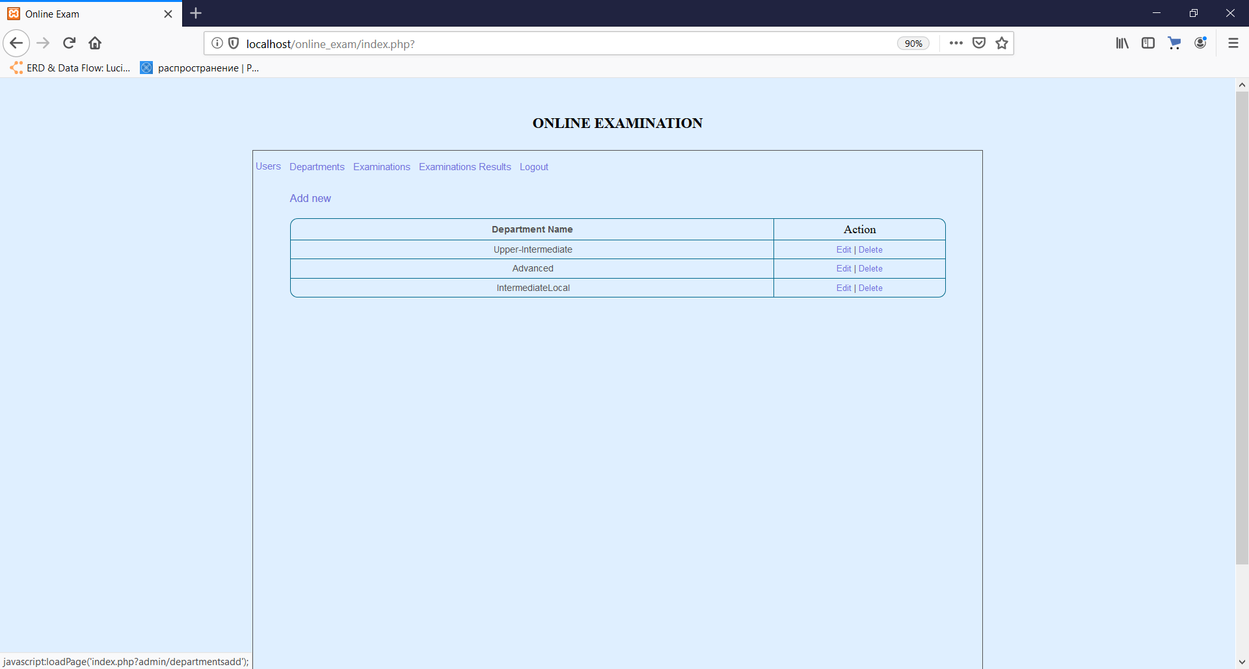

(Figure-188)

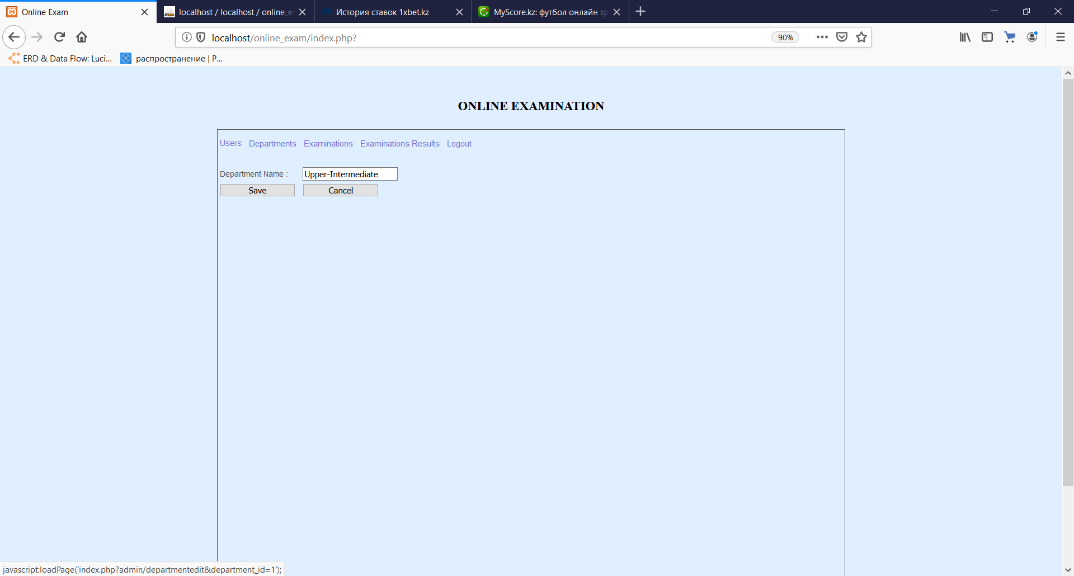

(Figure-189)

**Editing the question**

Teachers can edit the existing questions of a certain examination by clicking “Edit” link in the window showing the questions and answers of the examination. In the appeared window, teacher can edit some details in the input fields and submit the form by clicking on “Save” button or he may cancel it by clicking on “Cancel” button.

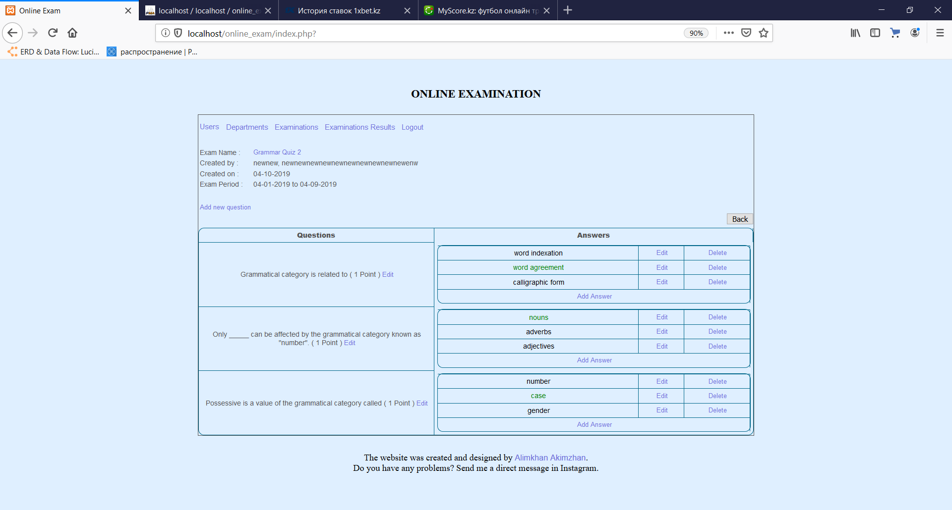

(Figure-190)

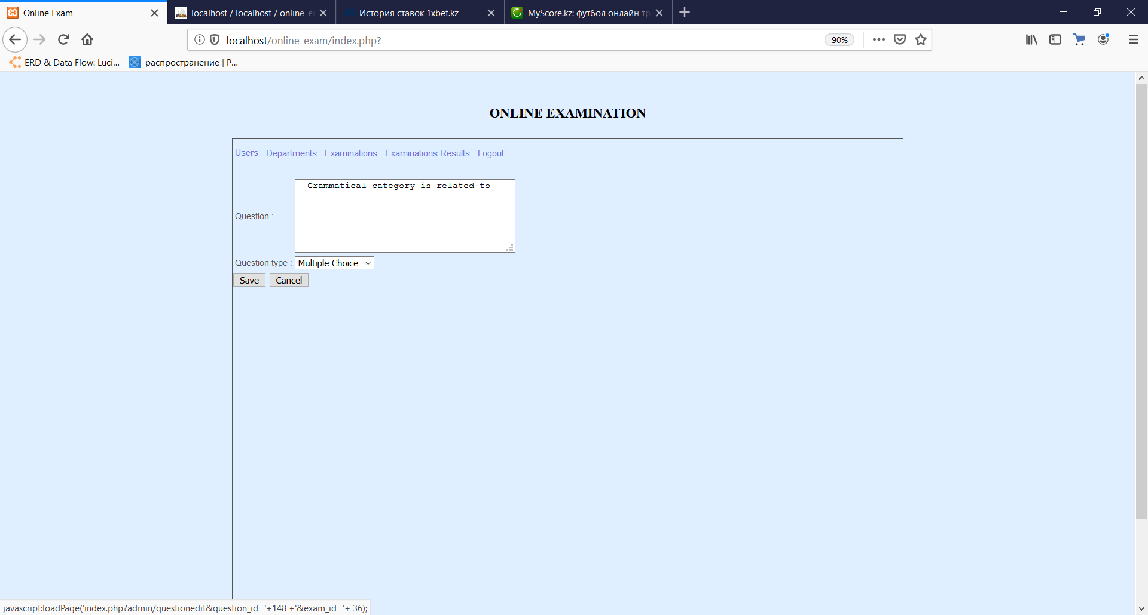

(Figure-191)

**Editing the answer**

Teachers can edit the existing answer of a certain question by clicking “Edit” link in the window showing the questions and answers of the examination. In the appeared window, teacher can edit some details in the input fields and submit the form by clicking on “Save” button or he may cancel it by clicking on “Cancel” button.



(Figure-192)

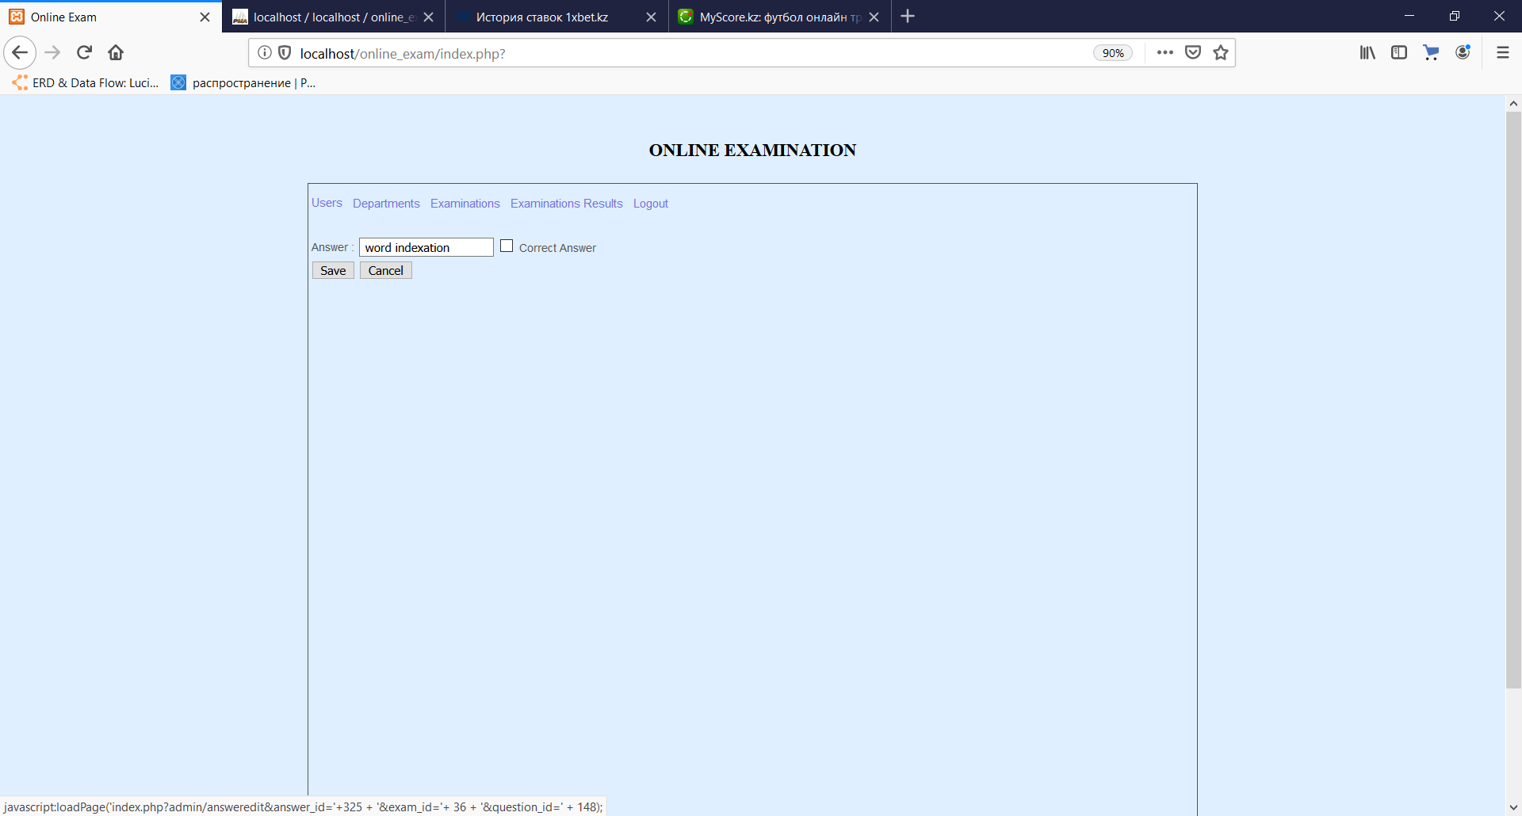

(Figure-193)

**Deleting the examination**

Teachers can delete the existing exams by clicking “Delete” link in the “Examinations” tab. In the appeared window, teacher can edit some details in the input fields and submit the form by clicking on “Save” button or he may cancel it by clicking on “Cancel” button.

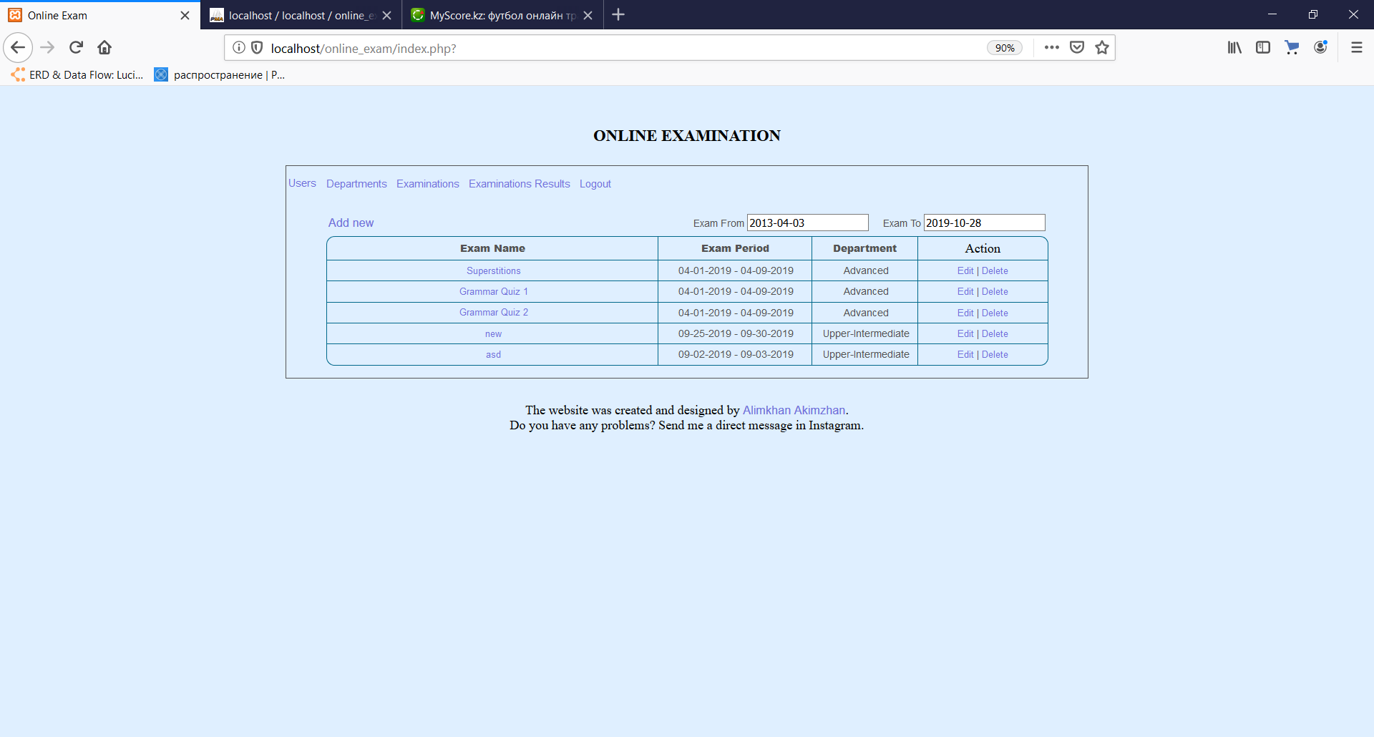

(Figure-194)

**Deleting the user**

Teachers can delete the existing users by clicking “Delete” link in the “Users” tab.

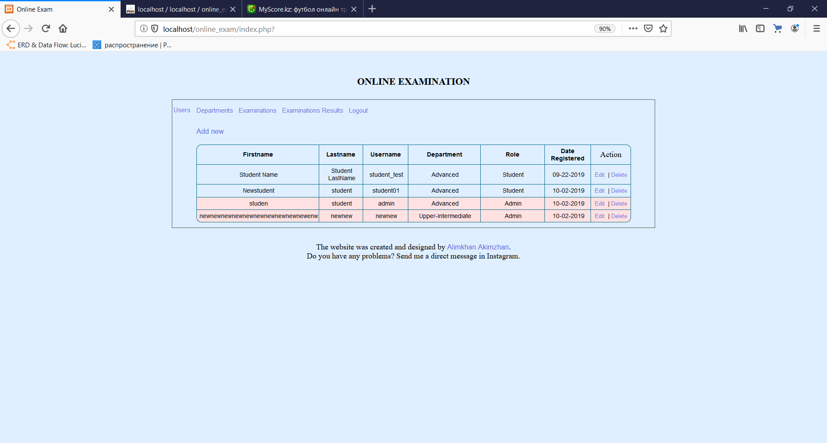

(Figure-195)

**Deleting the department level**

Teachers can delete the existing users by clicking “Delete” link in the “Departments” tab.

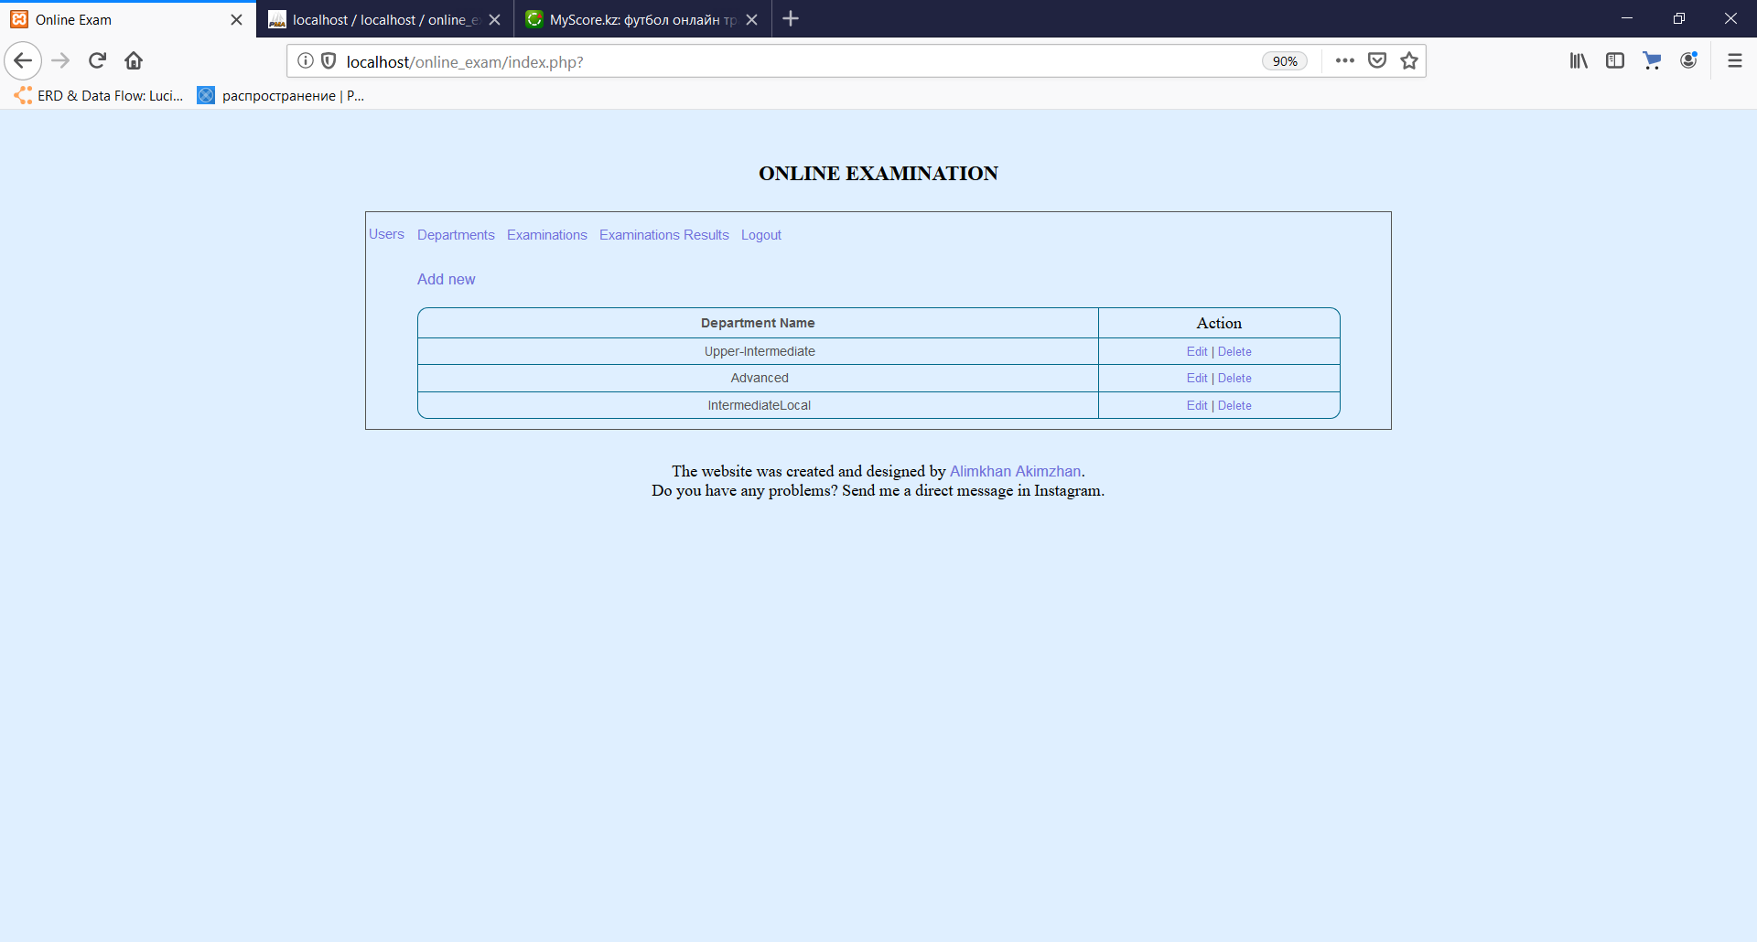

(Figure-196)

**Deleting the answer**

Teachers can delete the existing users by clicking “Delete” link in the “Exam” window.

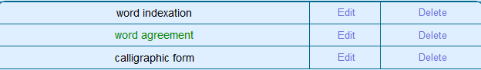

(Figure-197)

**Common Error Guide**

Table-32

|  |  |  |
| --- | --- | --- |
| **Error** | **Cause** | **Solution** |
| Message: “Incorrect Username or Password” | 1.The username or password is invalid  2.Trying to login with empty fields | 1. Try to login with the valid username and password  2. Fill the login form with valid credentials and login |
| Message: “Please fill up the requirement below” | 1. The form was submitted with the empty input fields | 1. Fill the empty input fields |
| Message: “Username is Already Exist” | 1. The user with the same username exists in the system | 1.Change the username written in the sign-up form |
| Message: “Your account needs to be activated” | 1. The admin hadn`t activate user`s account. | 1. Ask administrator to activate user. |

**Back-up full guide:**

To create a back-up file of files and database, user must to log into control panel of the hosting.

Go to “Backups” into “Files” section.



(Picture-14.)

Here, they will see the steps, what they should do.

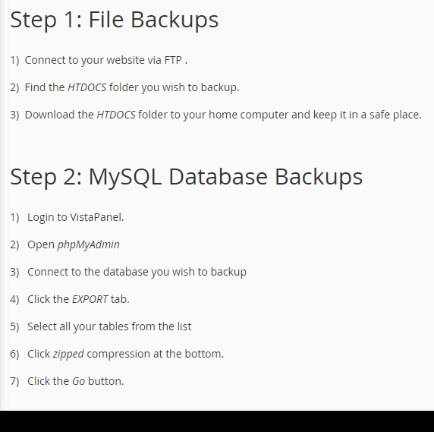

(Picture-15.)

To create a back-up of files, user must log in into online “File Manager”, where they find “htdocs”, and by clicking it, they should click on “Download” to download a full back-up copy of files.

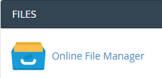

(Picture-16.)



(Picture-17.)

To create a copy of database correctly, user must to go to “phpMyAdmin”, which is in section of “Databases”

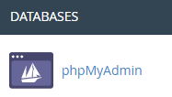

(Picture-18.)

Then by connecting to “online_exam” database, go to “Export” directory and choose the type of exporting (Fast/Default), and the click on “Go”.

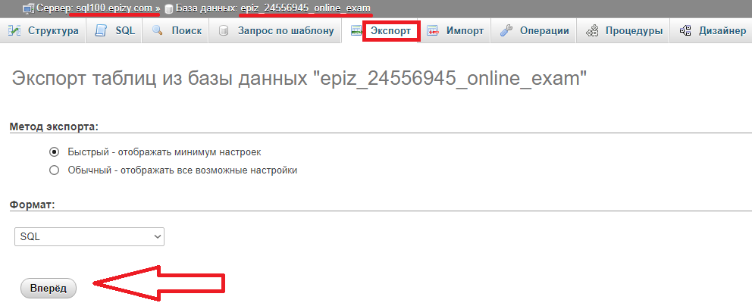

(Picture-19.)

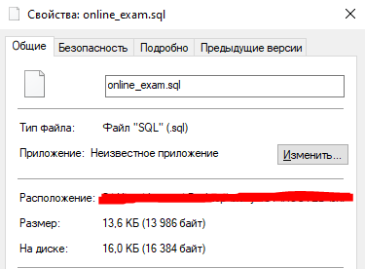

The File size of database

**Glossary**

*Form:* the element of an interface that gives the opportunity to transfer the data and control components of a webpage

*Field/input*: an area where user can enter the data as name, password, username and etc.

*Checkbox:* an element used to set some values on/off, 1/0 or True/False. For example, make user enabled or exam checker.

*Selector:*an element which consists of different options and user can choose one of them as a parental object.

*Record:* A special data which can be entered by user

*Database:* a comprehensive collection of the data organized for convenient access

*Session:* variables are used to store temporary information, sometimes to use for retrieving and

viewing data on multiple web pages.

*Hosting:* store (a website or other data) on a server or other computer so that it can be accessed

over the Internet.

*Domain name:* the part of a network address that identifies it as belonging to a particular

domain.

*Back-up:* reserve copy of the website or database.

**Index**

|  |  |
| --- | --- |
| User Manual (instructions) …………………………………………………………………..  Common Error Guide ……………………………………..…………………………………  Glossary ……………………………………………………………………………………... | 108  117  119 |

# (F) EVALUATION

## (i) Discussion of the degree of success in meeting the original objectives

The list of objectives for the website which is agreed and were already mentioned in the C(i) part of this documentation:

* The website should be loaded in the different browsers with no functionality lost and conflicts;
* The system should provide the opportunity to register new users in the system and store the details about them in the database;
* In registering stage, user can have a chance to choose the department level he wants to learn;
* The system must include practical authorization method;
* Database should store all recordings with no loss of data;
* Interface should be very simple and easy to understand;
* The administrator should have the opportunity to:
  + Add users profiles, departments, question, answers;
  + Edit users profiles, departments, question, answers;
  + Delete users profiles, departments, question, answers;
  + To time limit the passing exams;
  + See the results of the students` exam grades taken;
  + Check the results (“Checked/Not yet”);
  + Sort the data by date;
  + Activate/disactivate account;
  + Change passwords of users;
  + Assign the role of the user;
* The activated authorized student should have the opportunity to:
  + Take an exam;
  + View results of passed exam;
  + View passed grade and remarking;
* The system must not give the access to unauthorized users to use the website functions, such as taking exam, editing users and etc.;
* The system must allow the registered users to log in their accounts as the account is activated by the administrator;
* The encrypting of the password into database must be included;
* Site must be protected by own framework:
  + Not to permit access to direct open the path into the URL;
  + To redirect user to the error page, if the page is not existing;
  + To hide the full catalog of files that are stored in the hosting.

The given evidences show that the objectives of the project are achieved. And they show the moments where those objectives can be met in the website.

Table-33

|  |  |  |
| --- | --- | --- |
| **№** | **Evaluation** | **Evidence** |
| 1 | The main pages layouts are loaded in the different browsers with no functionality lost and conflicts | p.91, Figures 114-115 |
| 2 | Registering new users is provided by the system, and insert all information about them into the databases. | p.91, Figures 116-118 |
| 3 | User can choose the department level he wants to learns | p.91, Figures 117 |
| 4 | Practical authorization method is included in the system | p.92, Figures 119-122 |
| 5 | Database stores all recordings with no loss of data | p.91, Figures-118 |
| 6 | Interface is very simple and easy to understand | p.91-93, Figures 114-155 |
| 7 | The administrator can: | |
| * + Add users profiles, departments, question, answers; | p.63-64, Figures 67-68  p.70, Figures 82  p.72, Figures 89  p.78, Figures 98  p.94-95, Figures 130-138  p.96, Figures 142, 146 |
| * + Edit users profiles, departments, question, answers; | p.64, Figures 69  p.71, Figures 87  p.73, Figures 90  p.80-81, Figures 102-103  p.94-95, Figures 133, 139  p.96-97, Figures 144, 148 |
| * + Delete users profiles, departments, question, answers; | p.68, Figures 76-79  p.72, Figures 88  p.80, Figures 101 |
| * + Limit the passing exams` time; | p.96, Figure 144  p.93, Figures 125-127 |
| * + See the results of the students` exam grades taken; | p.74-75, Figures 93-94  p.86, Figures 110-111  p.93, Figure 128,  p.98, Figures 153-155 |
| * + Check the results (“Checked/Not yet”); | p.76-77, Figure 96-97 |
| * + Sort the data by date; | p.96, Figure 144 |
| * + Activate/disactivate account; | p.94 Figures 130 |
| * + Change passwords of users; | p.65, Figures 70  p.94 Figure 133 |
| * + Assign the role of the user; | p. 64-65, Figures 69  p.94 Figures 130-131 |
| 8 | The activated authorized student is given to: | |
| * + Take an exam; | p.93 Figures 125-128 |
| * + View results of passed exam; | p.84, Figure 107 |
| * + View passed grade and remarking; | p.98 Figures 153-155 |
| 9 | The system does not give an access to unauthorized users to use the website functions, such as taking exam, editing users and etc. | p.92 Figure 123  p.97 Figures 150-152 |
| 10 | Only users, whose accounts are activated by the administrator can log into the system with their accounts. | p.92 Figure 121-122 |
| 11 | The methods of encryption of password works. | p.91-93, Figures 118, 124 |
| 12 | Webpages are protected by own framework, which does: | |
|  | * + Not to permit access to direct open the path into the URL; | p.87, Figure 112  p.97, Figure 150 |
| * + To redirect user to the error page, if the page is not existing; | p.87, Figure 113  p.97, Figure 151 |
| * + To hide the full catalog of files that are stored in the hosting. | p.87, Figure 113  p.97 Figure 152 |

**Degree of success**

The table above shows that all of the objectives of the new system are fully met and it can be considered that the website is succeeded.

## (ii) Evaluate client’s and user’s response to the system

**Client’s Response**

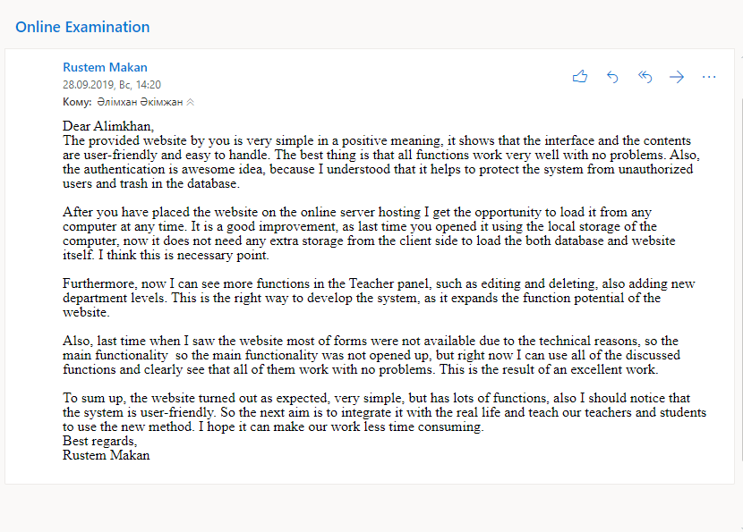

**User’s response**

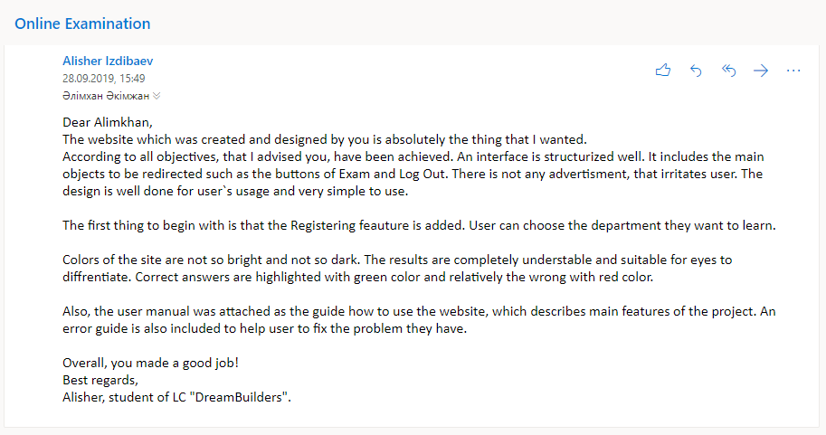

**Analysis of the client’s and user`s response**

The client was provided with the pre-final version of the website 2 weeks before asking his final response and opinion about it, so the client had enough time to get used to the website and to understand all features of it, to exptestinglore most of things about the new system. This gives the opportunity to get the feedback from the client. So right after the testing of the functions used in the website from the client side and using most of them, Mr.Makan was asked for the thoughts about the fixes that should be done on the system and future developments.

After the feedback of the client the only mistake faced by the him was fixed. It was the alerting of a message which tells that “Username already exists” even if no user has the same username. This was the single trouble found in the work of the website.

Then the fixed website was given to the client again in order to check it for other errors and mistakes for the one week time. And the last feedback of Mr.Makan and user`s response (Alisher, student of DreamBuilders) is collected on 28th of September. He has given own answers to the questions in the questionnaire via email. He has noticed that the system works with no faults.

It can be read that user is showing own satisfactory about the features of the website in the email received by me on the 28th of September, 2019:

* Client noted that the website is simple, user-friendly and easy to handle: “The provided website by you is very simple in a positive meaning, it shows that the interface and the contents are user-friendly and easy to handle”
* Client supports the idea of using the hosting server: “After you have placed the website on the online server hosting I get the opportunity to load it from any computer at any time. It is a good improvement, as last time you opened it using the local storage of the computer, now it does not need any extra storage from the client side to load the both database and website itself. I think this is necessary point.”
* Client can see the developments added to the system: “now I can see more functions in the Teacher panel, such as editing and deleting, also adding new department levels. This is the right way to develop the system, as it expands the function potential of the website.”
* Client sees the differences between old and new versions of the website: “last time when I saw the website most of forms were not available due to the technical reasons, so the main functionality so the main functionality was not opened up, but right now I can use all of the discussed functions”
* Client marks the website with the positive mark and gives the future step of the development: “the website turned out as expected, very simple, but has lots of functions, also I should notice that the system is user-friendly. So the next aim is to integrate it with the real life and teach our teachers and students to use the new method. I hope it can make our work less time consuming.”.